**API TESTING:**

Contents

Authentication: 3

Signup: 3

Test 1: Creating duplicate users: 3

Test 2: Sending incomplete data: 4

Test 3: Sending Null Values: 10

Test 4: Multiple fields missing: 11

Test 5: Creating a new user: 12

Login: 14

Test 1: Attempting a successful login: 14

Test 2: Testing Invalid Login: 17

Test 3: Missing Data 20

Logout: 23

Test 1: Logging out without having a cookie/token: 24

Test 2: Testing a successful logout: 25

Test 3: Testing Logout with expired token: 27

Post API: 28

All Posts: 28

Test 1: Testing API call without authentication token 28

Test 2: Call after logging in: 32

MyPosts 33

Test 1: Sending a GET request without authentication: 33

Test 2: Sending a GET request after authentication and with query params: 33

New Post: 35

Test 1: Sending a POST request without authentication: 36

Test 2: Sending a POST request after authentication: 36

Test 3: Sending a POST request with incomplete/incorrect Data: 37

View Post: 39

Test 1: Sending a GET request with incorrect post ID: 39

Test 2: Sending a GET request with correct post ID: 40

Edit/Update Post: 41

Test 1: Sending a PATCH request without authentication: 41

Test 2: Sending a PATCH request with authentication: 42

Test 1: Sending a DELETE request without authentication: 44

Test 2: Sending a DELETE request with authentication: 45

Test 3: Sending a DELETE request with incorrect Post ID: 46

Comments: 47

View Comments: 47

Test 1: Testing comment 47

Test 2: Testing incorrect post ID: 49

Create Comment: 50

Test 1: Sending a POST request without authentication: 50

Test 2: Posting a comment after authentication: 51

Delete Comment 54

Test 1: Sending a DELETE request without authentication: 54

Test 2: Sending a DELETE request after authentication as author: 55

Test 3: Sending a DELETE request after authentication (!Author) 56

Test 4: Sending DELETE request after authentication but with invalid comment ID: 57

Likes: 57

Create Likes: 57

Test 1: Sending a POST request without authentication: 57

Test 2: Sending a POST request with authentication: 58

Get Likes: 62

Test 1: Sending a GET request without authentication: 62

Test 2: Sending a GET request post authentication: 63

Test 3: Sending a GET request with invalid post ID: 63

Edit Likes: 64

Test 1: Sending a PATCH request without authentication: 64

Test 2: Sending a PATCH request with authentication: 65

Delete Like: 70

Test 1: Sending a DELETE request without authentication: 70

Test 2: : Sending a DELETE request with authentication: 71

# Authentication:

## Signup:

POST <http://localhost:3000/user/sign-up>

Starting server:

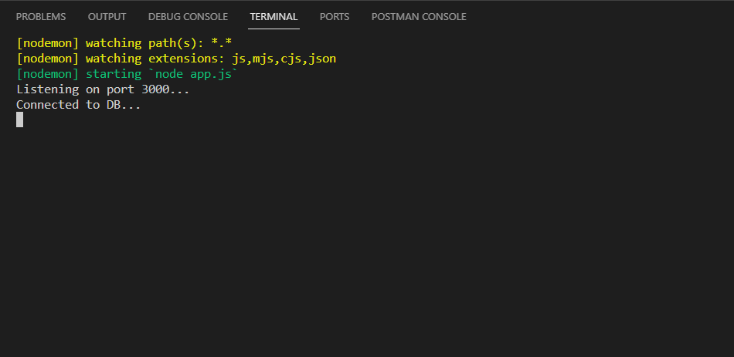

### Test 1: Creating duplicate users:

Sending a POST request to the signup route with new user details that has a duplicate username:

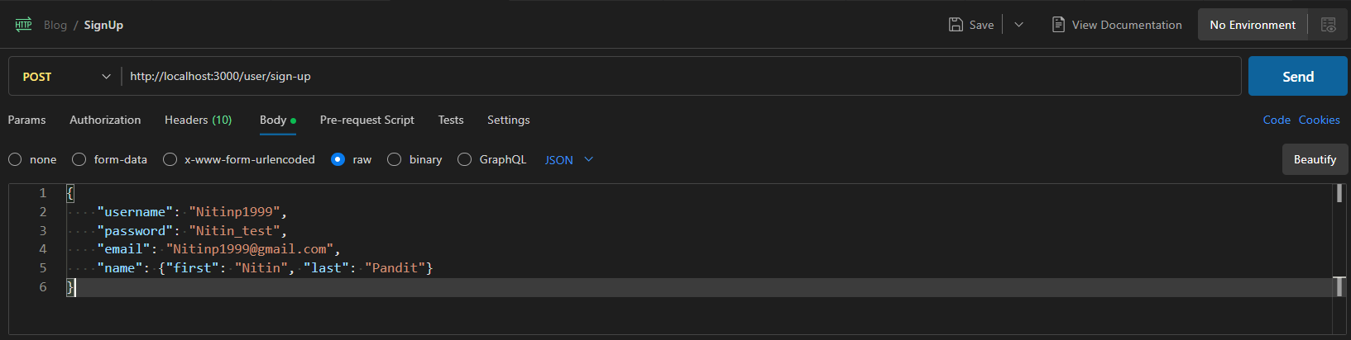

Server Output:

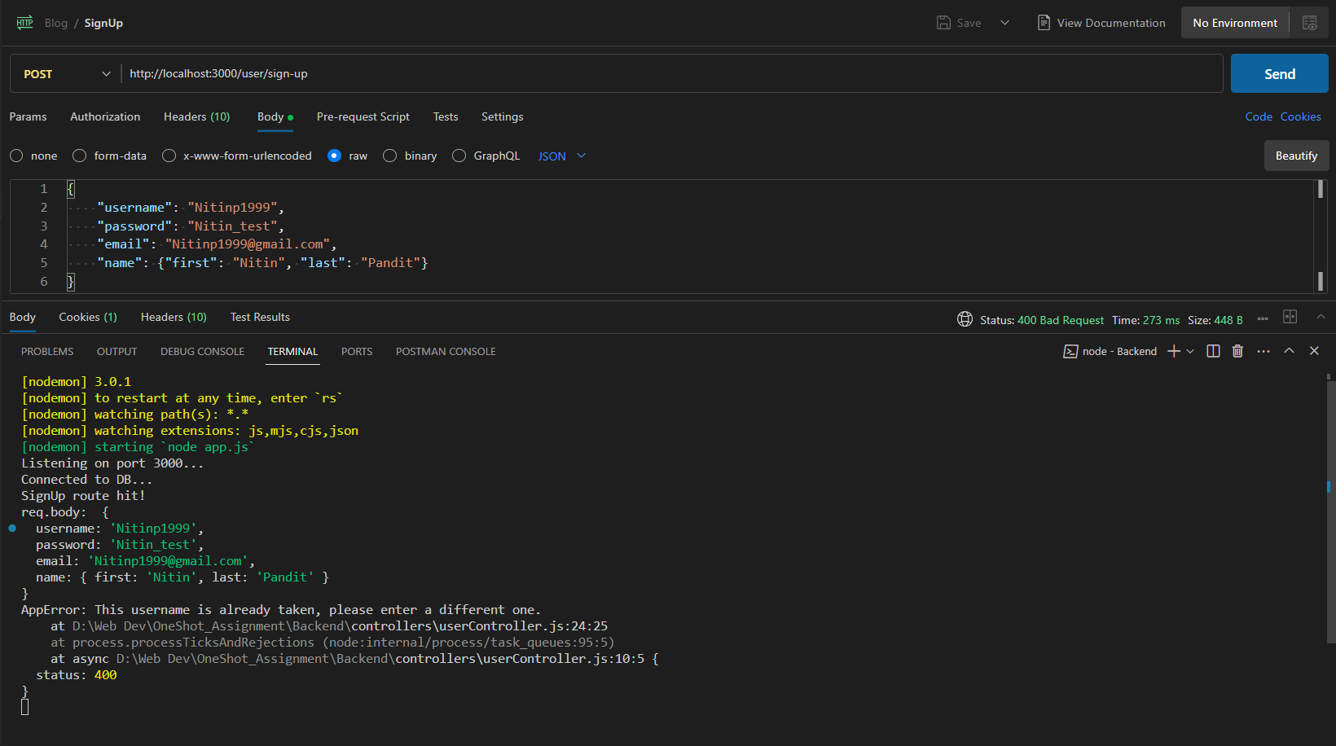

Server response: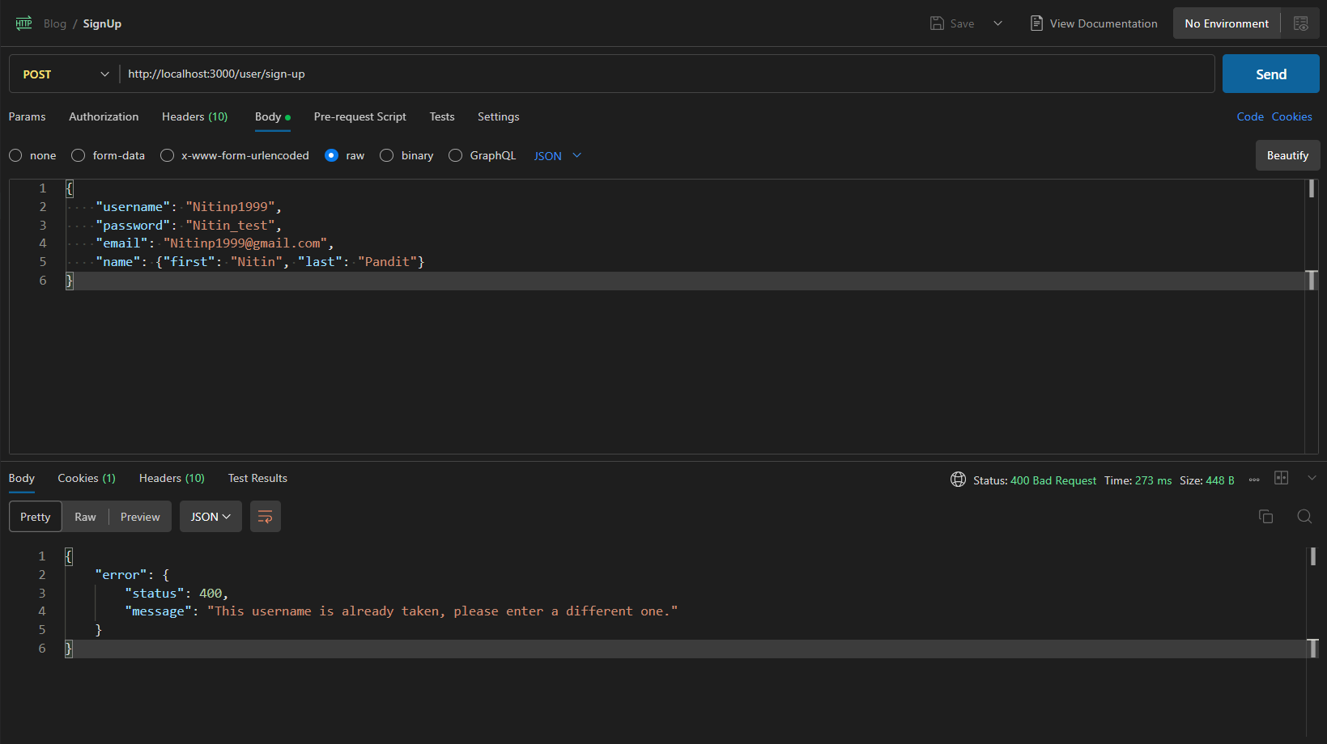

Result: The new user was not created and the error was successfully handled by the server.

### Test 2: Sending incomplete data:

#### Missing Username:

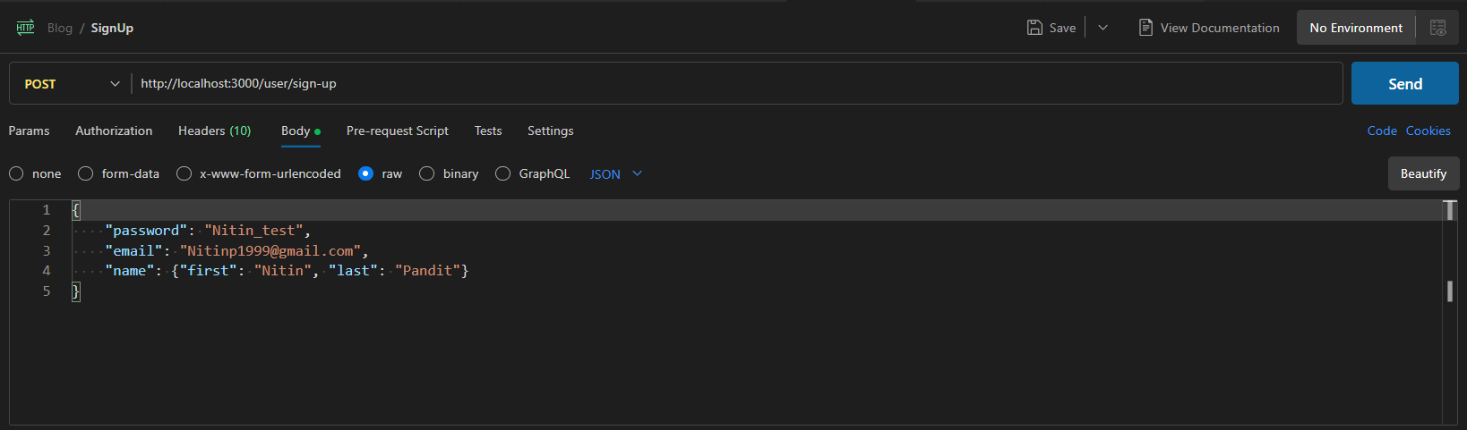

Server Output: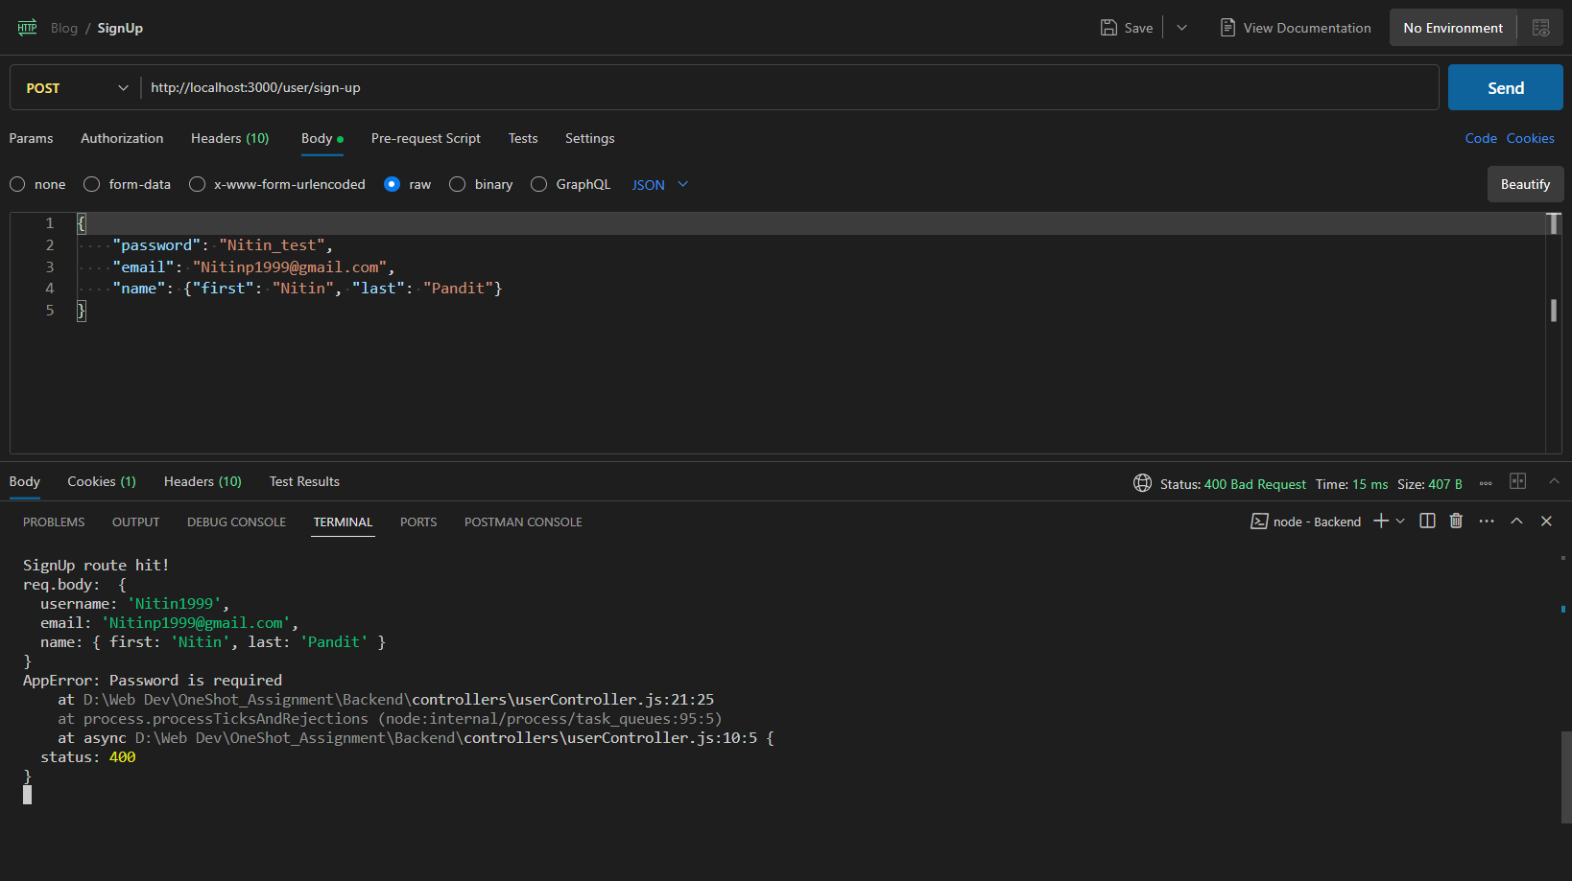

Server Response:

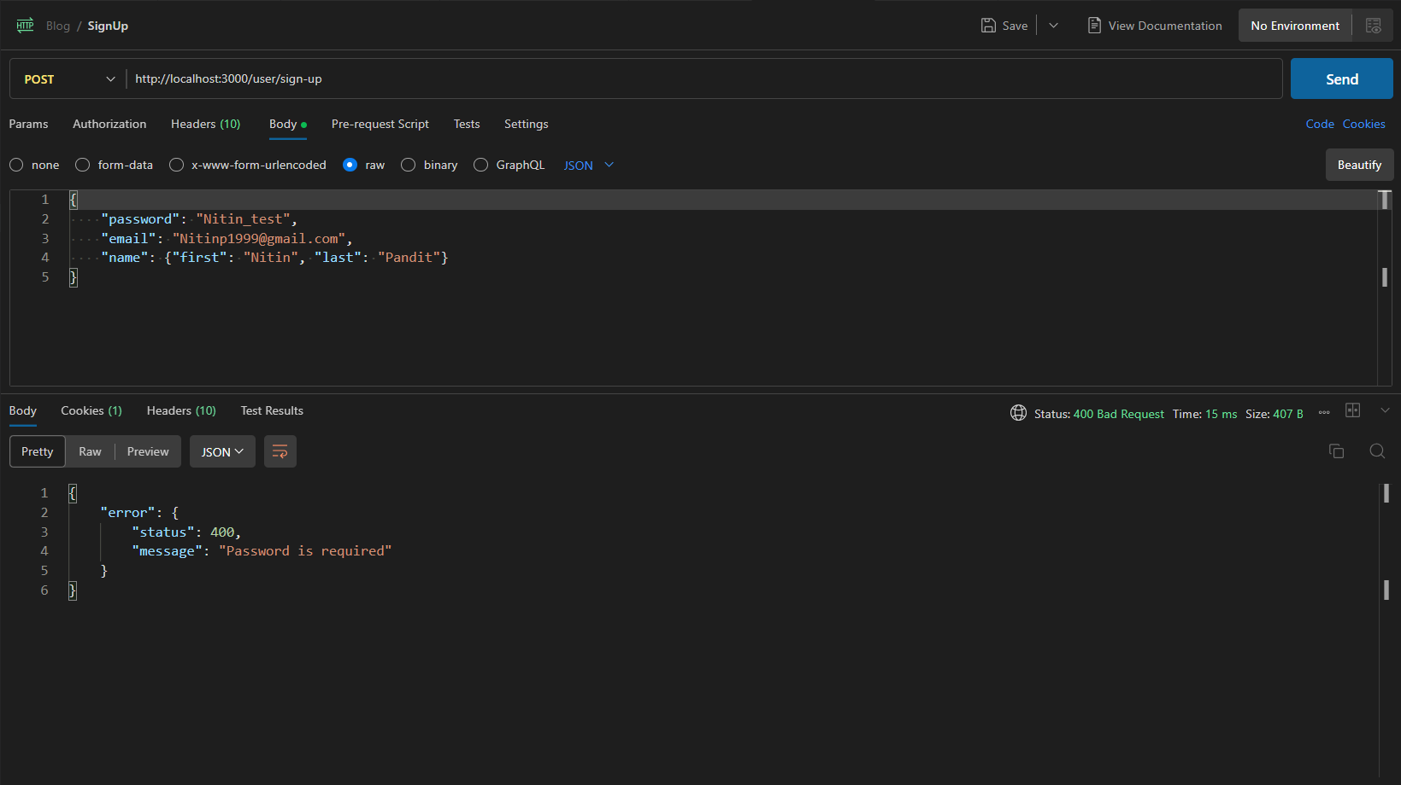

#### Missing Email:

Sending a POST request to the sign up route with missing email:

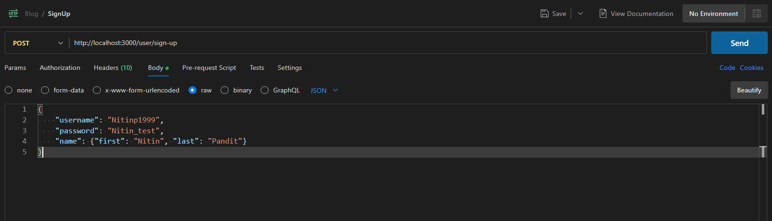

Server output: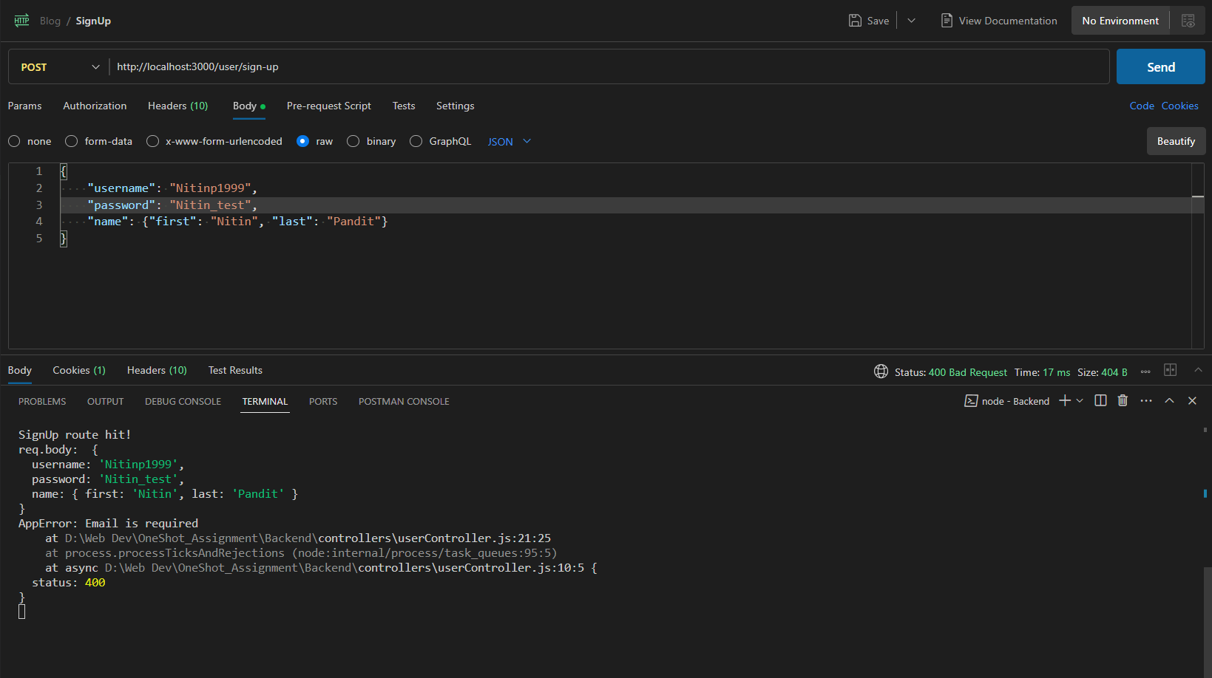

Server Response:

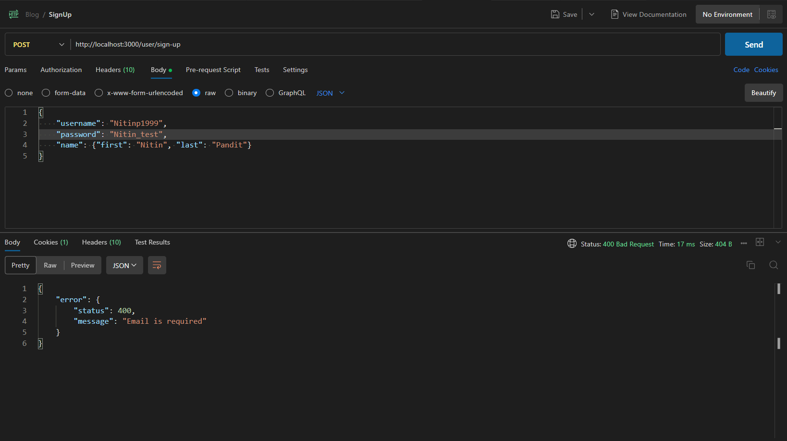

Missing Password: 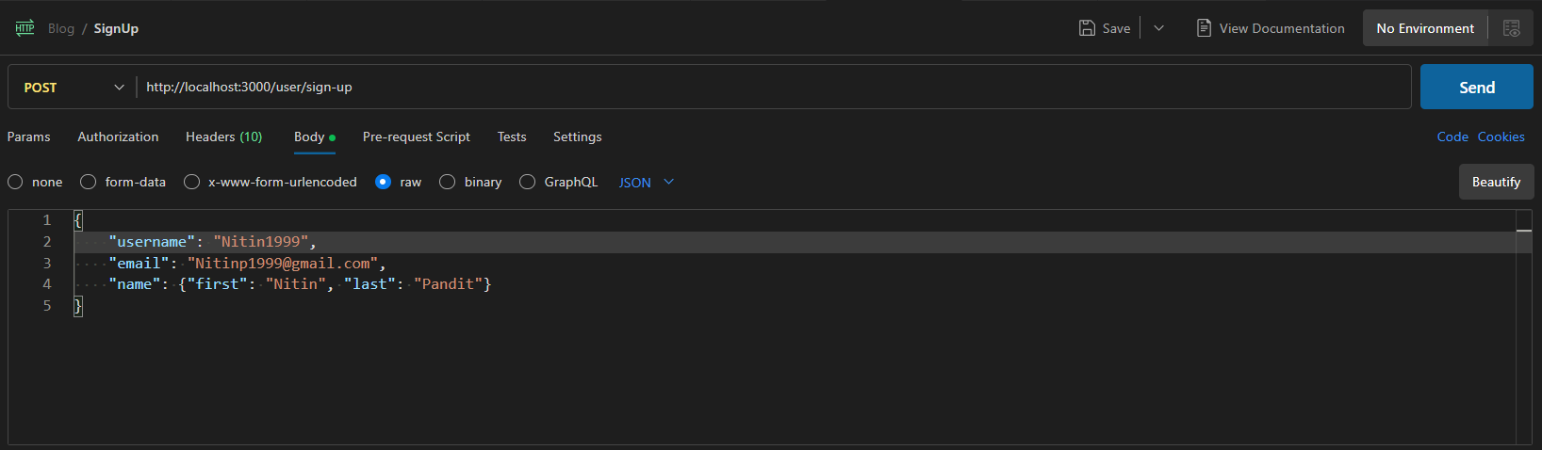

Server Output: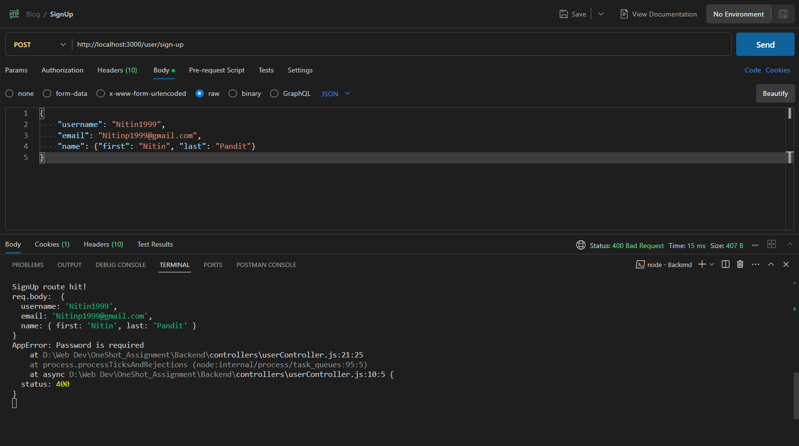

Server Response: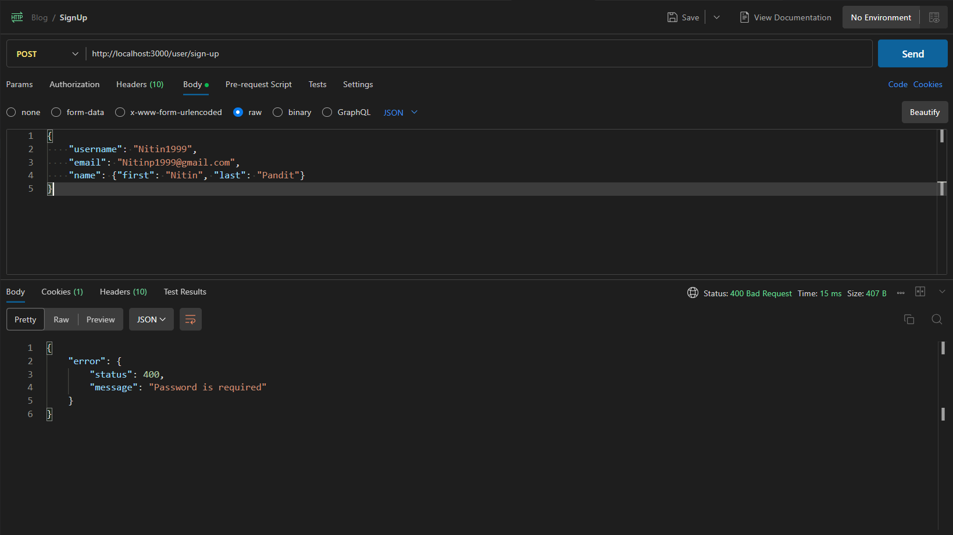

#### Missing Name:

##### Missing First Name:

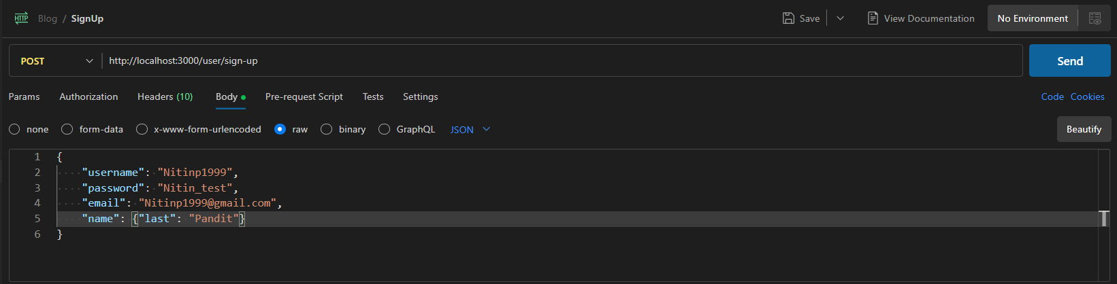

Server Output: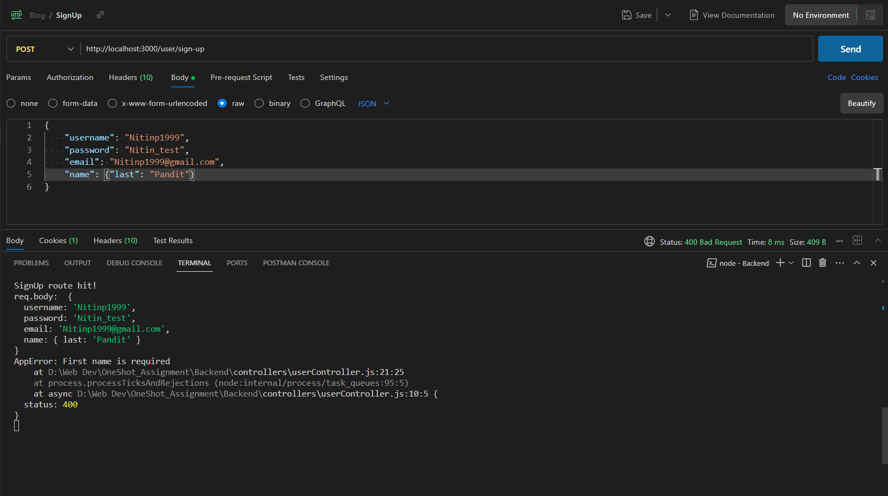

Server Response: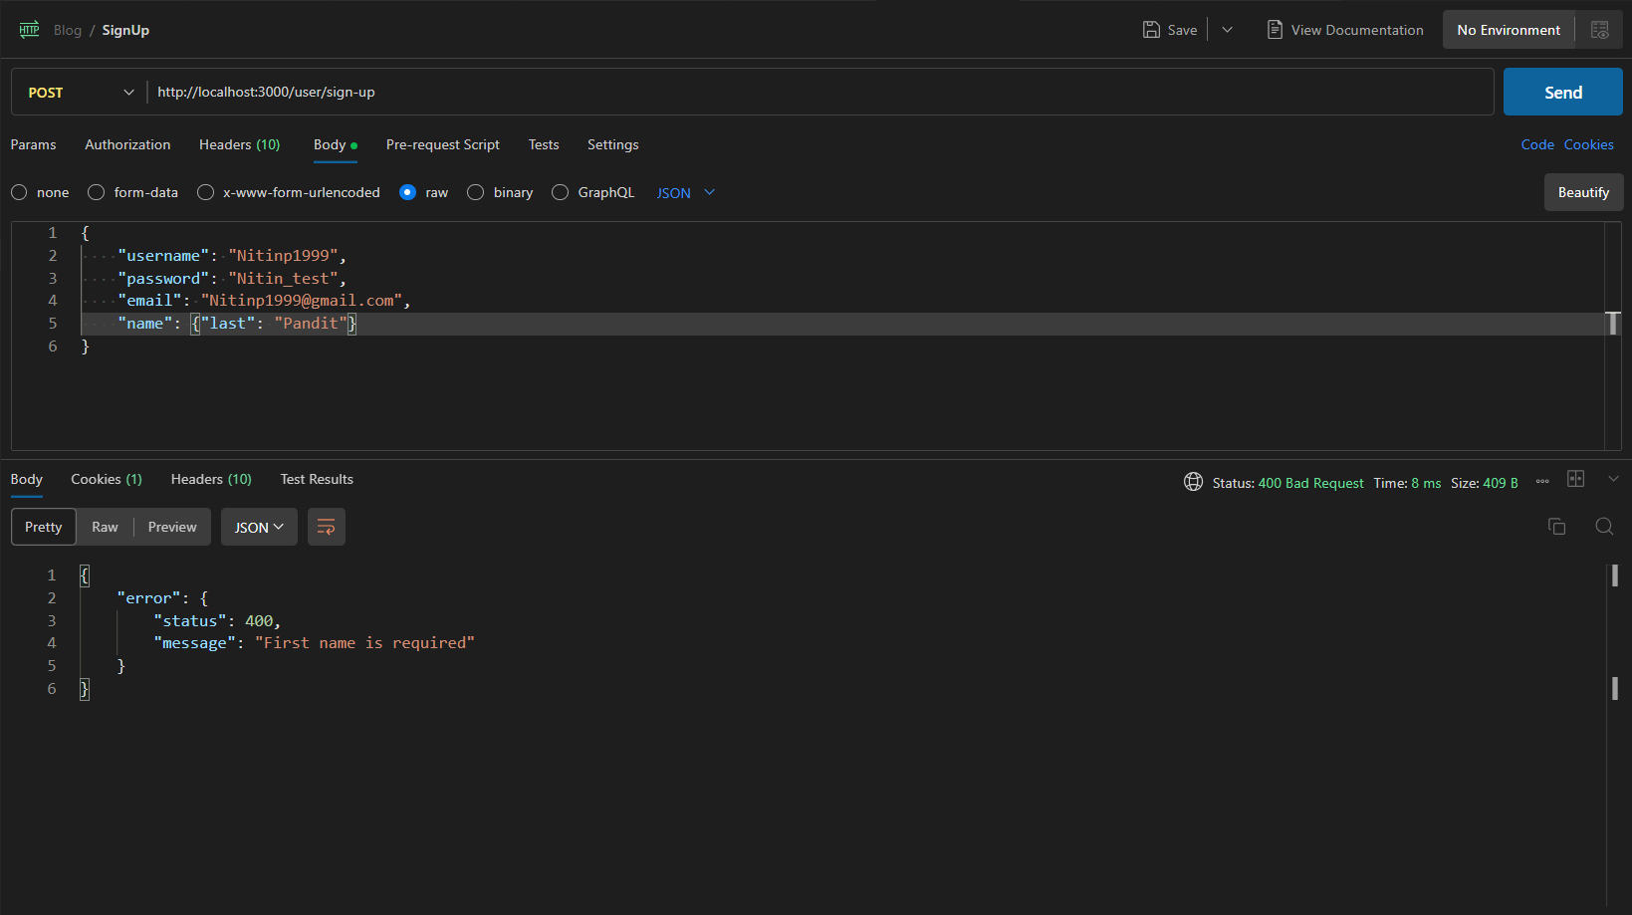

##### Missing Last Name:

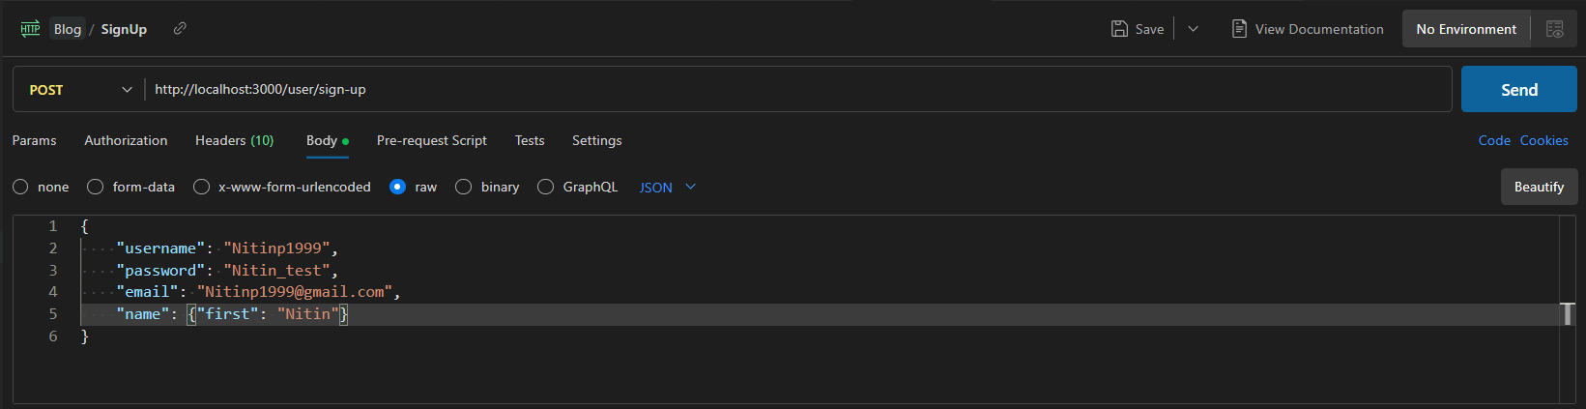

Server Output: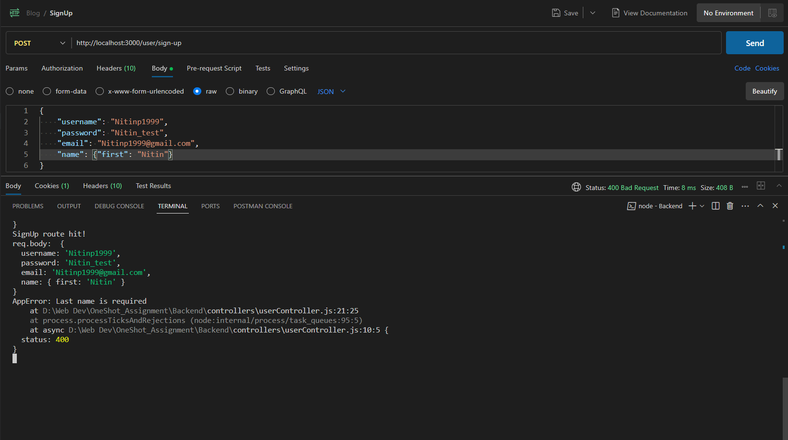

Server Response: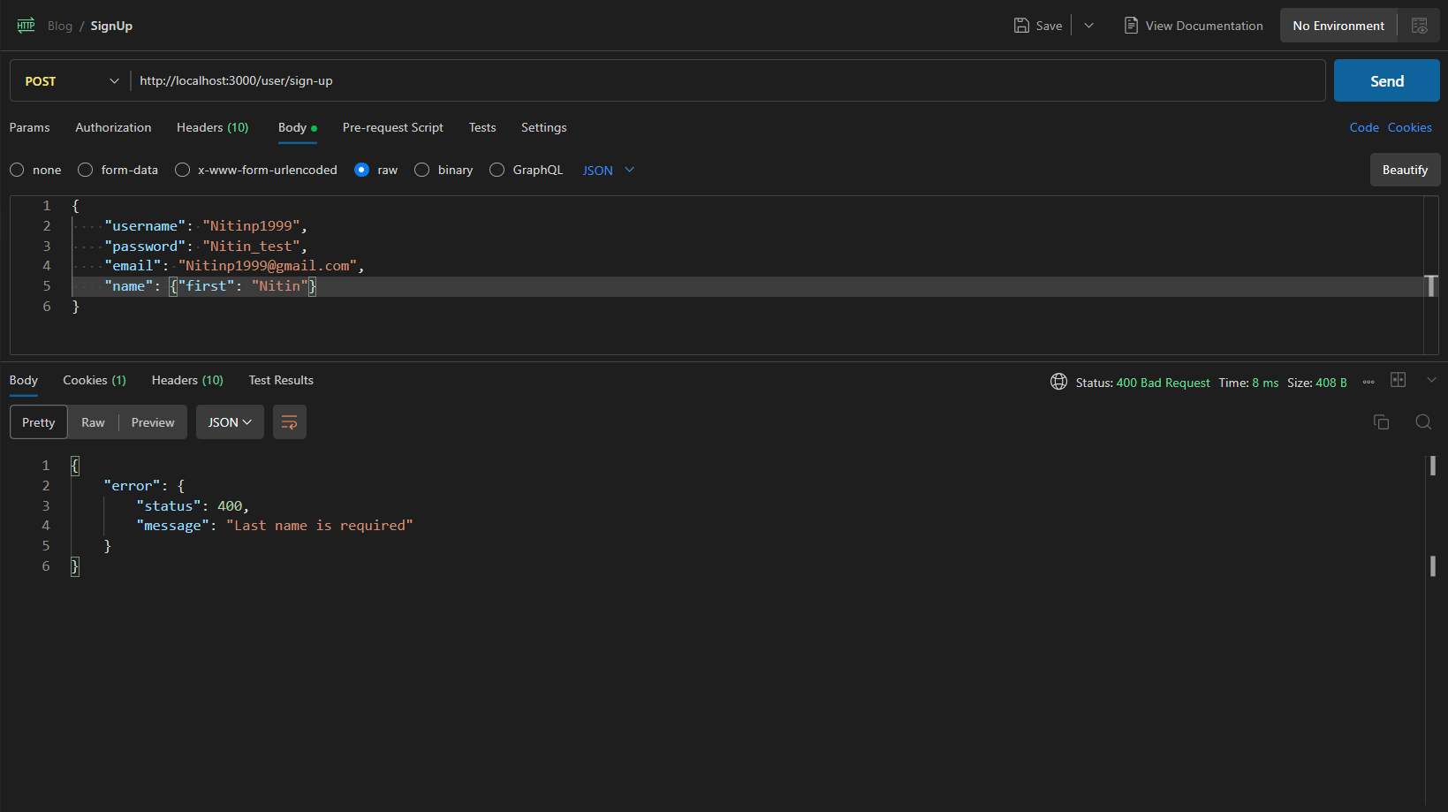

##### Missing Name Object:

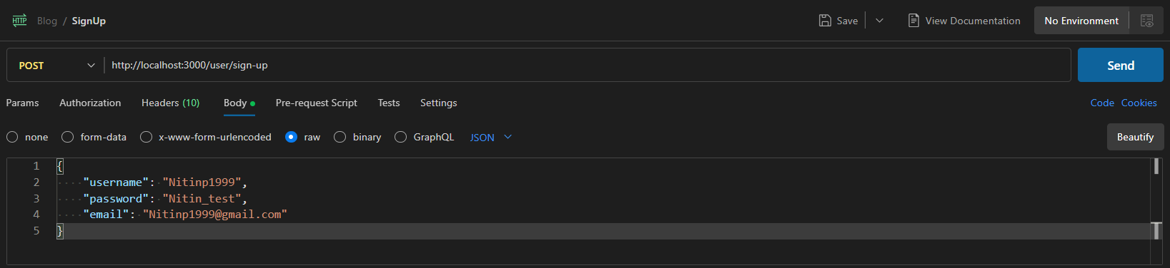

Server Output: 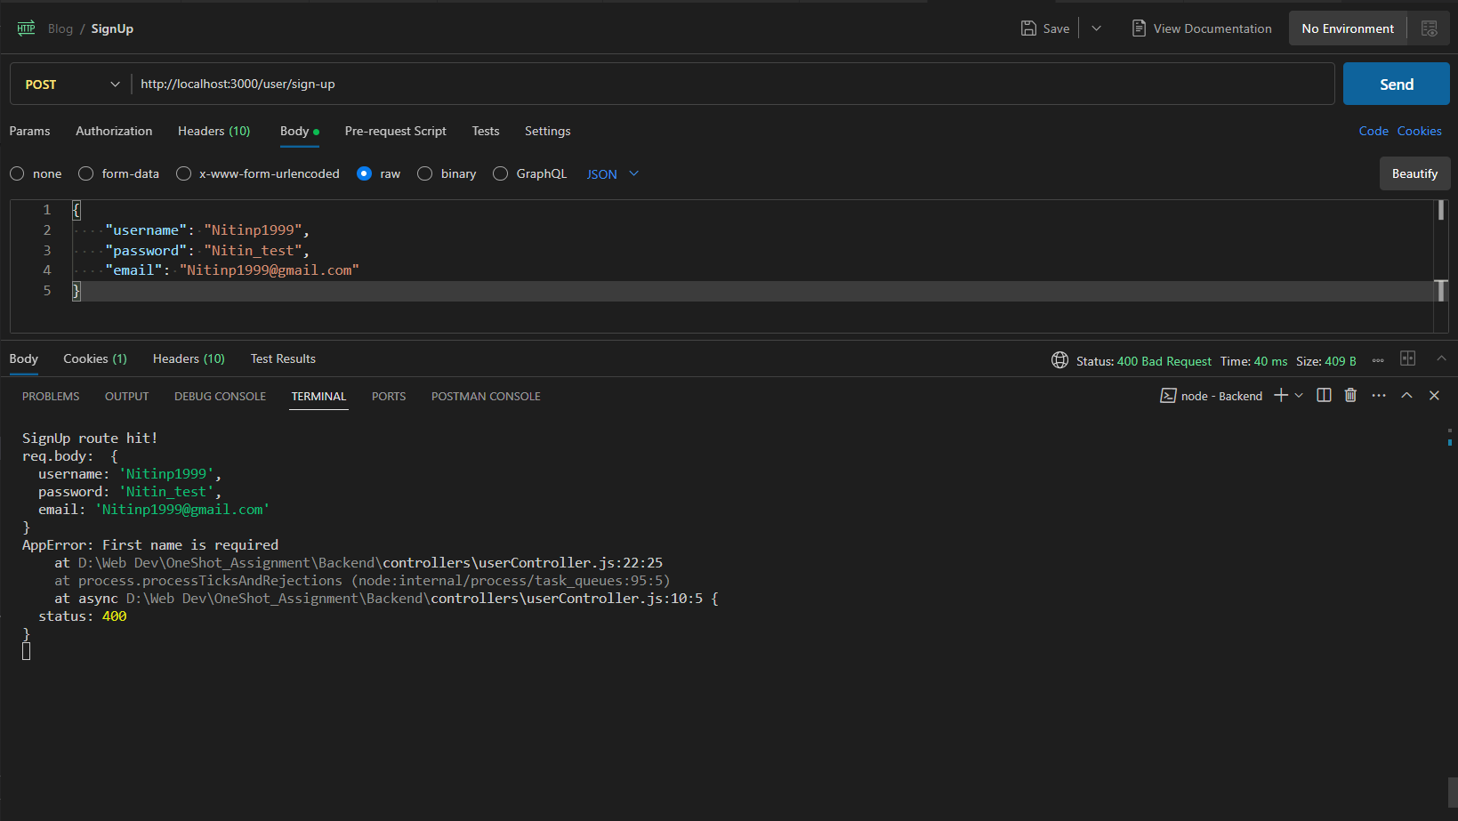

Server Response: 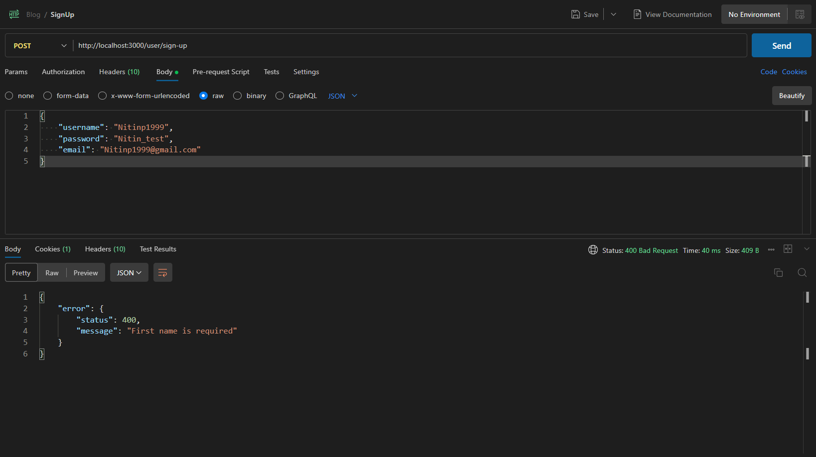

### Test 3: Sending Null Values:

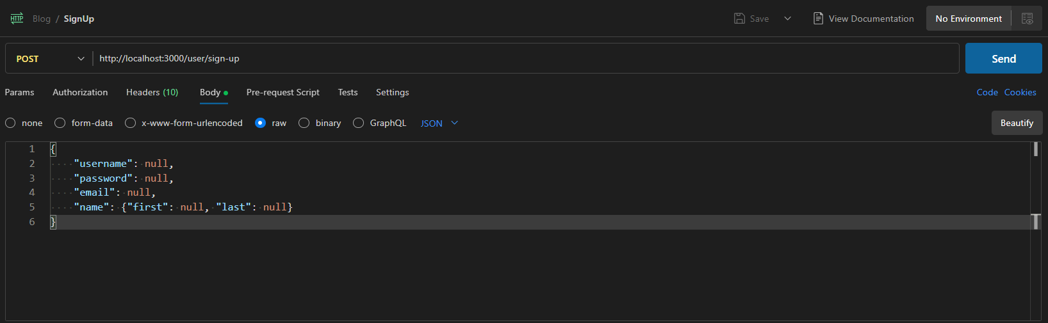

Server Output: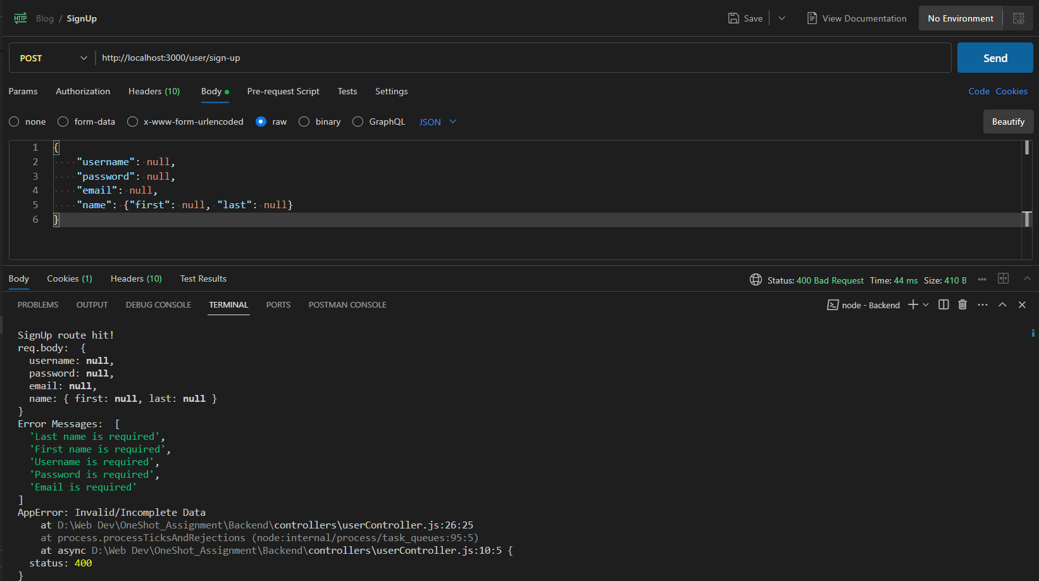

Server Response:

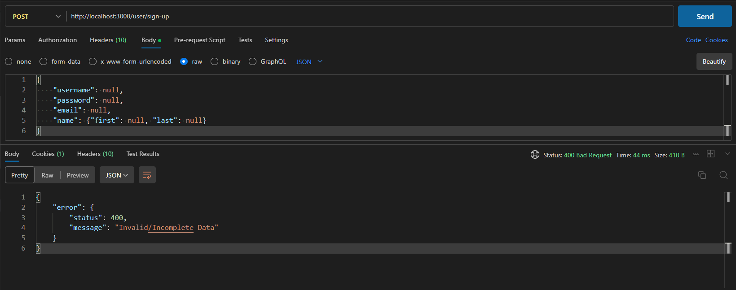

### Test 4: Multiple fields missing:

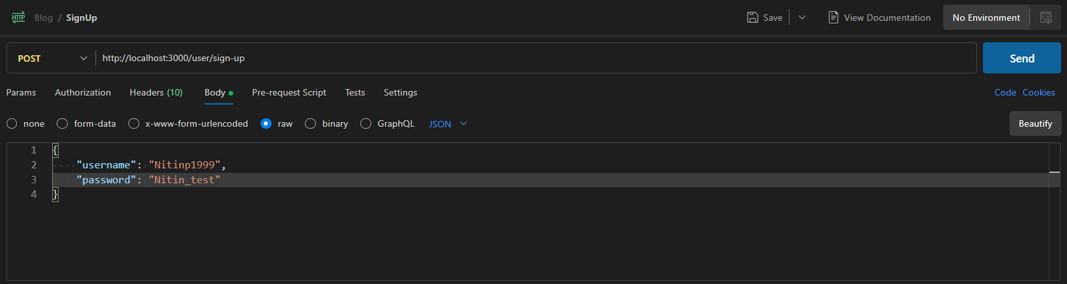

Server Output: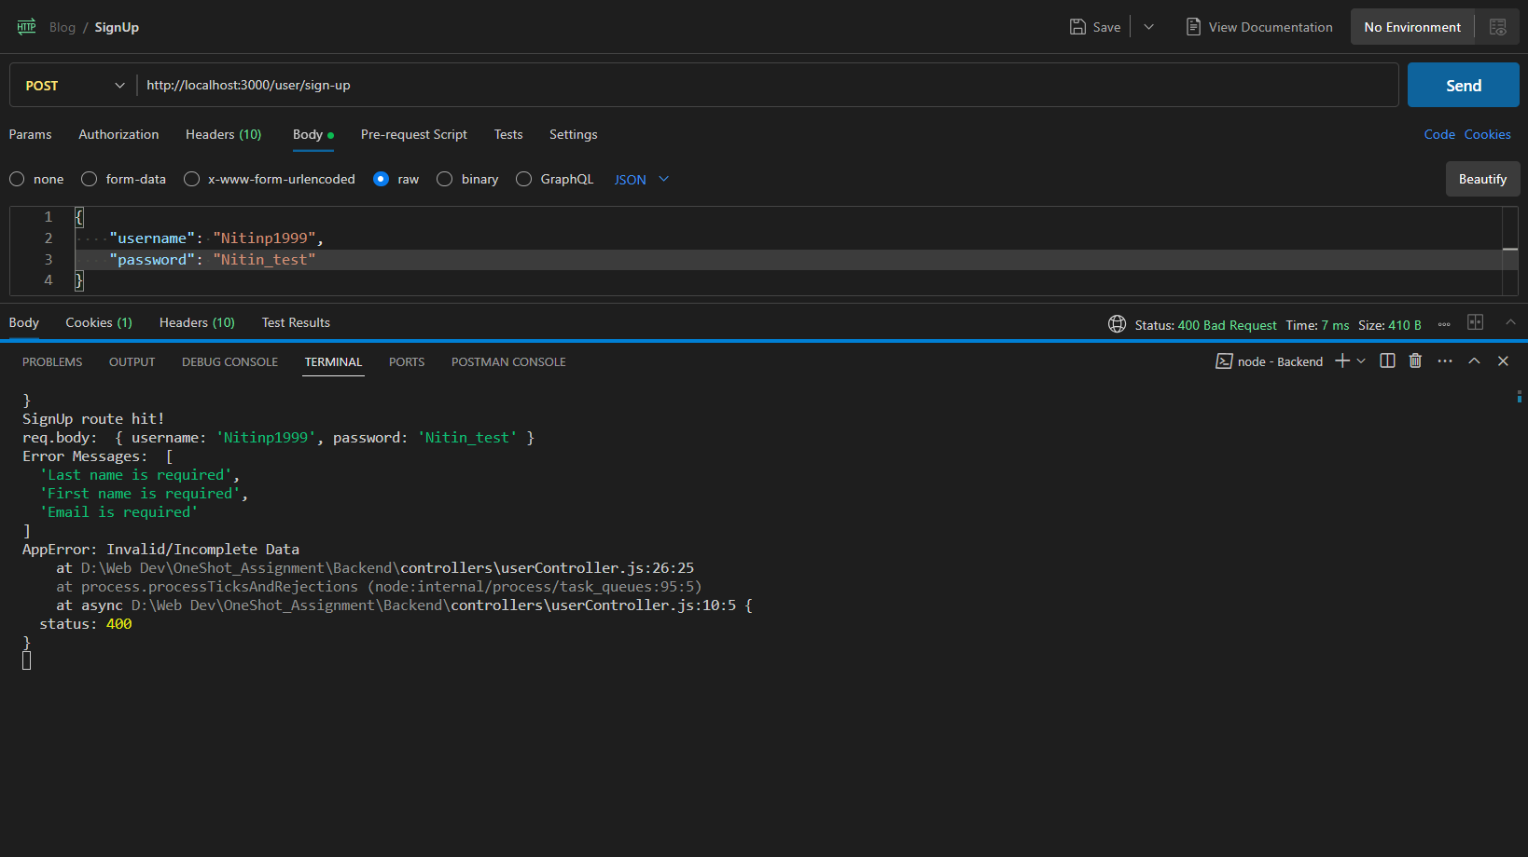

Server Response:

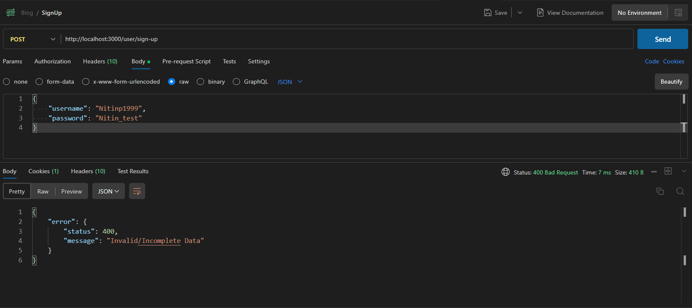

### Test 5: Creating a new user:

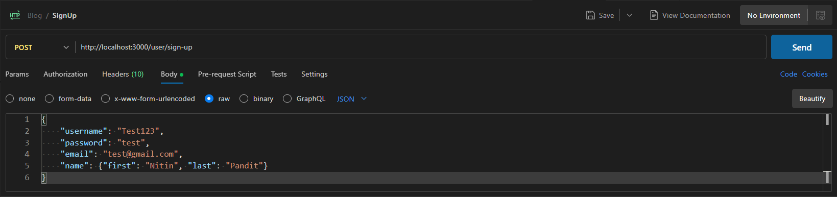

Server Output: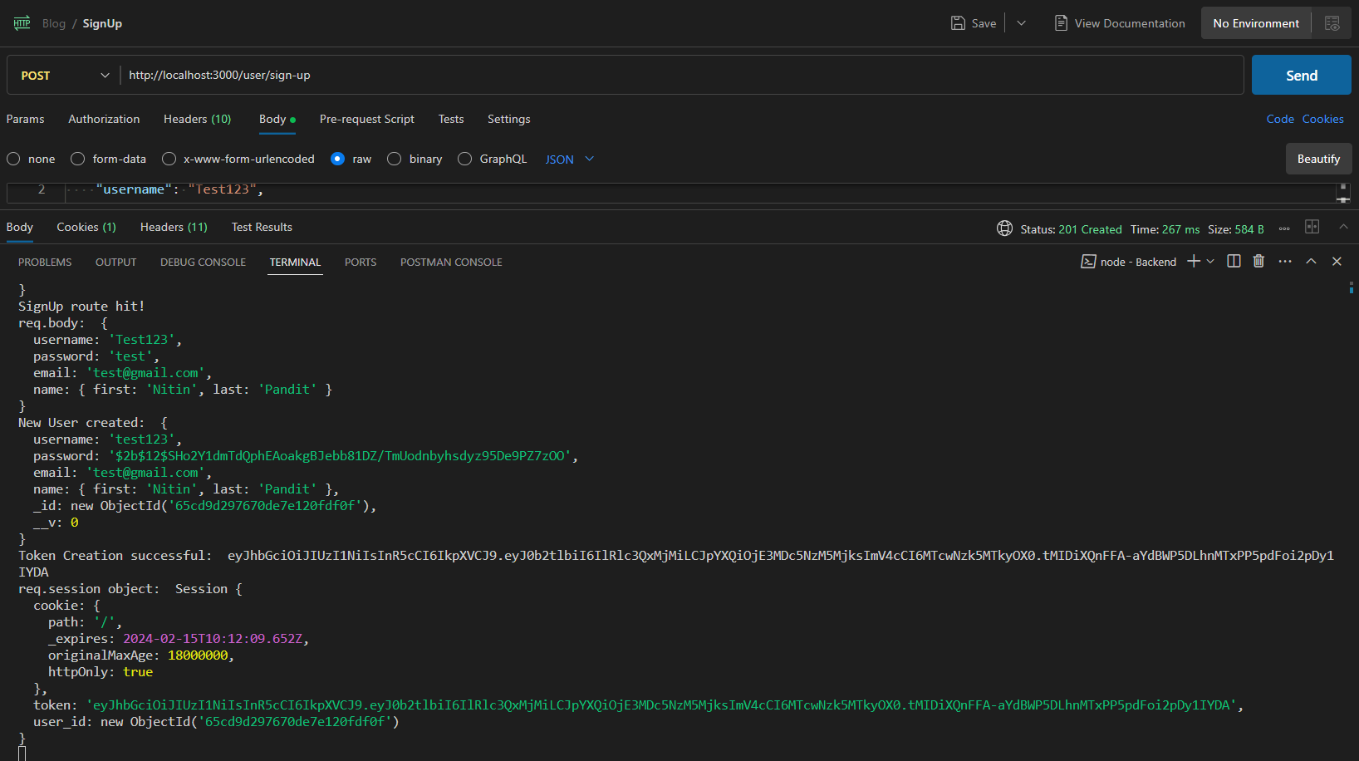

Server Response:

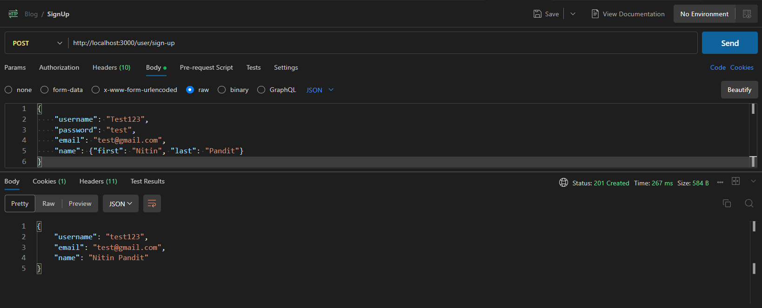

## Login:

POST <http://localhost:3000/user/login>

Starting server:

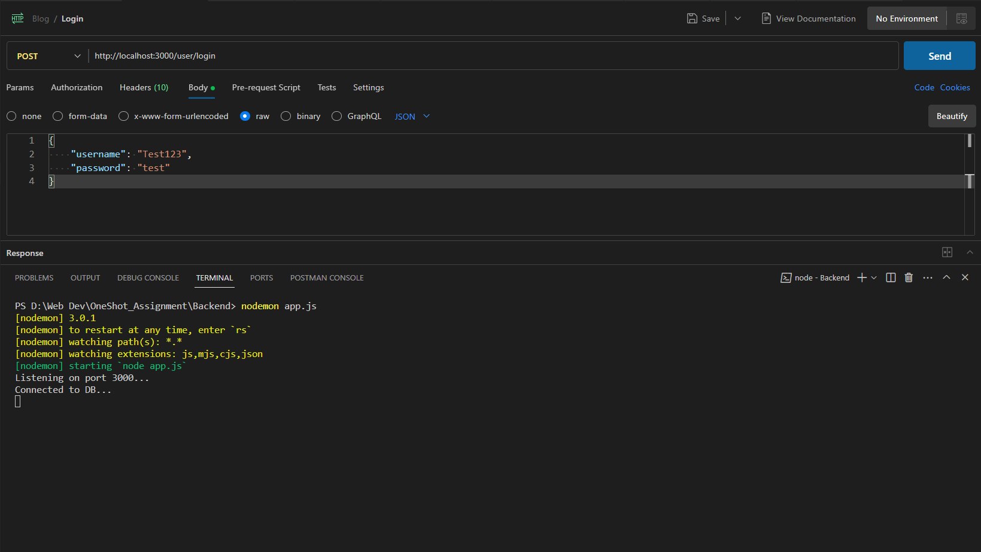

### Test 1: Attempting a successful login:

Sending a POST request to the login route with correct credentials:

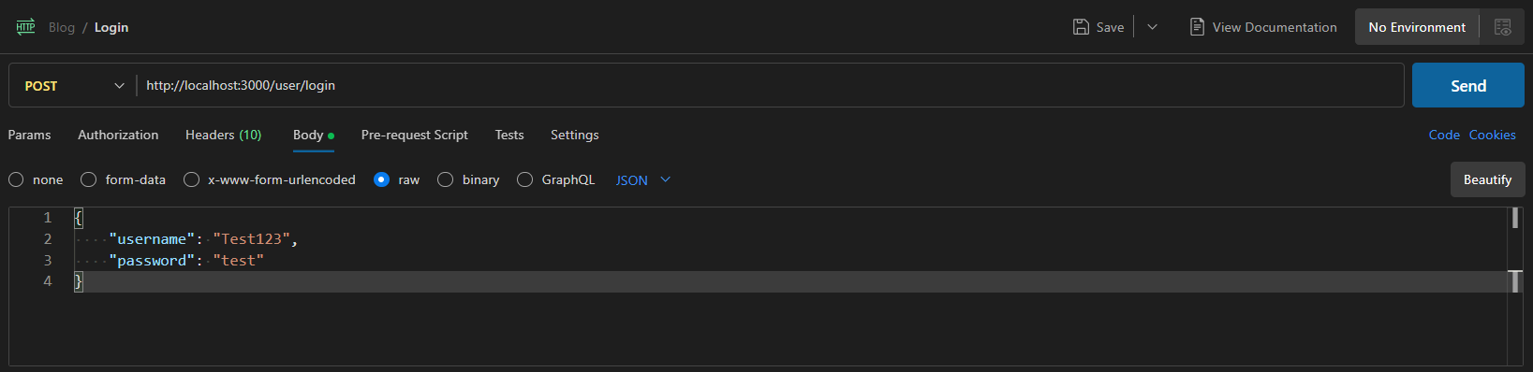

Server Output: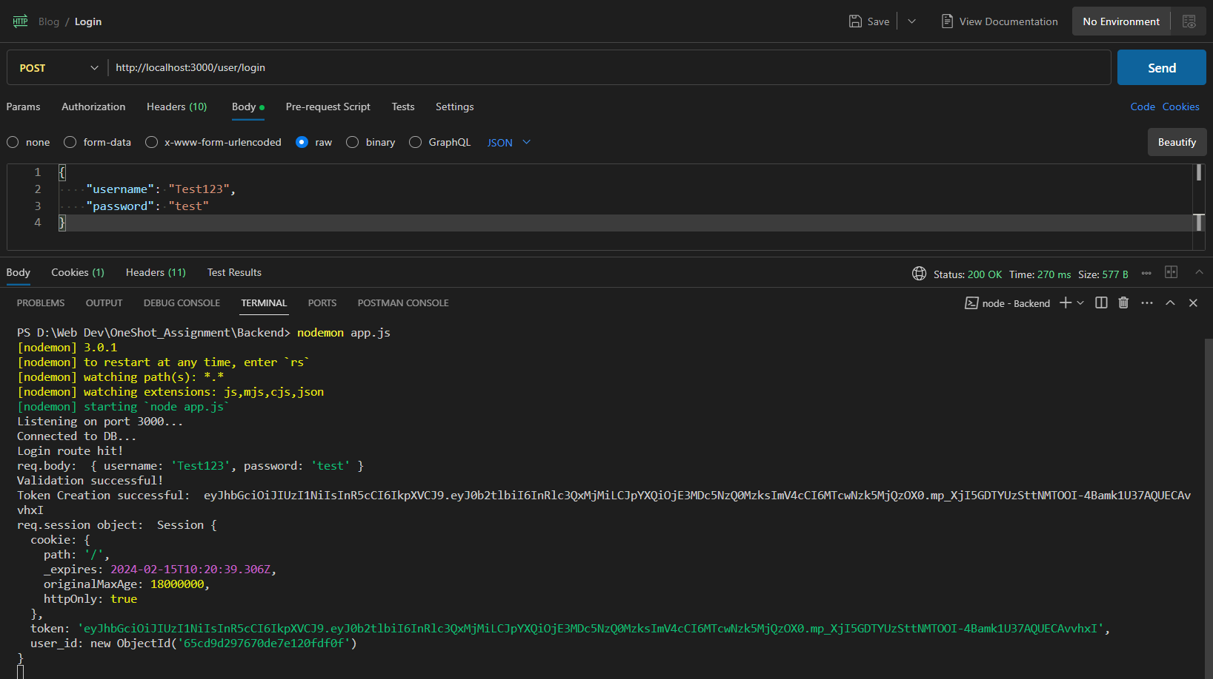

Server Response:

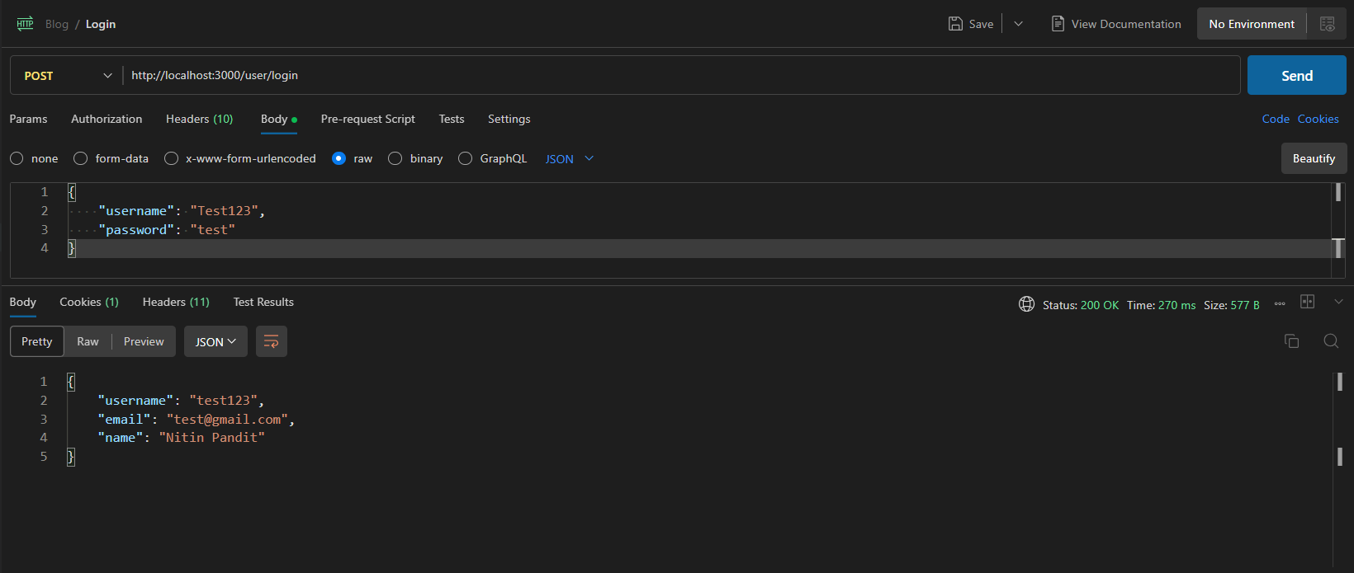

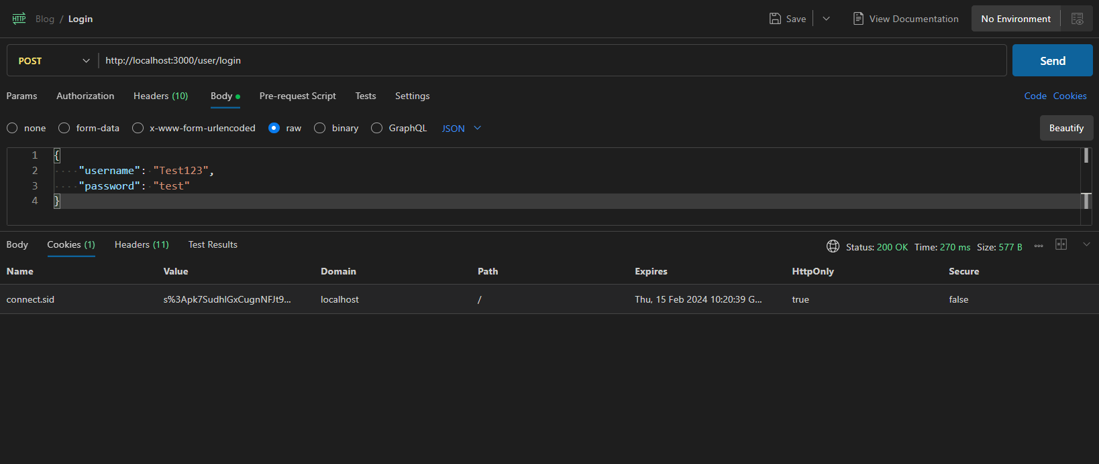

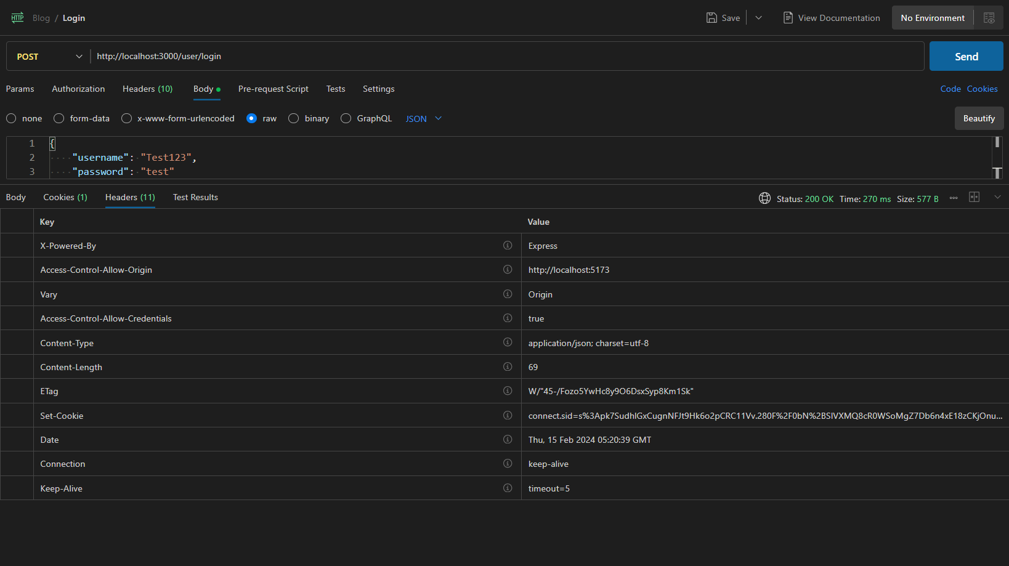

### Test 2: Testing Invalid Login:

Restarting Server:

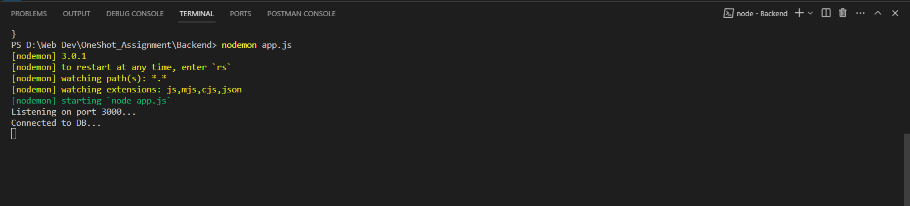

#### Invalid Username:

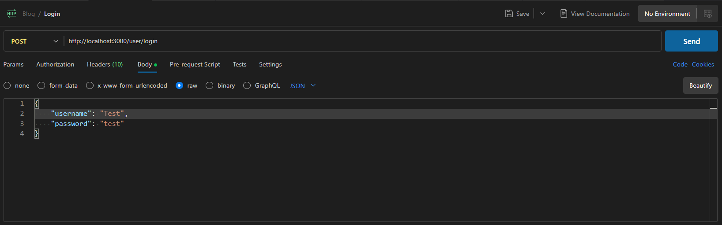

Server Output:

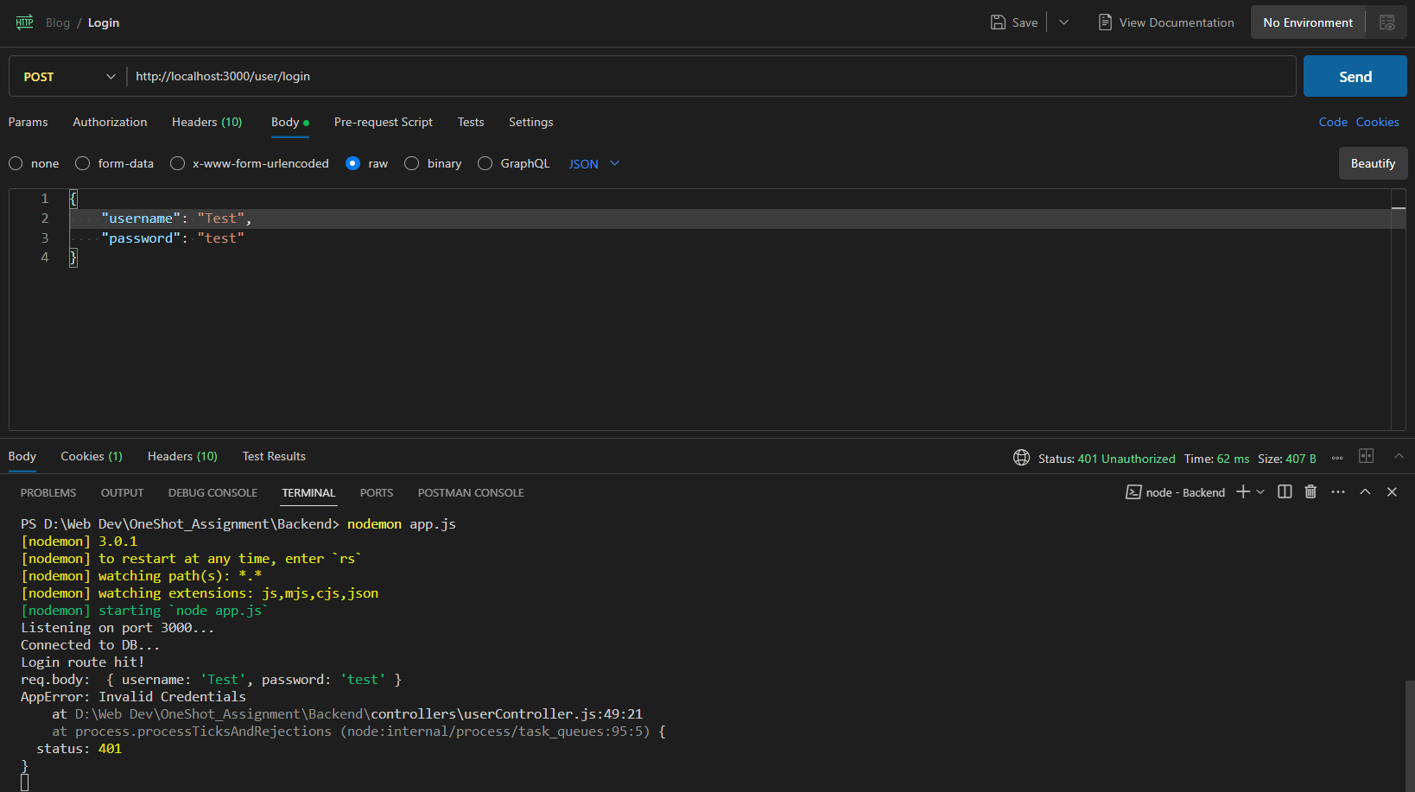

Server Response:

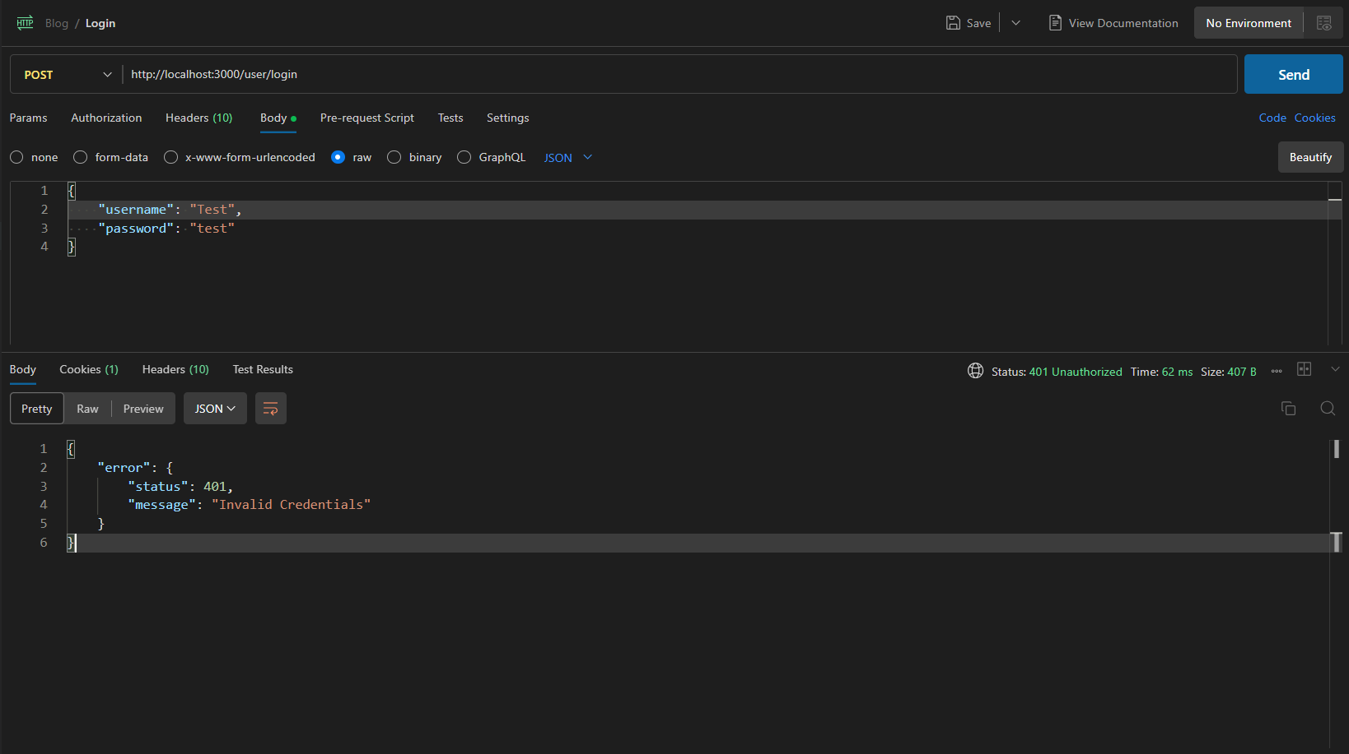

#### Invalid Password:

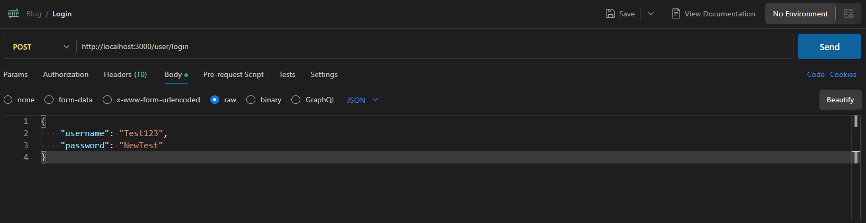

Server Output: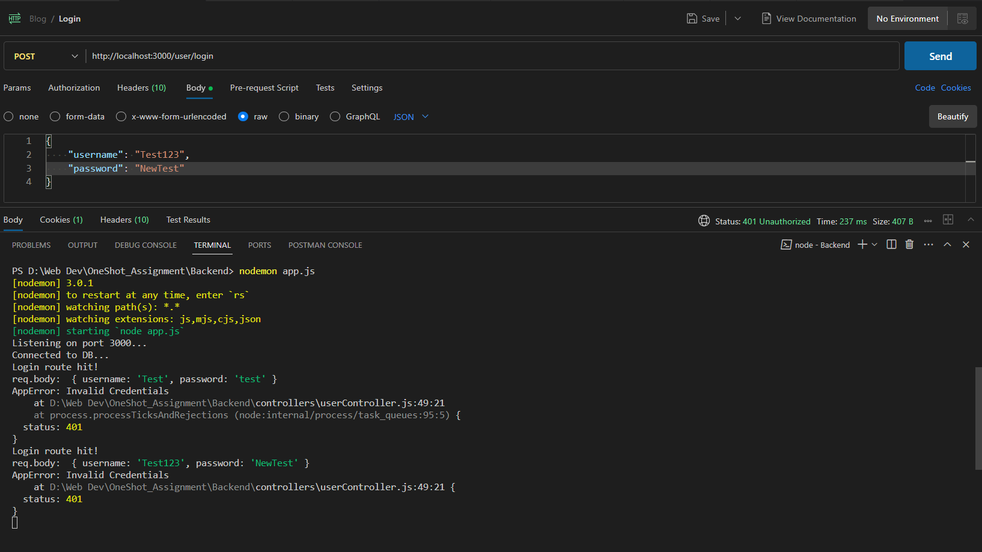

Sever Response: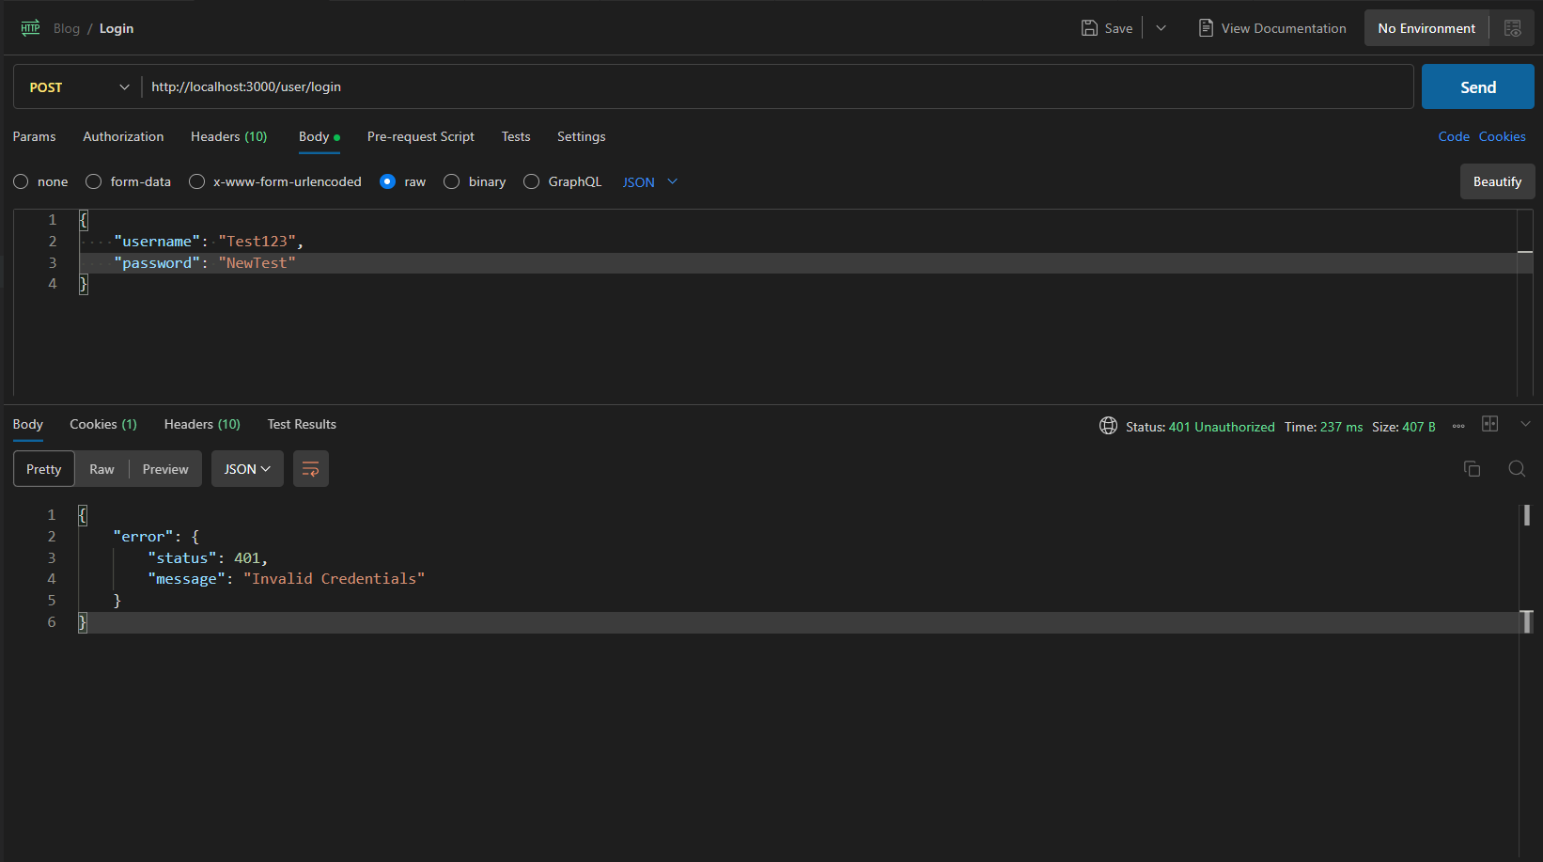

### Test 3: Missing Data

#### Missing Username:

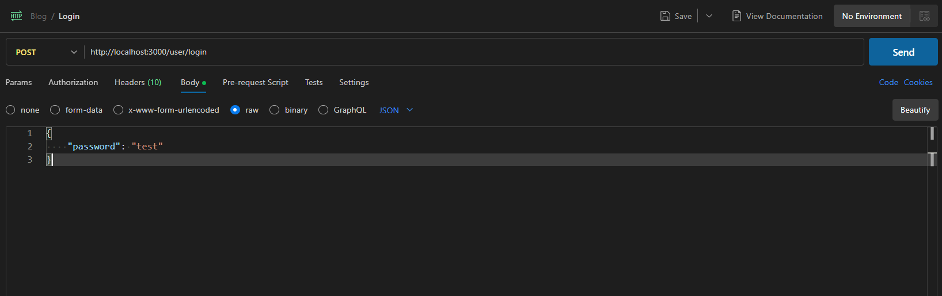Server Output: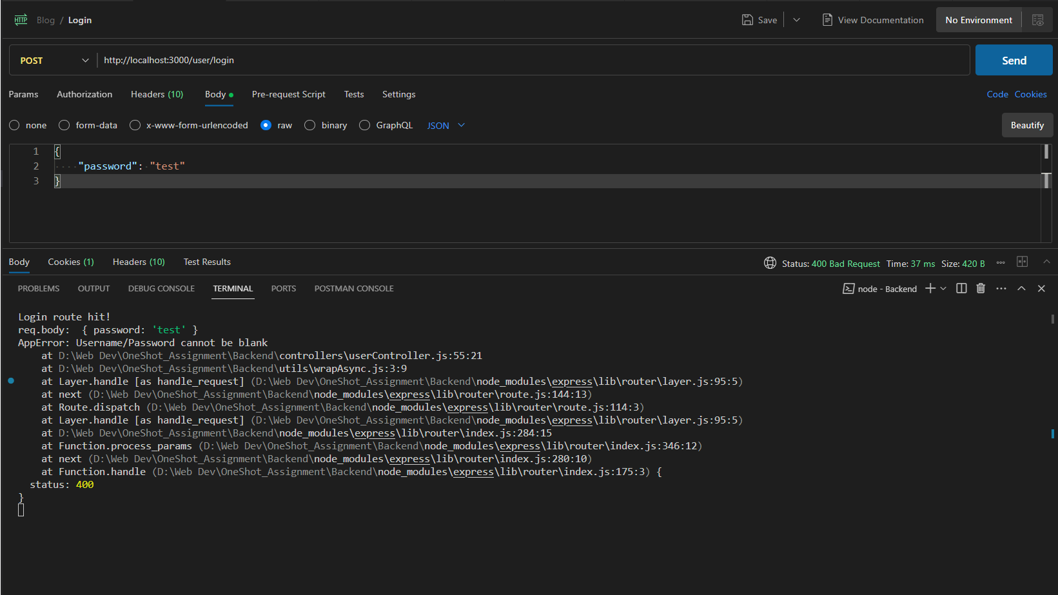

Server Response: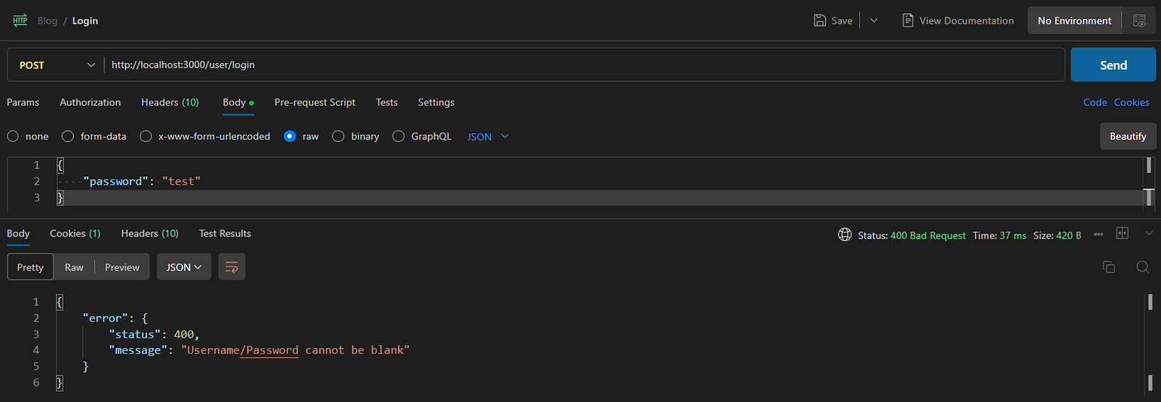

#### Missing Password:

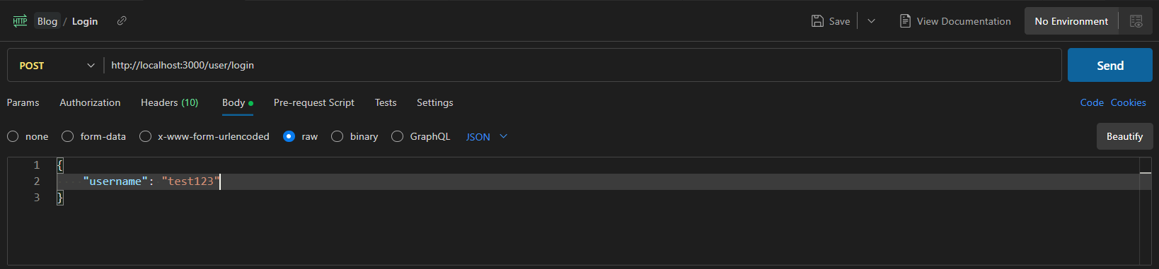

Server Output: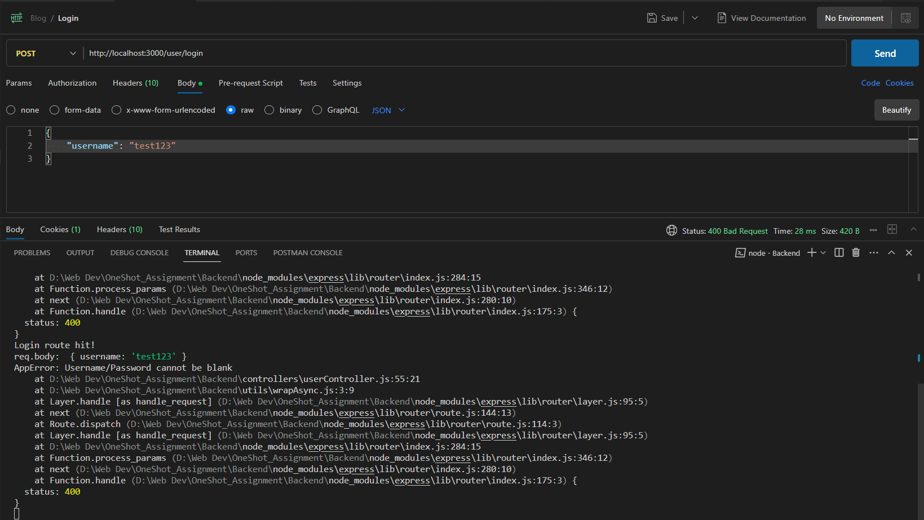

Server Response: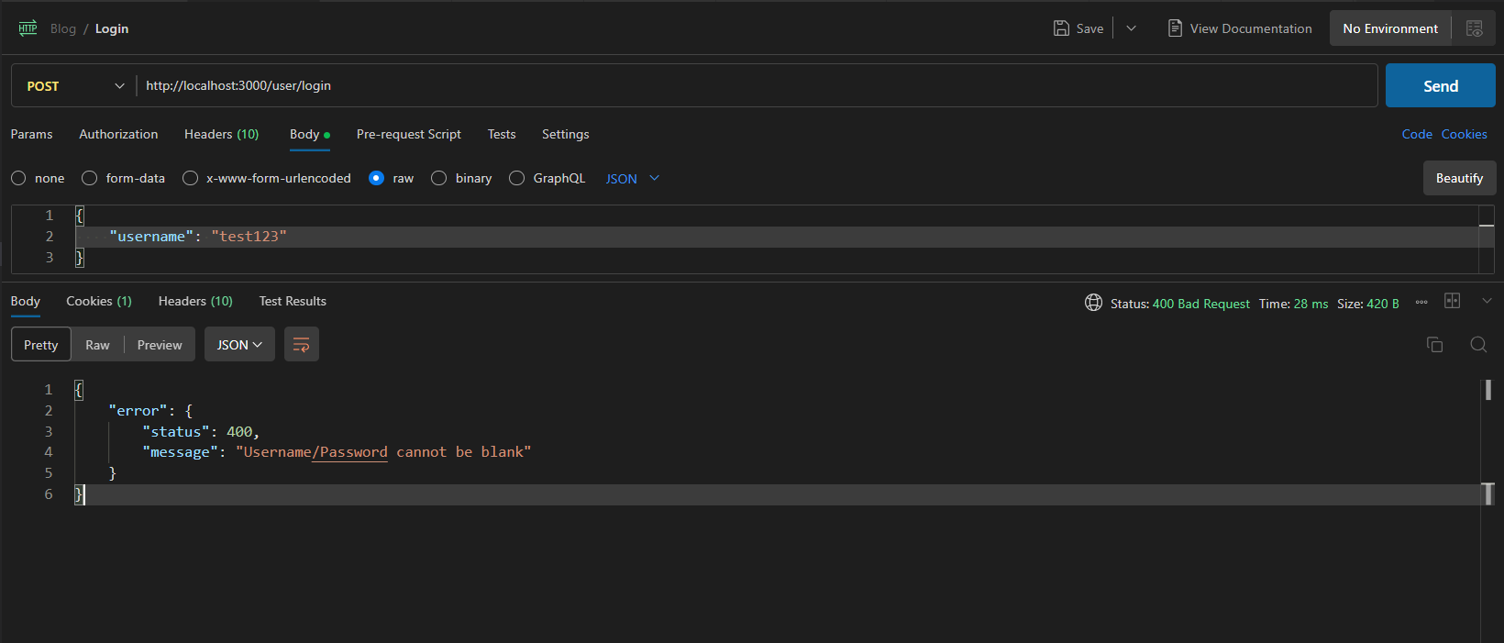

#### Missing Username & Password:

Server Output & Response:

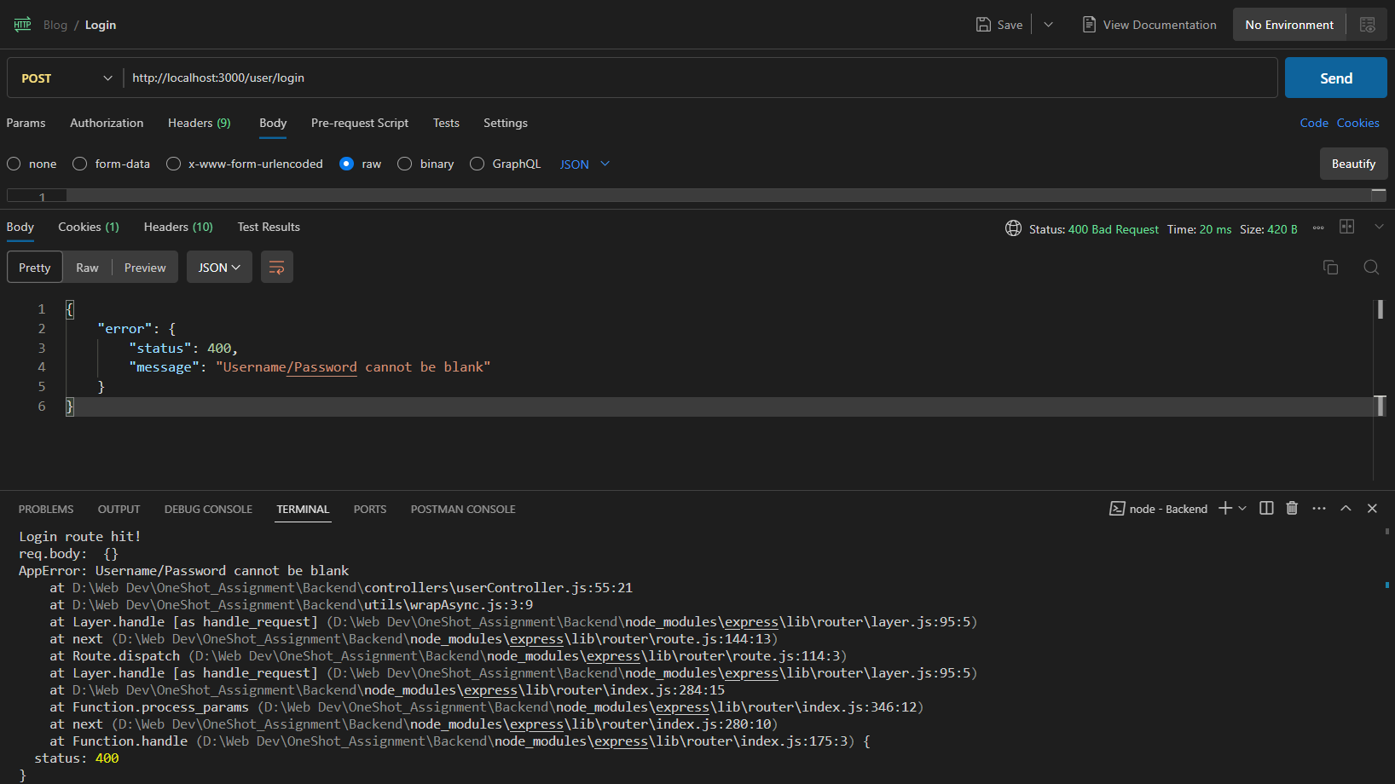

## Logout:

POST <http://localhost:3000/user/logout>

Starting server:

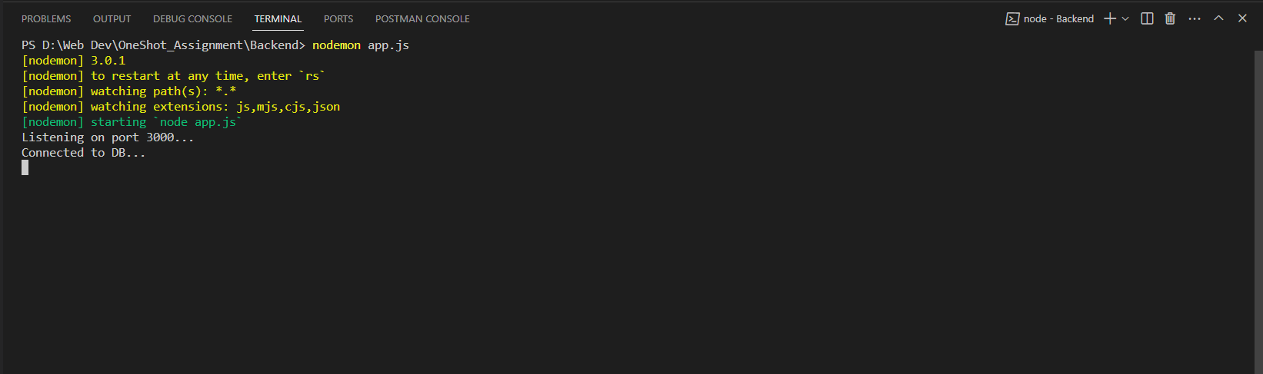

Clearing Cookies in postman:

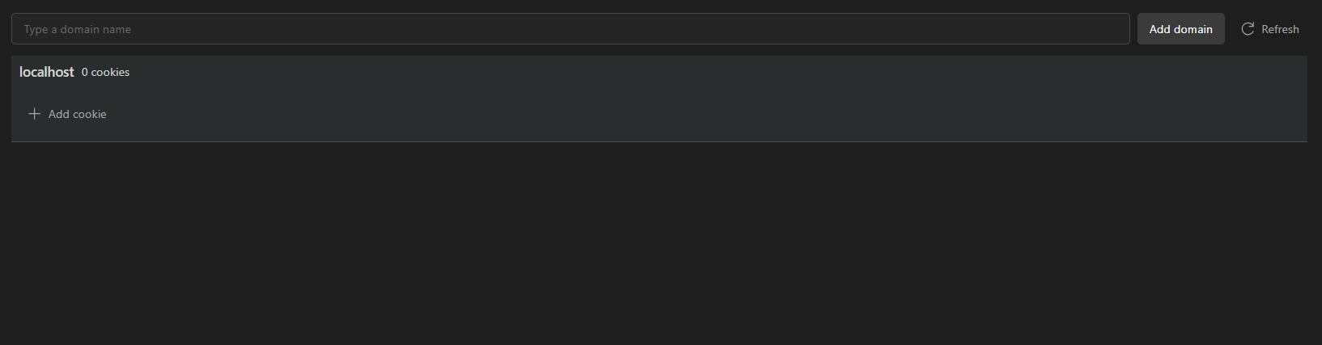

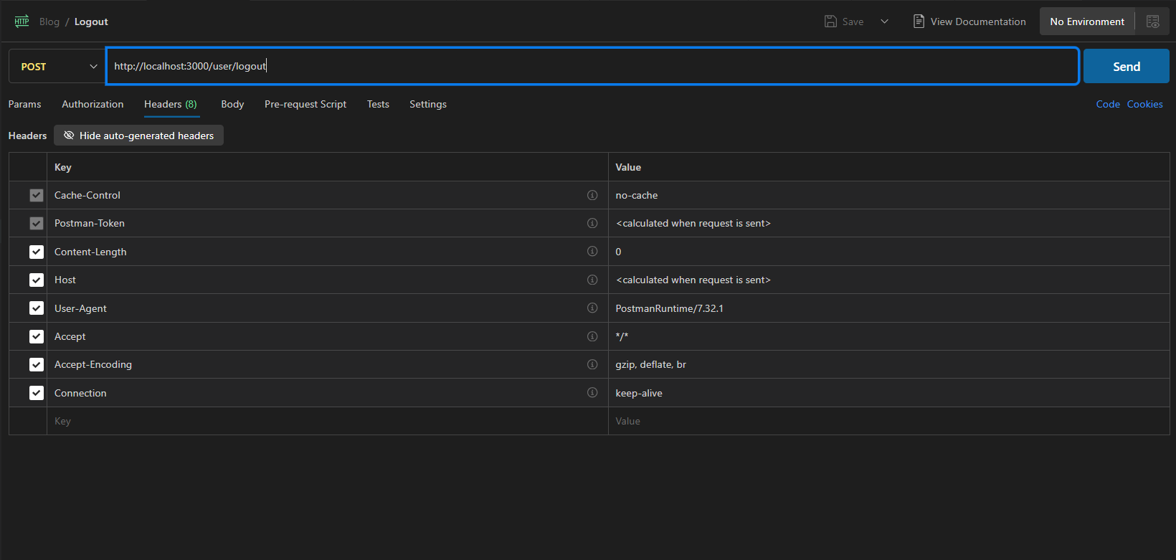

### Test 1: Logging out without having a cookie/token:

Server Response:

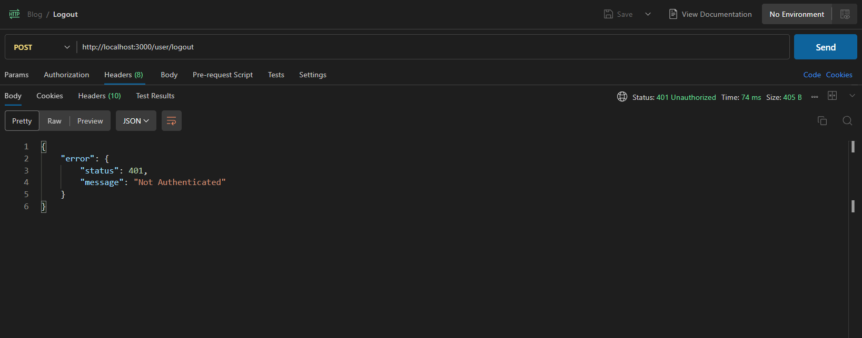

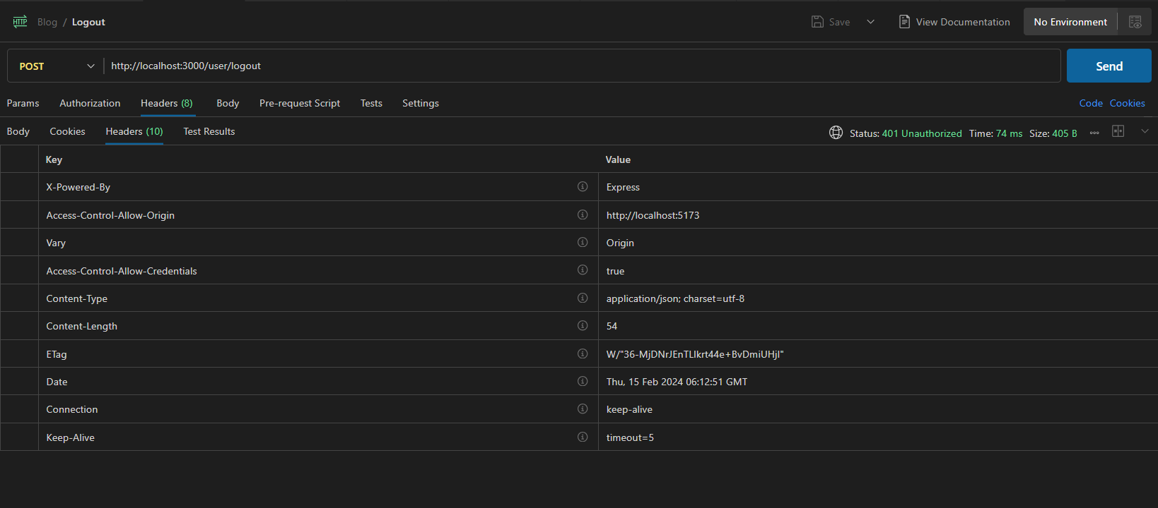

Server Output:

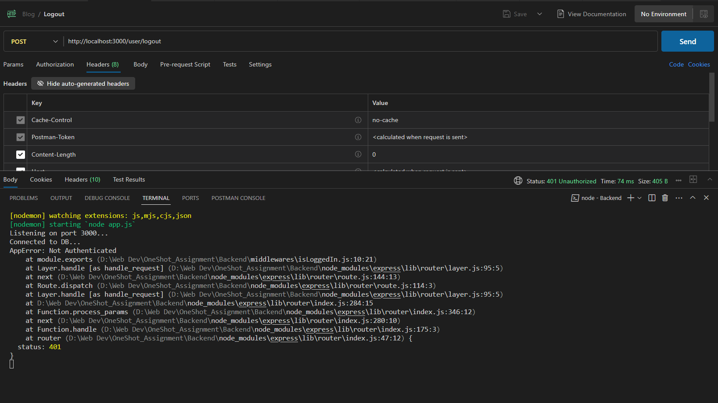

### Test 2: Testing a successful logout:

Performing a logon:

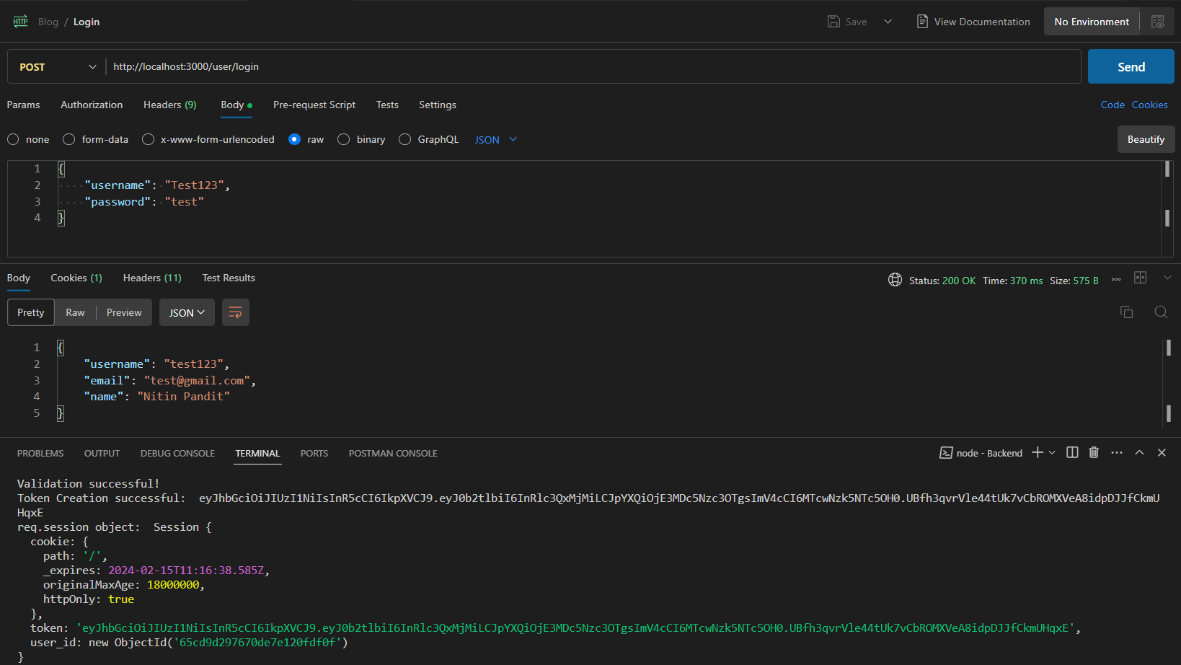

Attempting a logout:

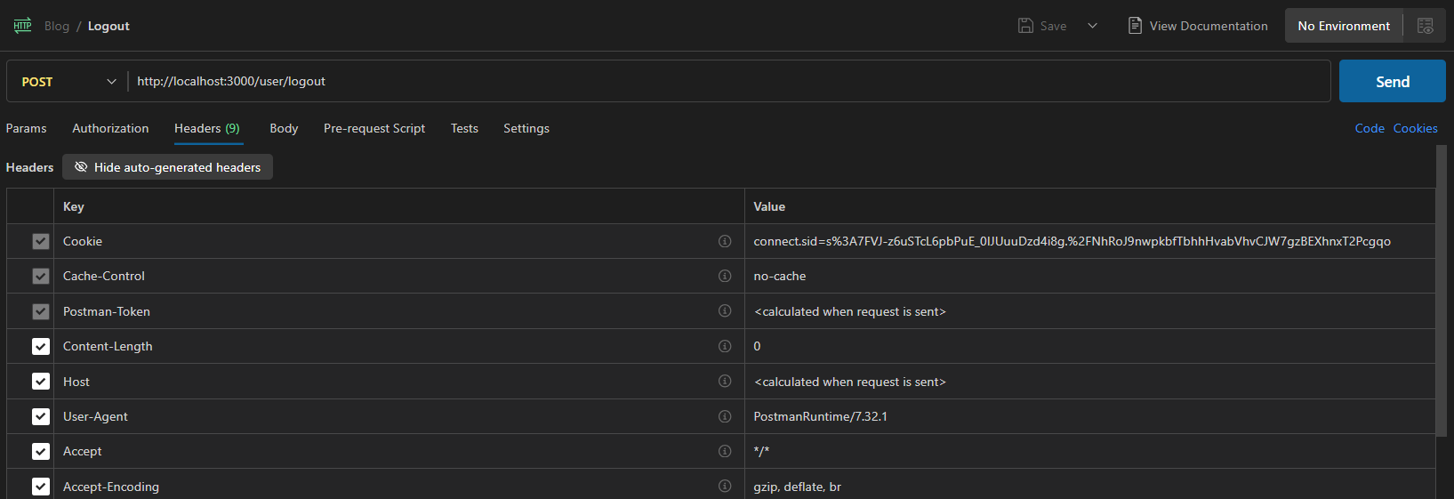

Server Output: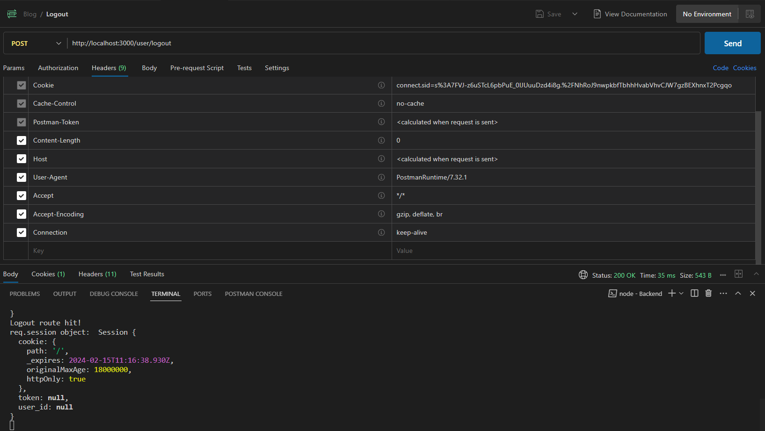

Server Response:

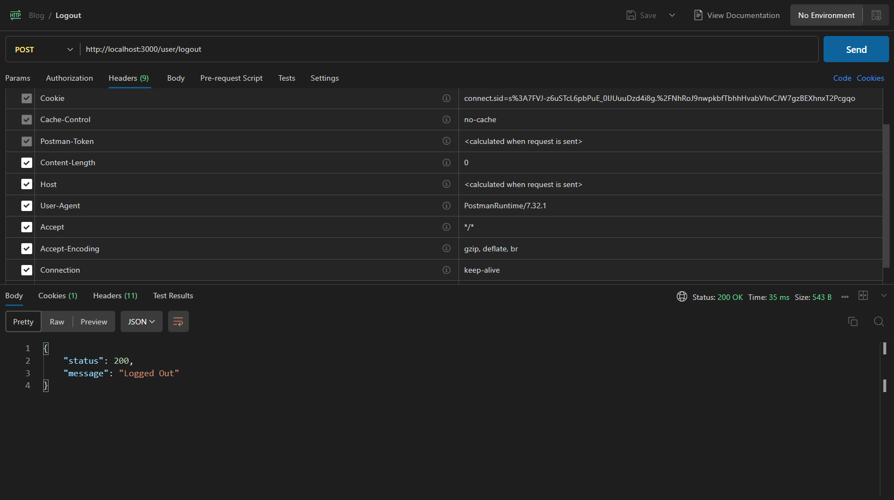

### Test 3: Testing Logout with expired token:

Server Output:

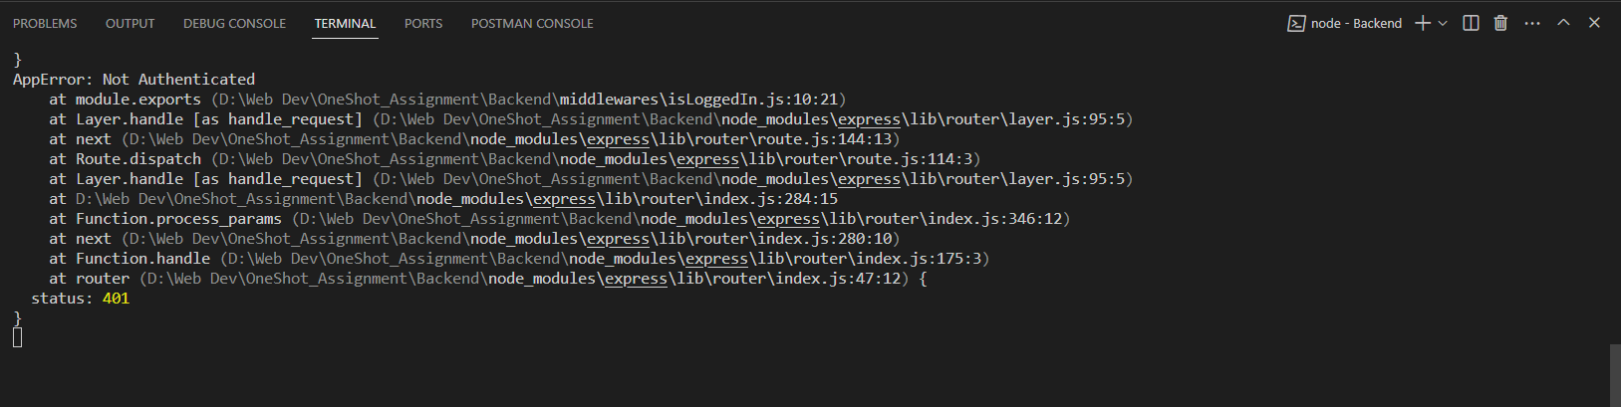

Server Response:

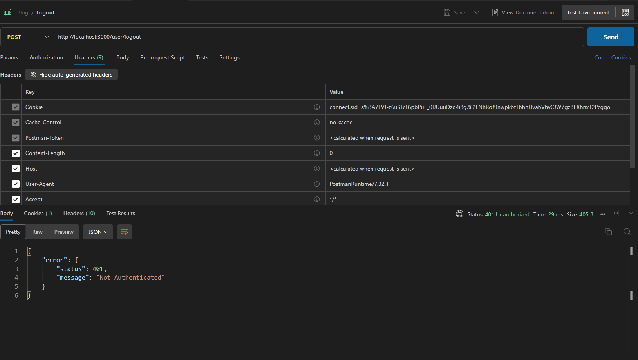

# Post API:

## All Posts:

GET <http://localhost:3000/posts/all>

### Test 1: Testing API call without authentication token

Deleting session cookie in Postman:

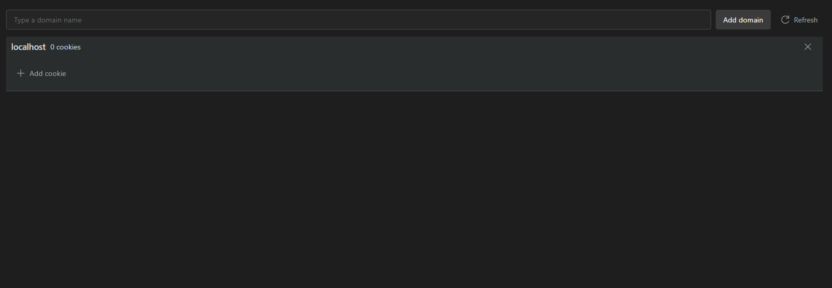

#### API call without query params:

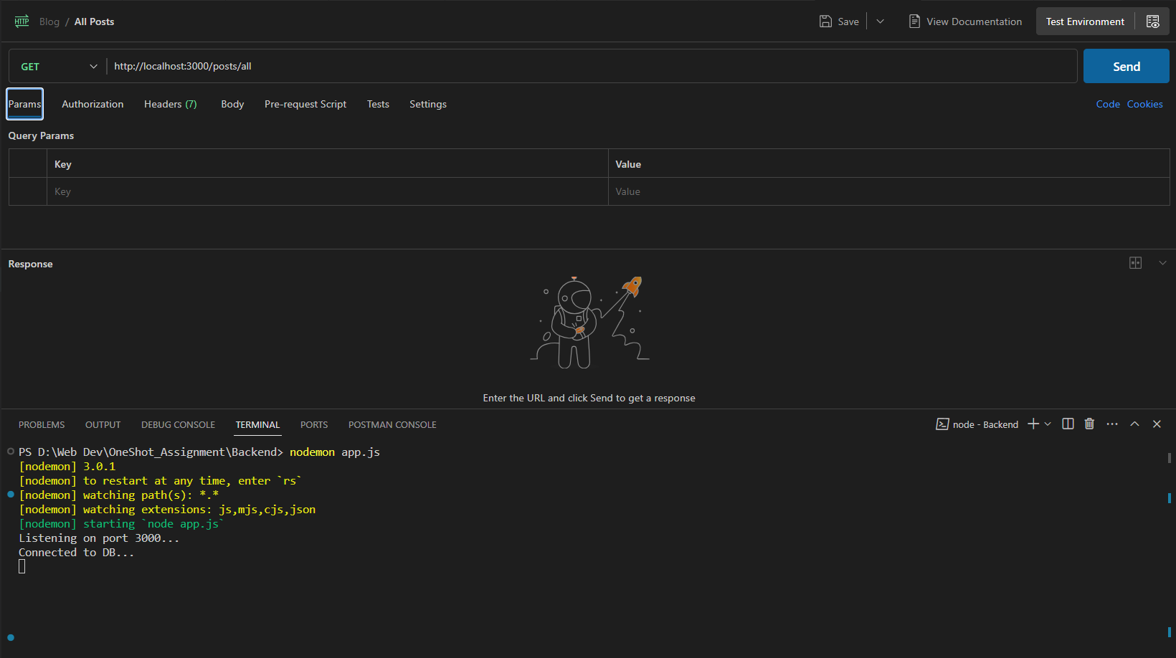

Server Output: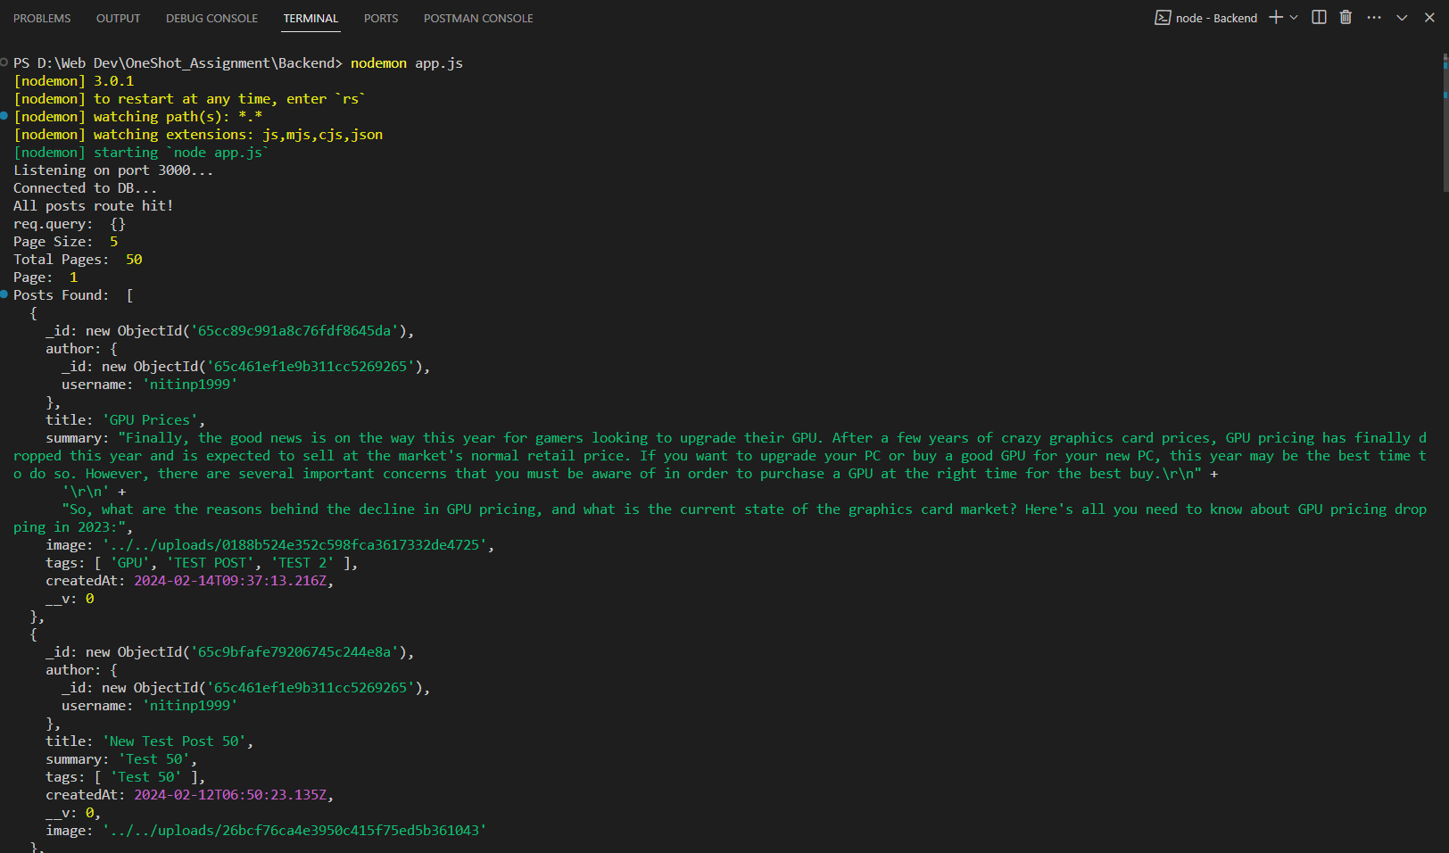

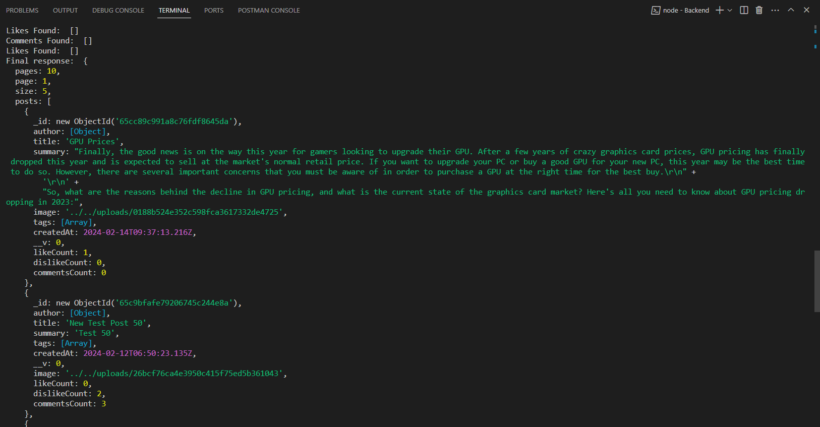

Server Response: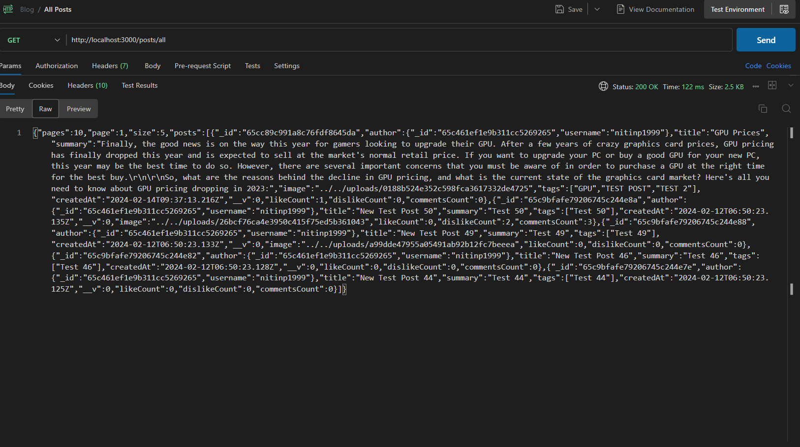

Server Response: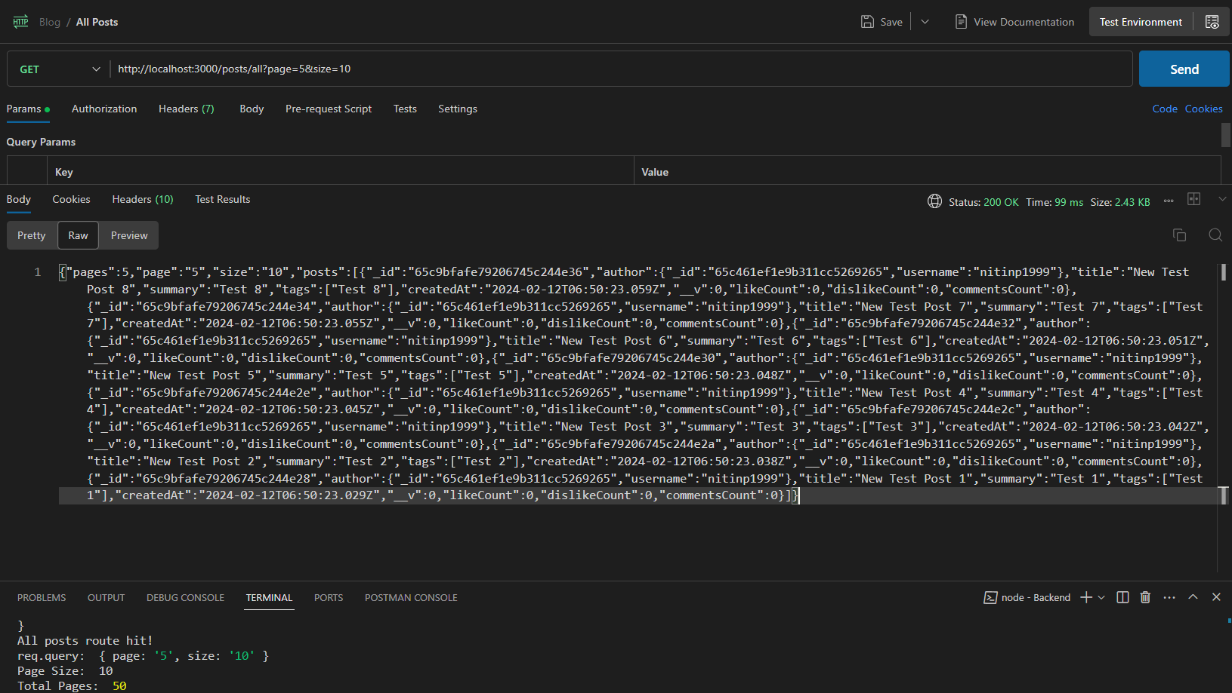

### Test 2: Call after logging in:

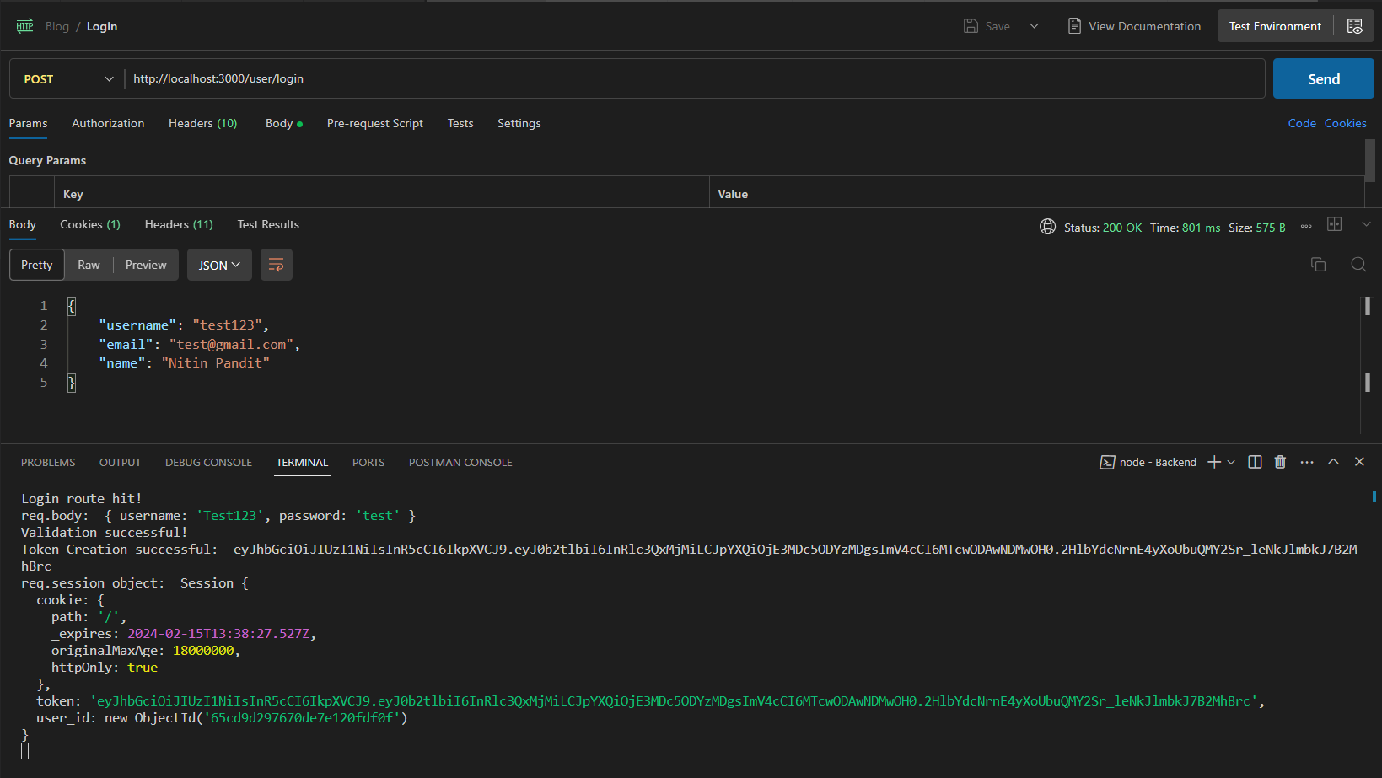

Server Response:

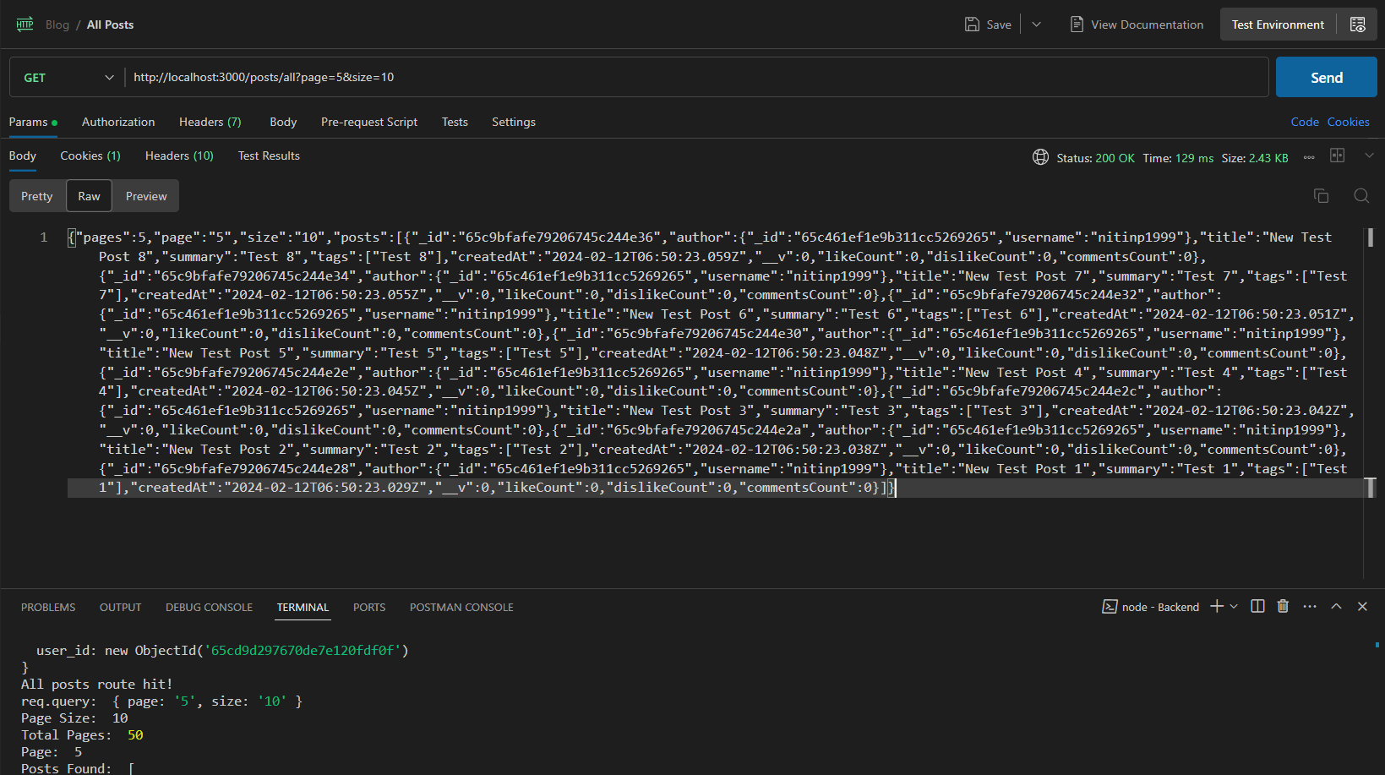

## MyPosts

GET <http://localhost:3000/posts/all>

### Test 1: Sending a GET request without authentication:

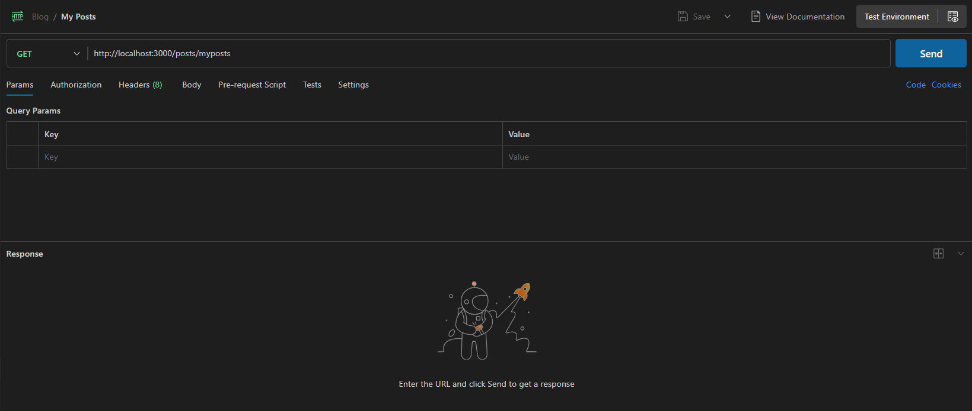

Server Response:

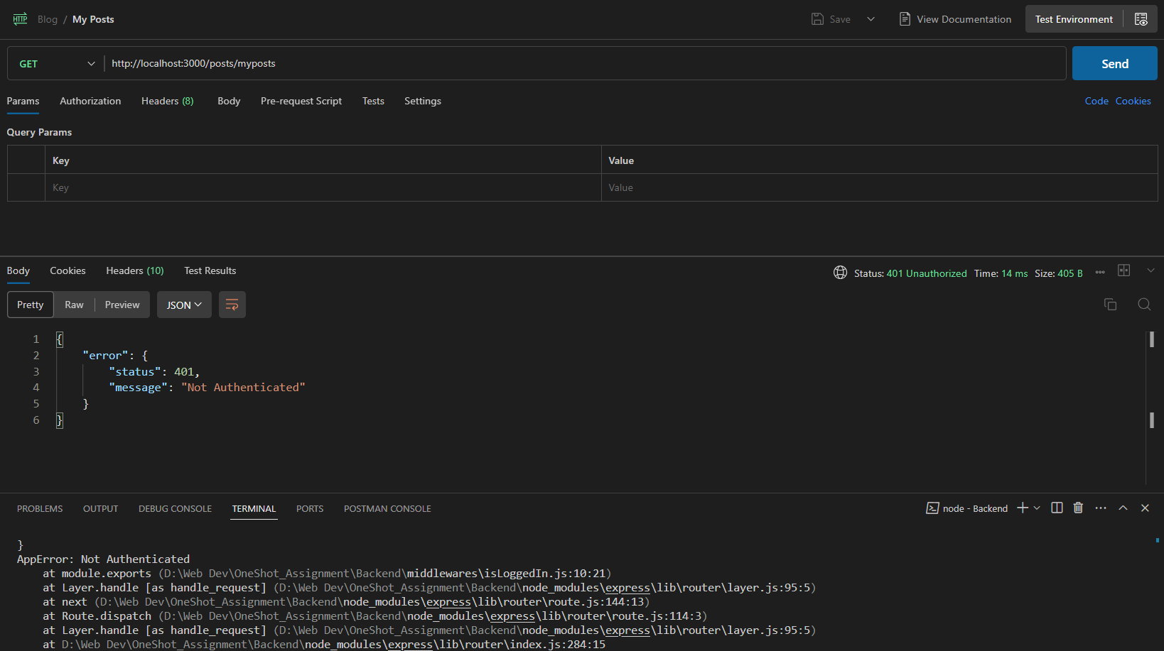

### Test 2: Sending a GET request after authentication and with query params:

#### No Posts for current user:

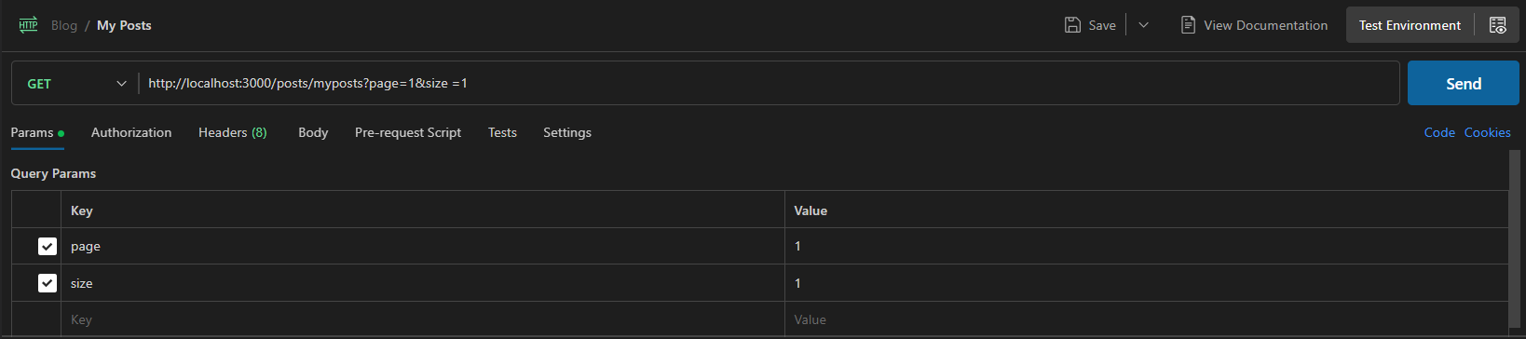

Server Response:

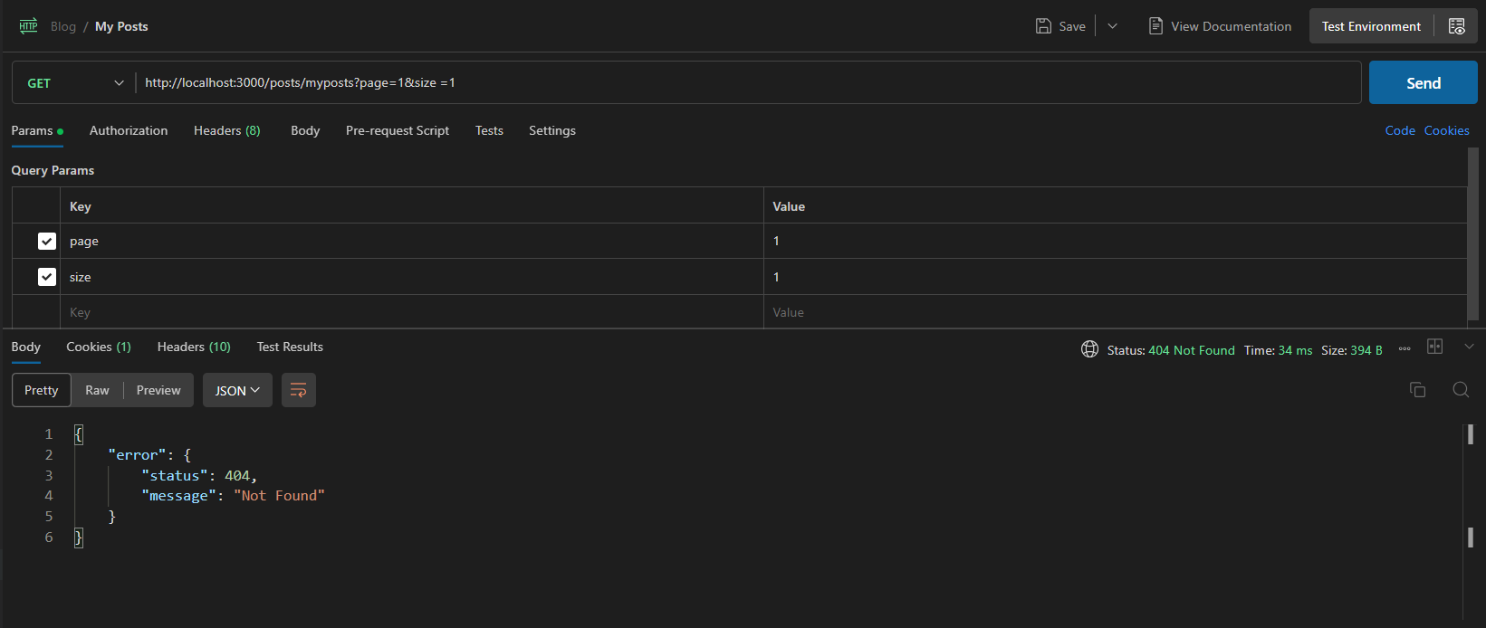

#### With posts for current user:

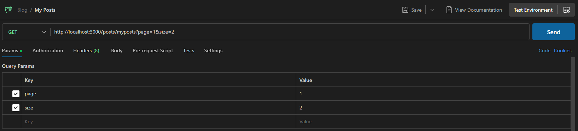

Server Response: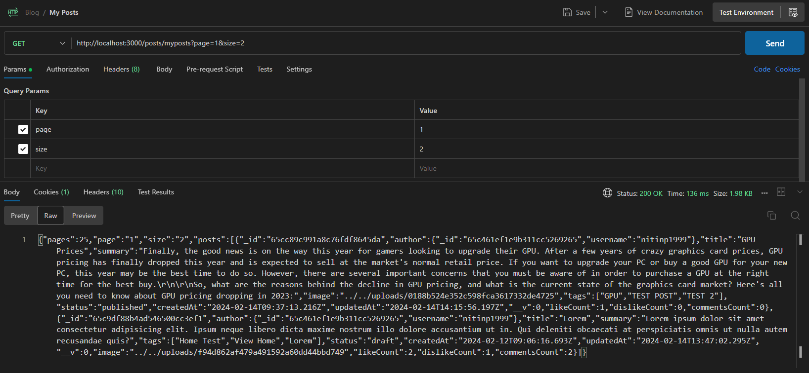

## New Post:

POST <http://localhost:3000/posts/new>

### Test 1: Sending a POST request without authentication:

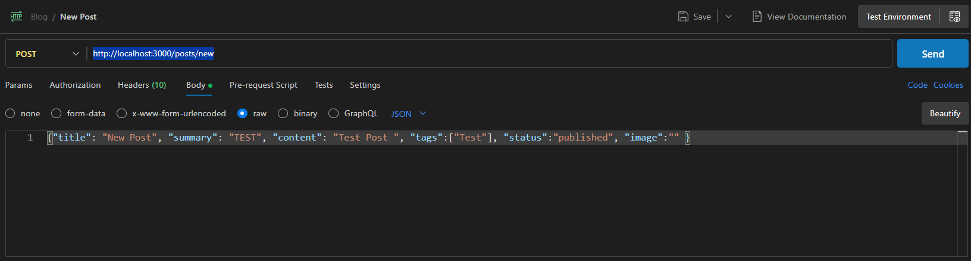

Server Response: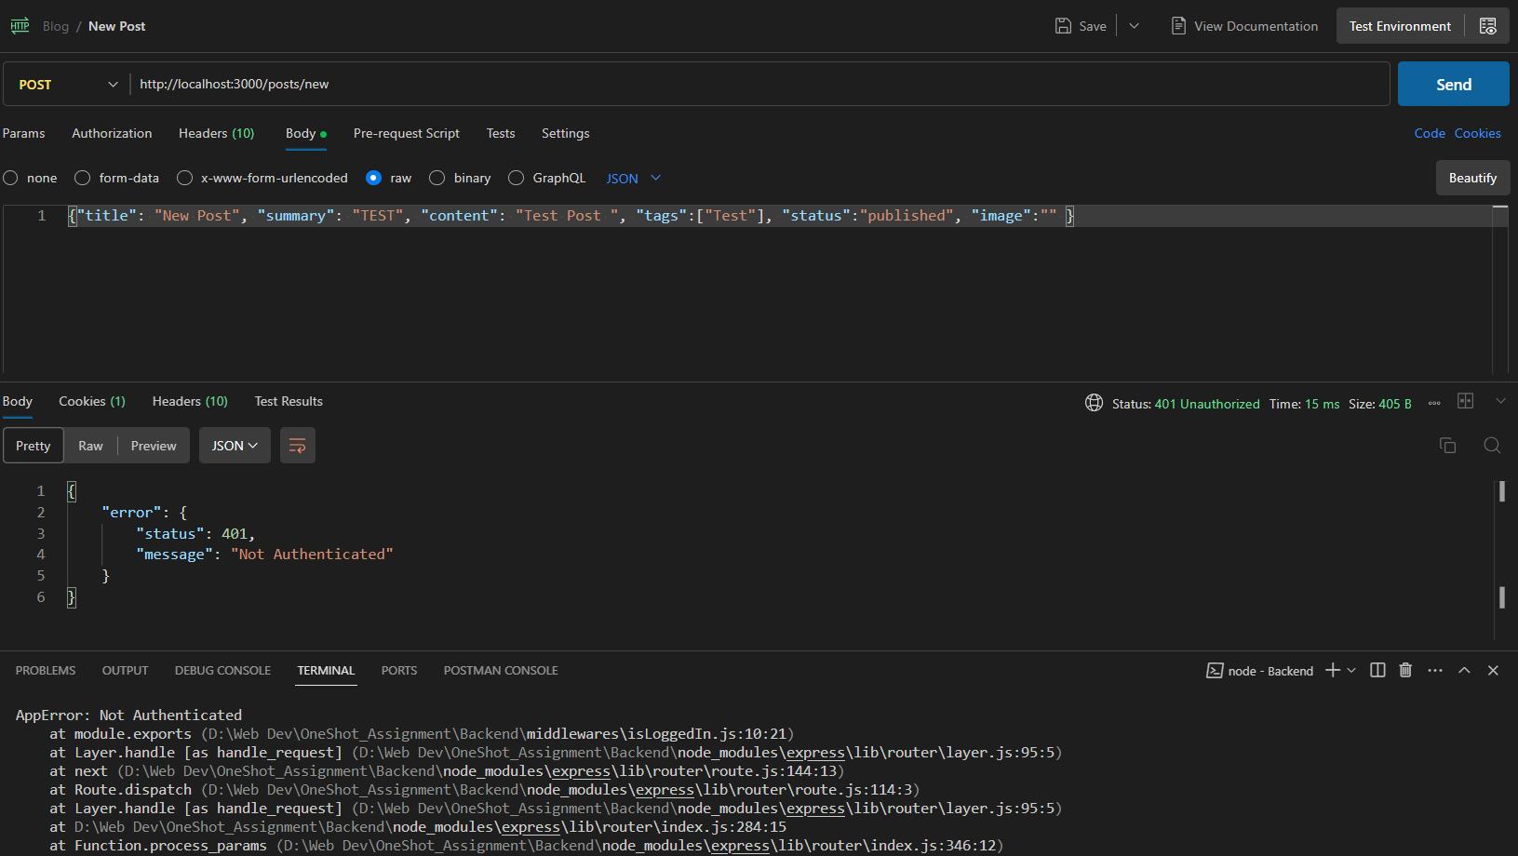

### Test 2: Sending a POST request after authentication:

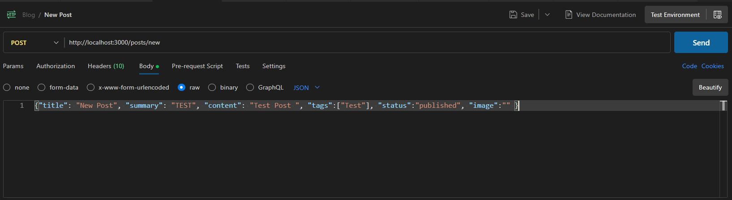

Server Output & Response: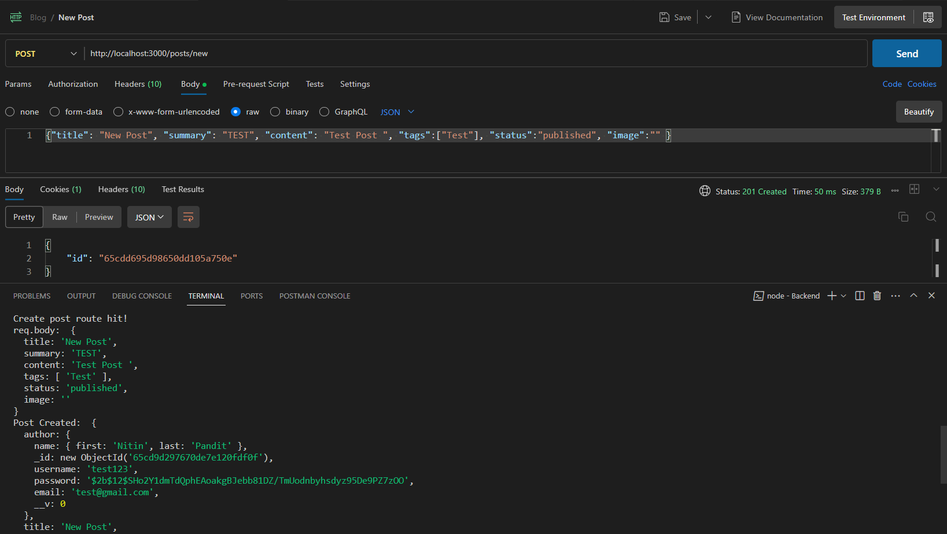

### Test 3: Sending a POST request with incomplete/incorrect Data:

Server Outputs & Responses:

#### All fields missing:

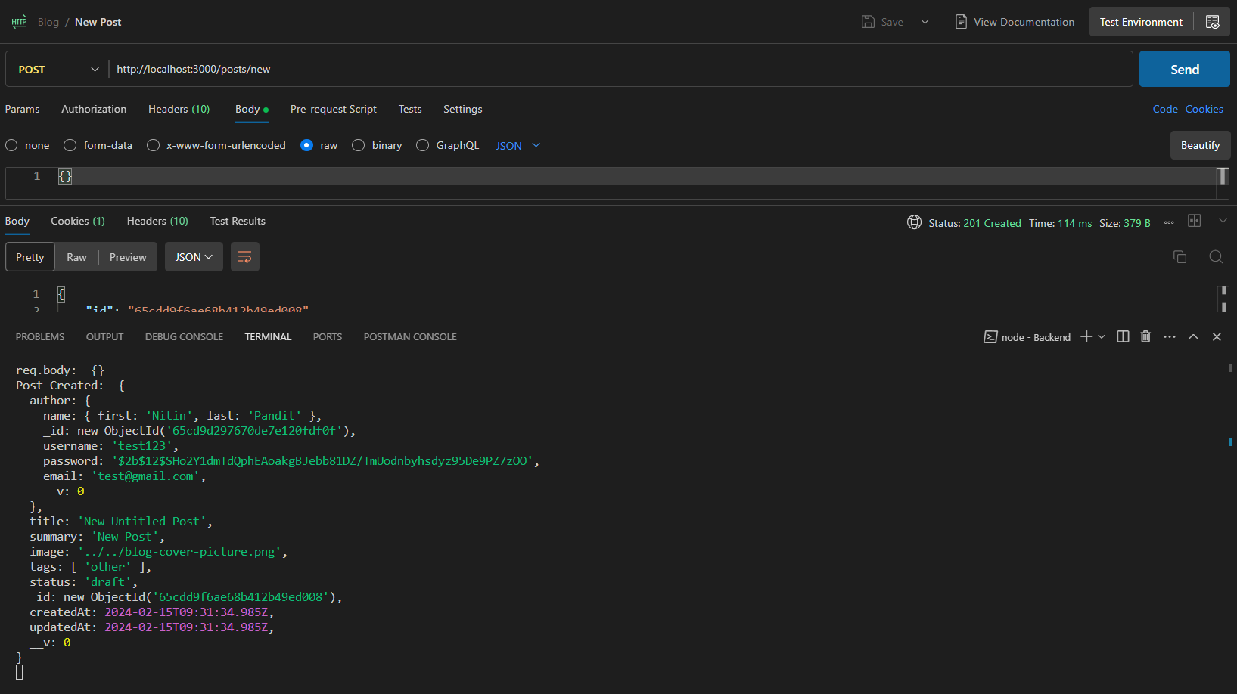

## View Post:

GET <http://localhost:3000/posts/:id>

### Test 1: Sending a GET request with incorrect post ID:

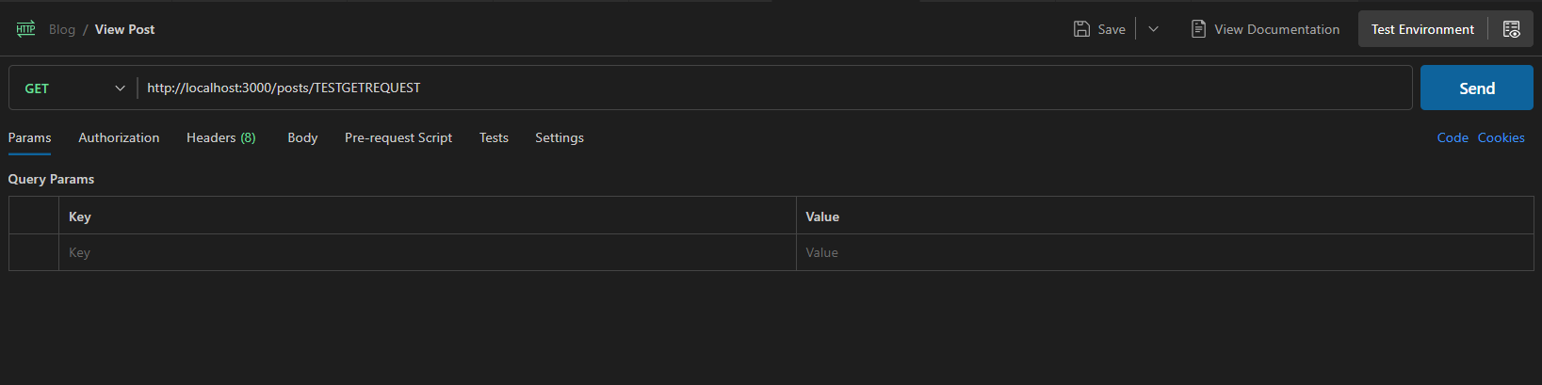

Server Output & Response: 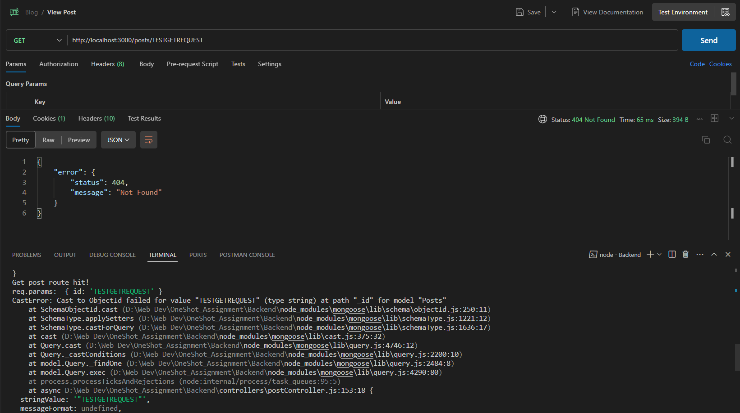

### Test 2: Sending a GET request with correct post ID:

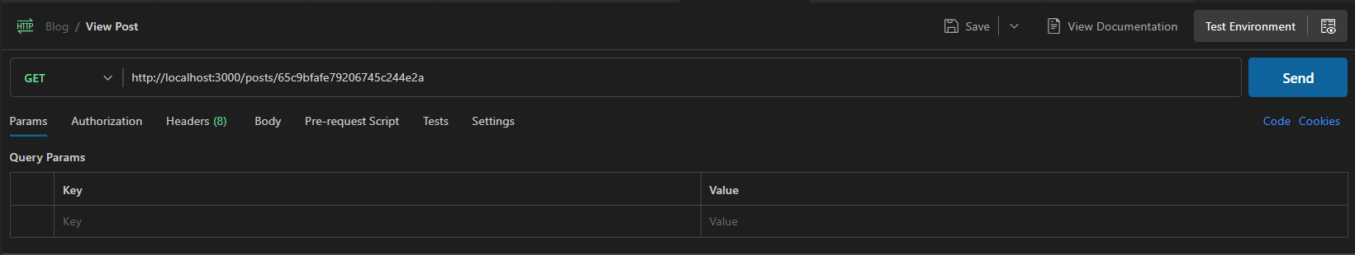

Server Output & Response:

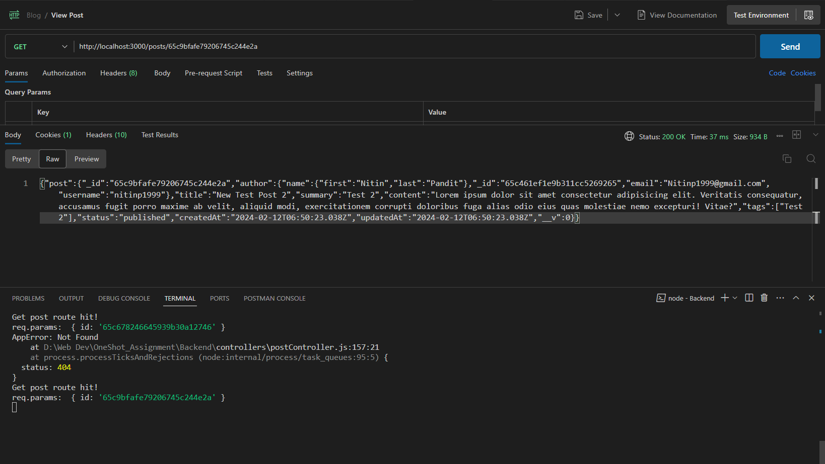

## Edit/Update Post:

PATCH <http://localhost:3000/posts/:id>

### Test 1: Sending a PATCH request without authentication:

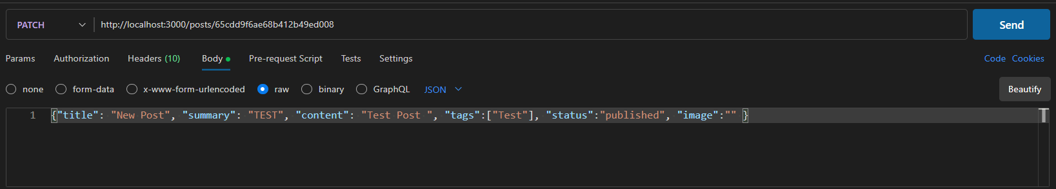

Server Output & Response:

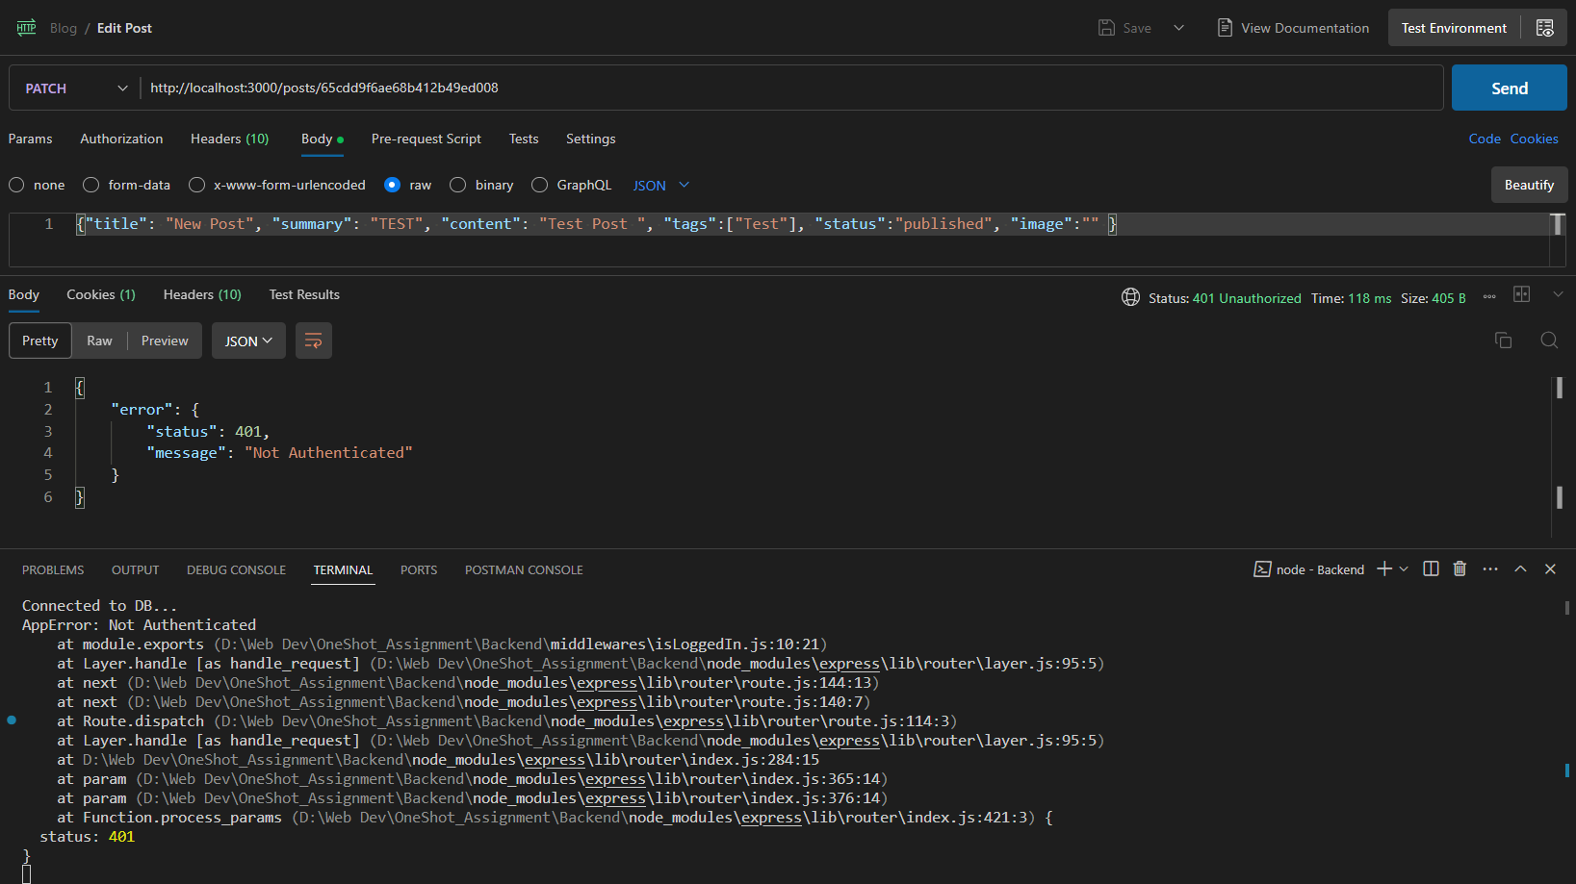

### Test 2: Sending a PATCH request with authentication:

#### Testing a successful update

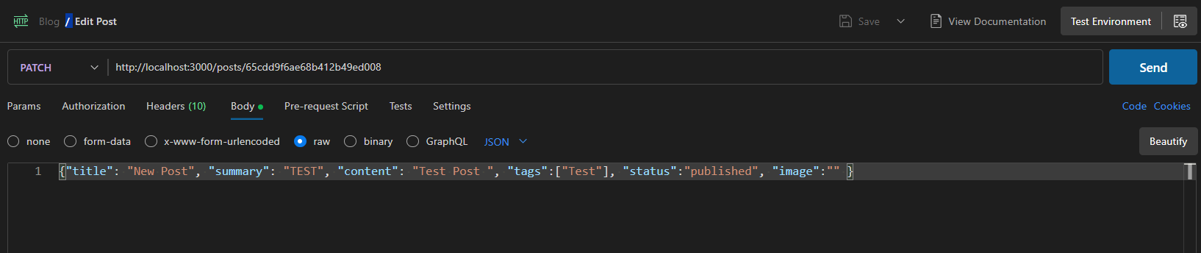

Server Output & Response:

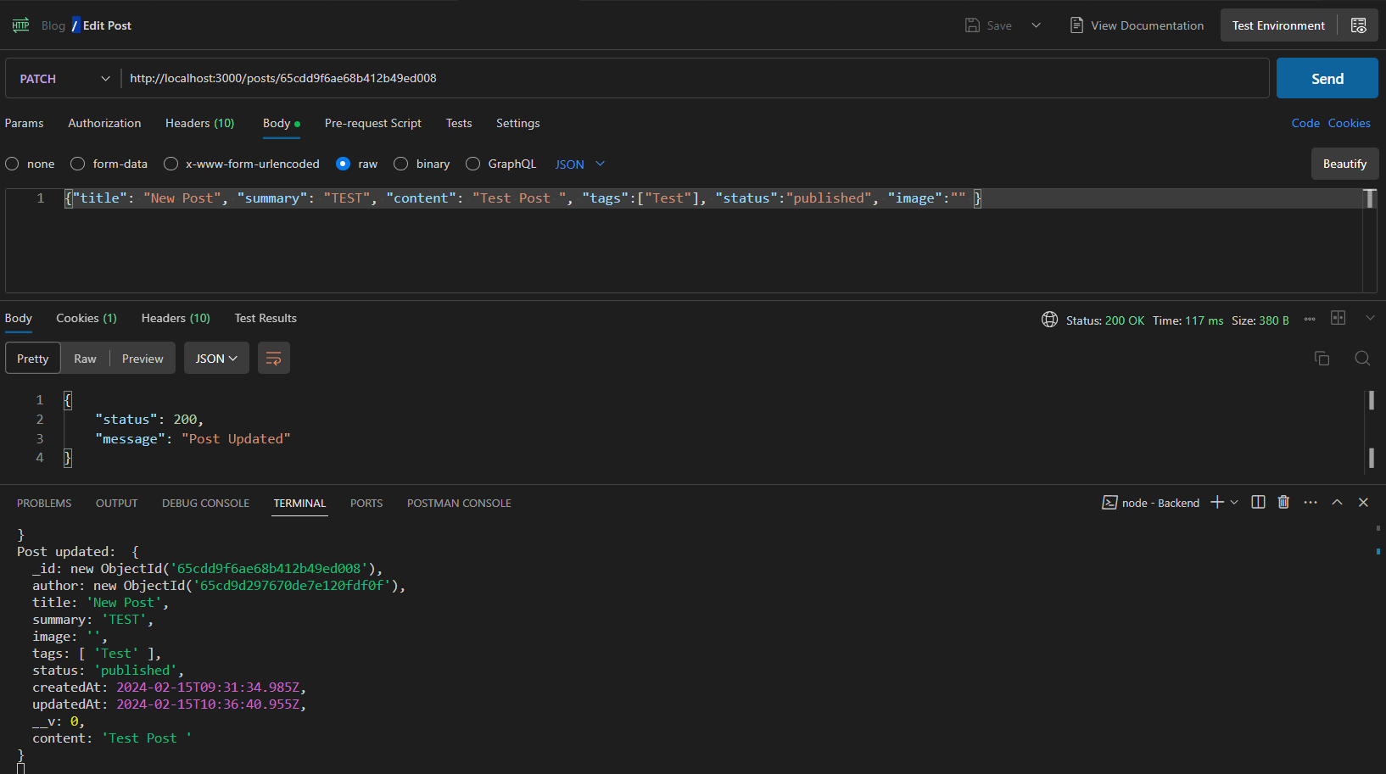

#### Updating specific fields:

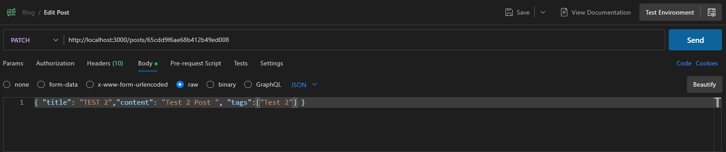

Server Output & Response: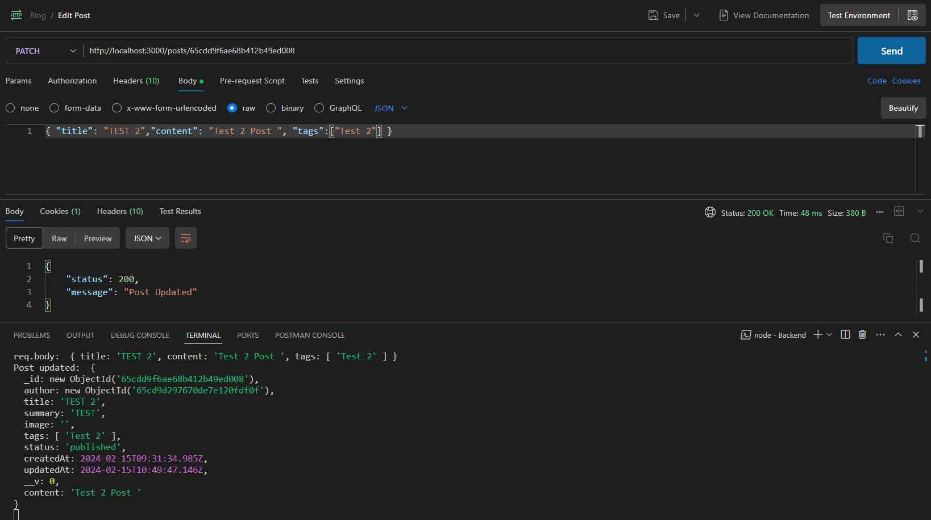

#### Sending an empty request:

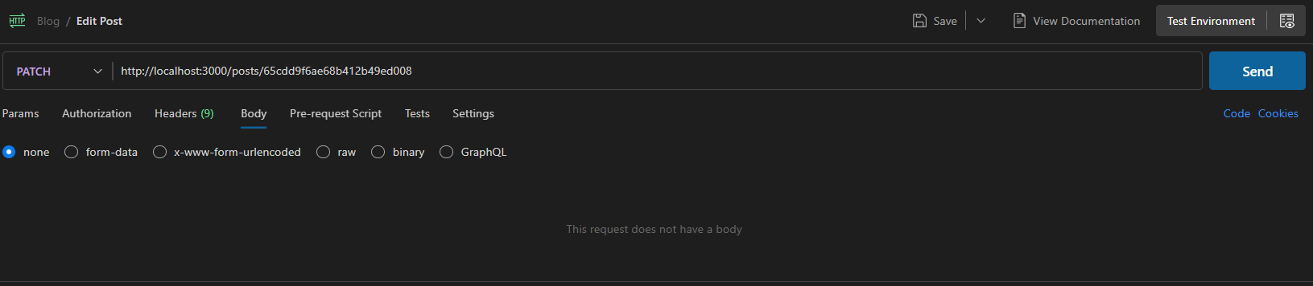

Server Output & Response: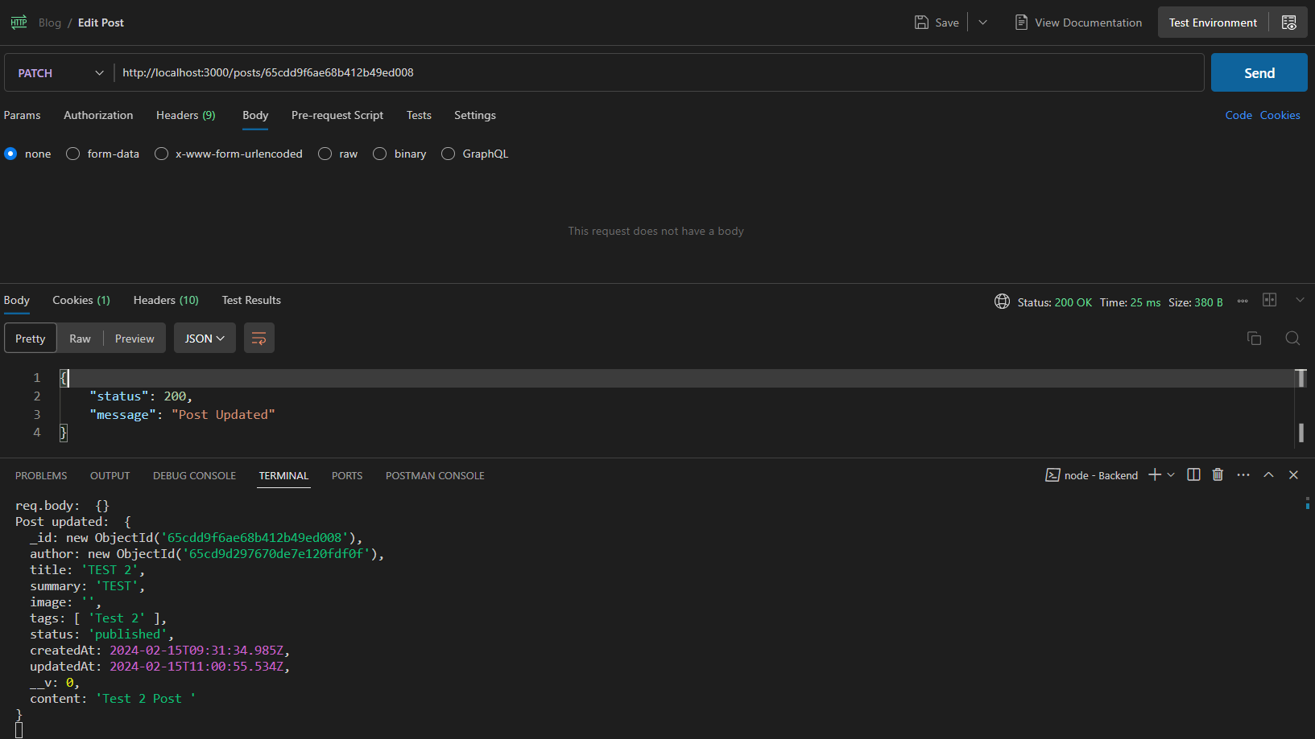

Delete Post:

DELETE http://localhost:3000/posts/:id

### Test 1: Sending a DELETE request without authentication:

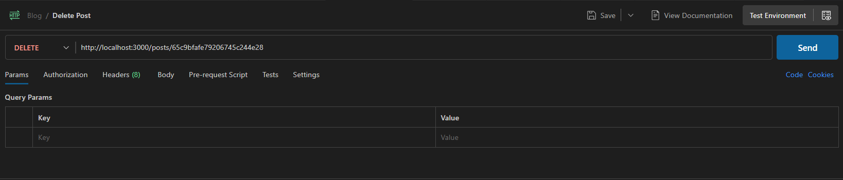

Server Output and Response: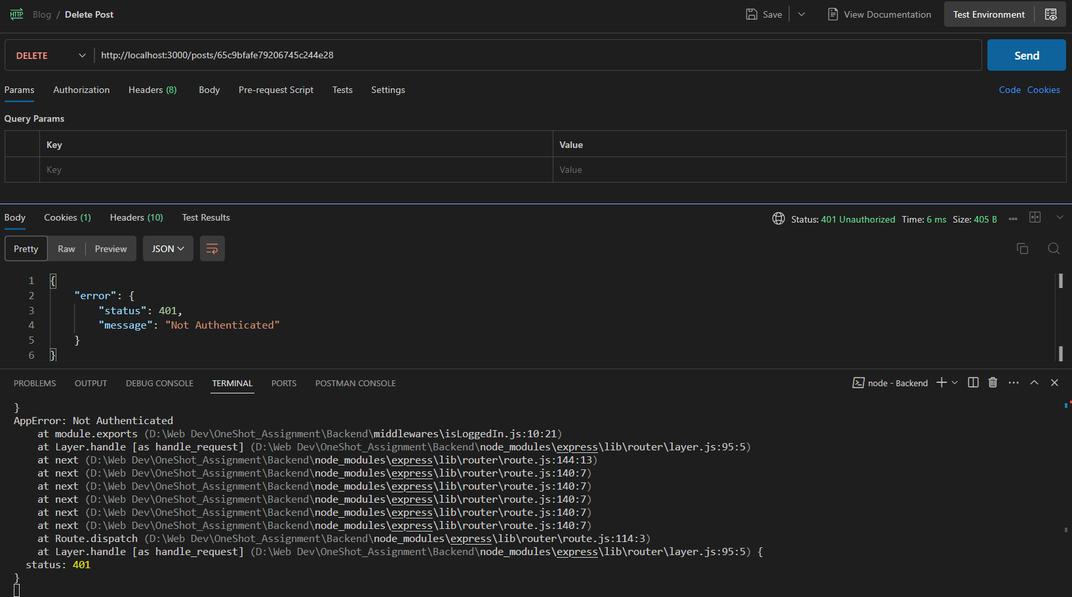

### Test 2: Sending a DELETE request with authentication:

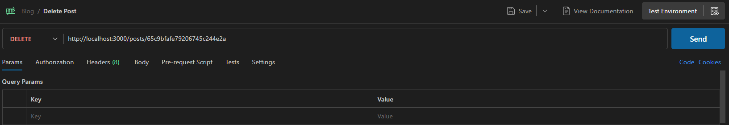

#### Deleting a post that was posted by another user:

Server Output & Response: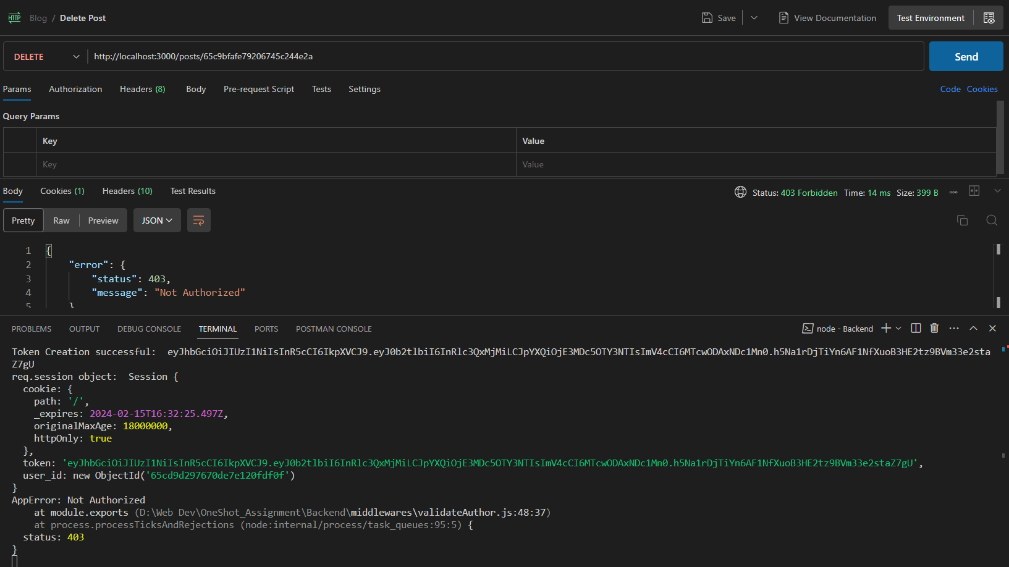

#### Deleting a Post with correct authentication:

Server Output & Response:

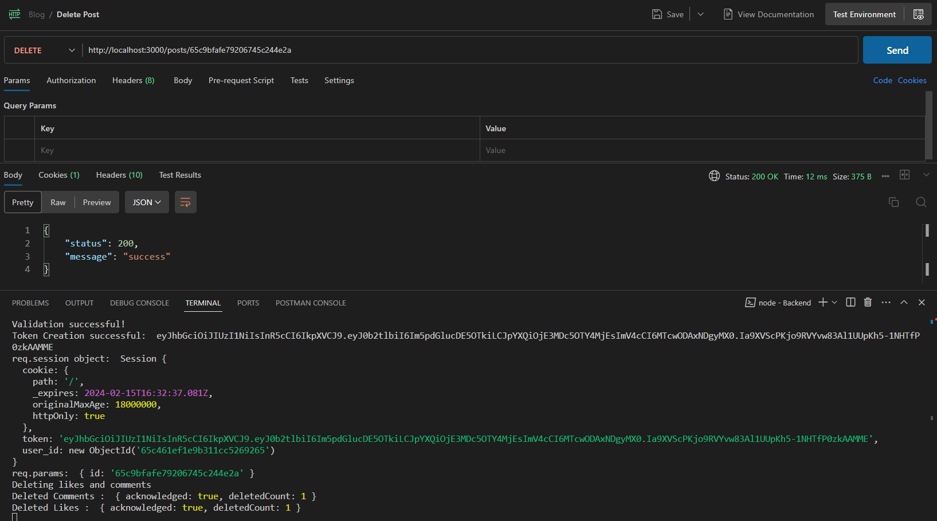

### Test 3: Sending a DELETE request with incorrect Post ID:

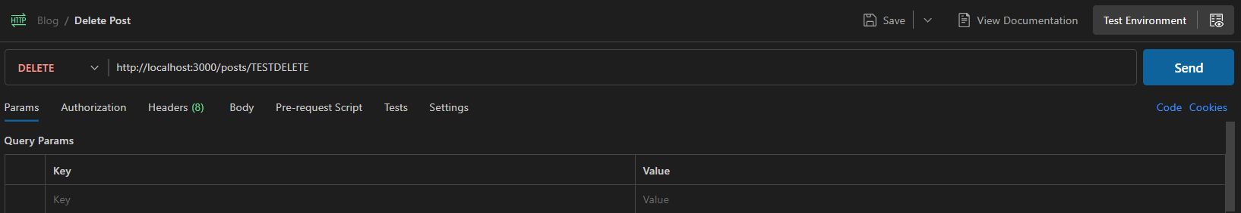

Server Output & Response:

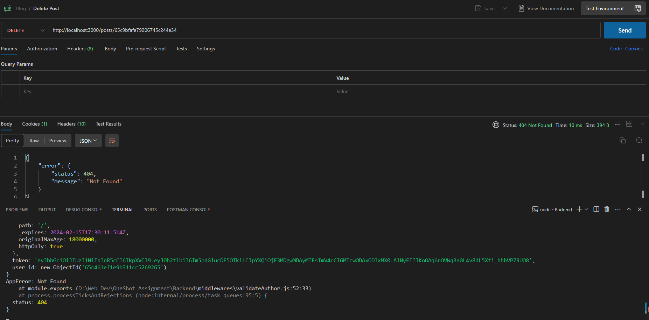

# Comments:

## View Comments:

GET <http://localhost:3000/comments/:post_id/all>

### Test 1: Testing comment

#### Sending a GET request without authentication:

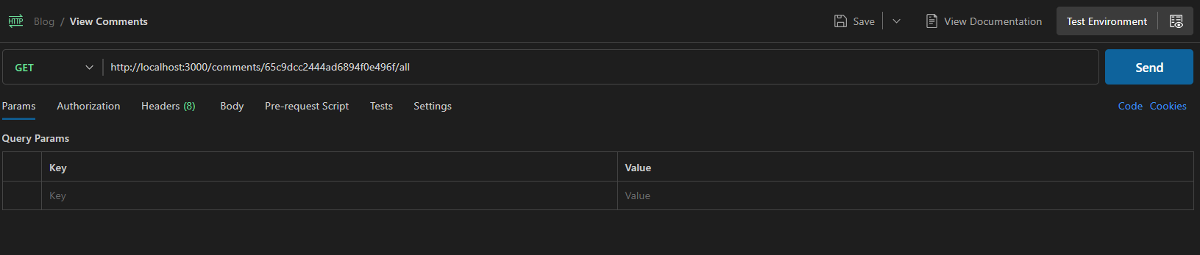

Server Output & Response:

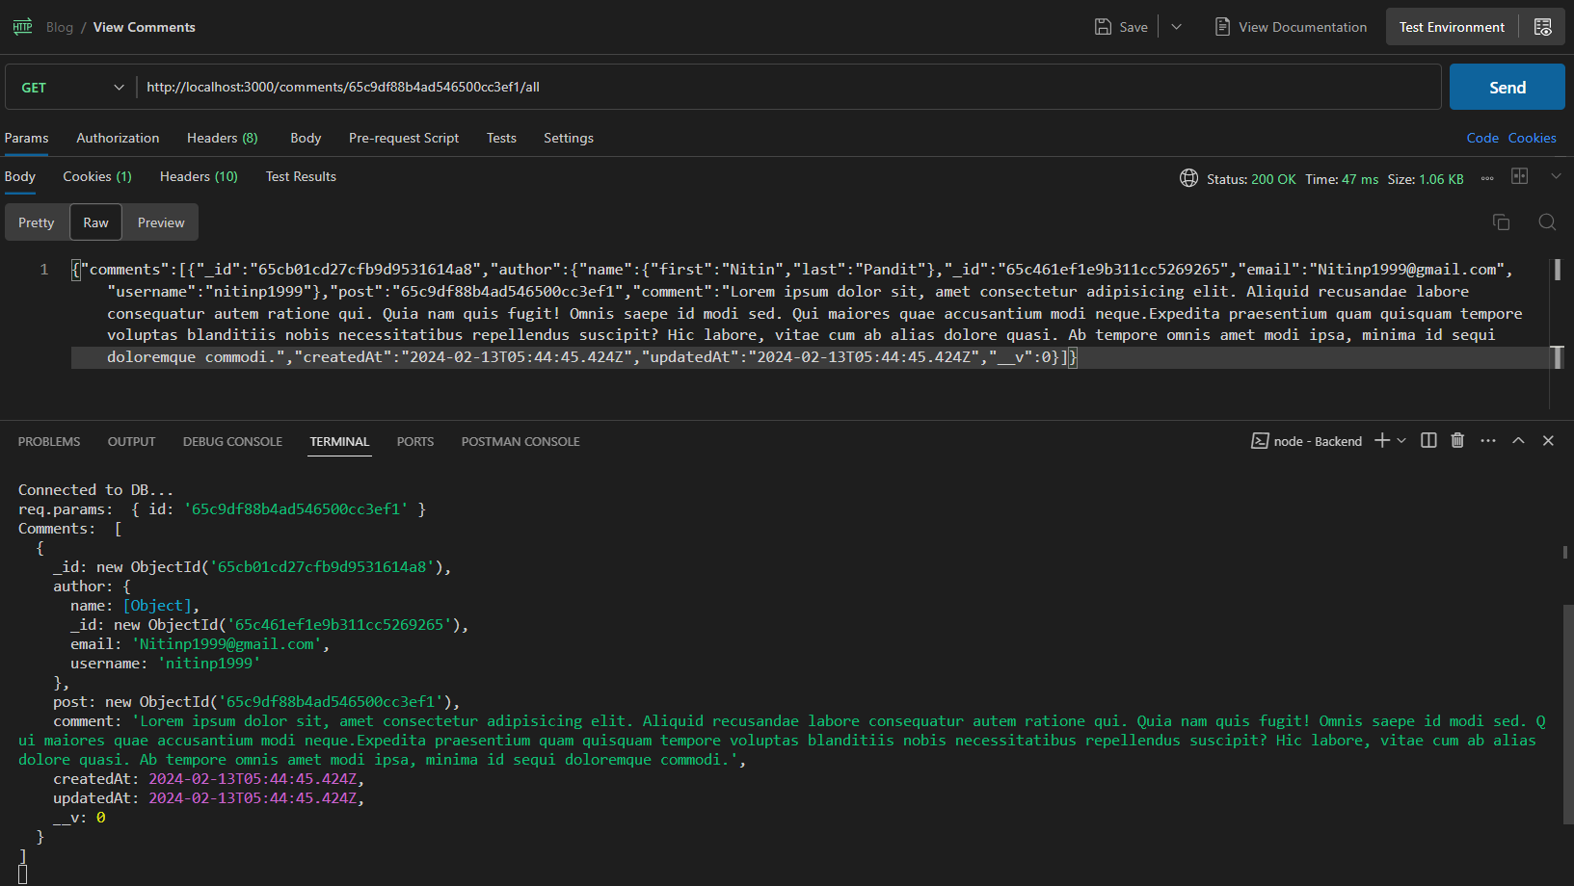

#### Sending a GET request with authentication:

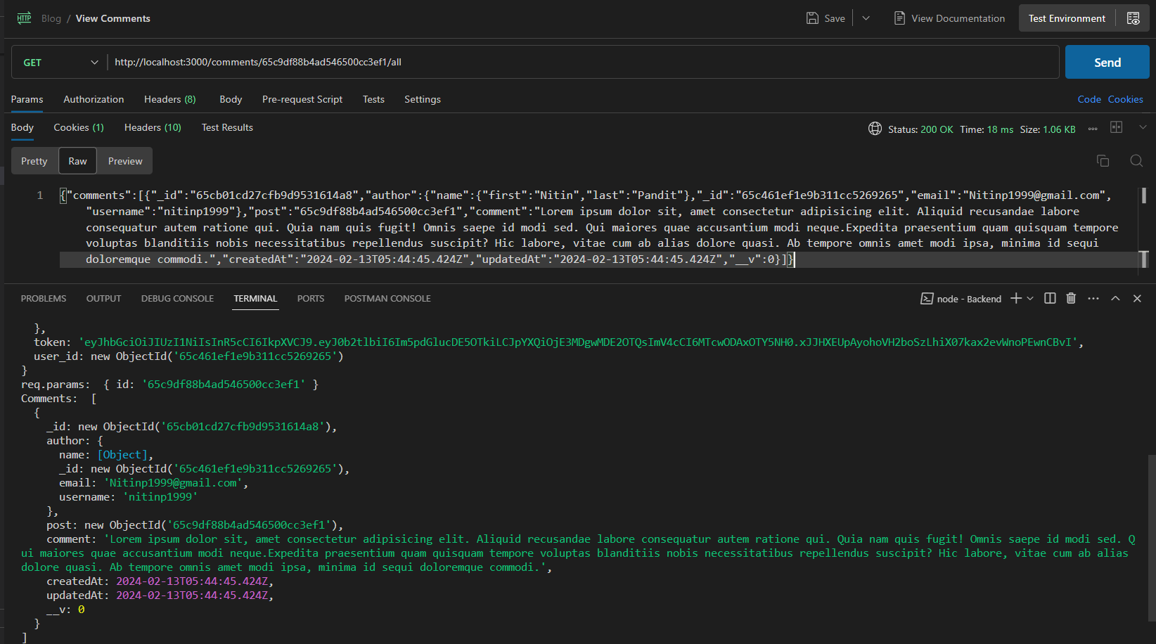

### Test 2: Testing incorrect post ID:

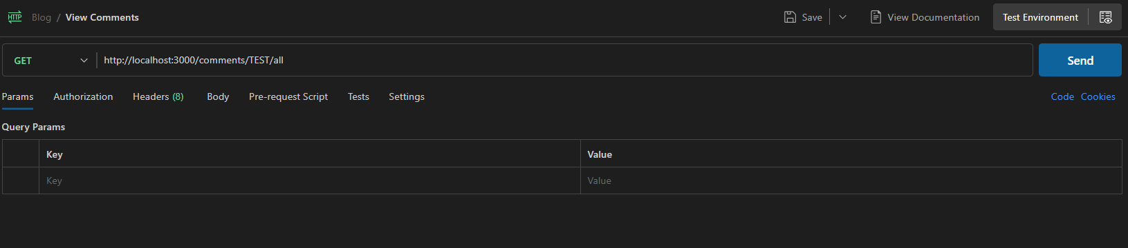

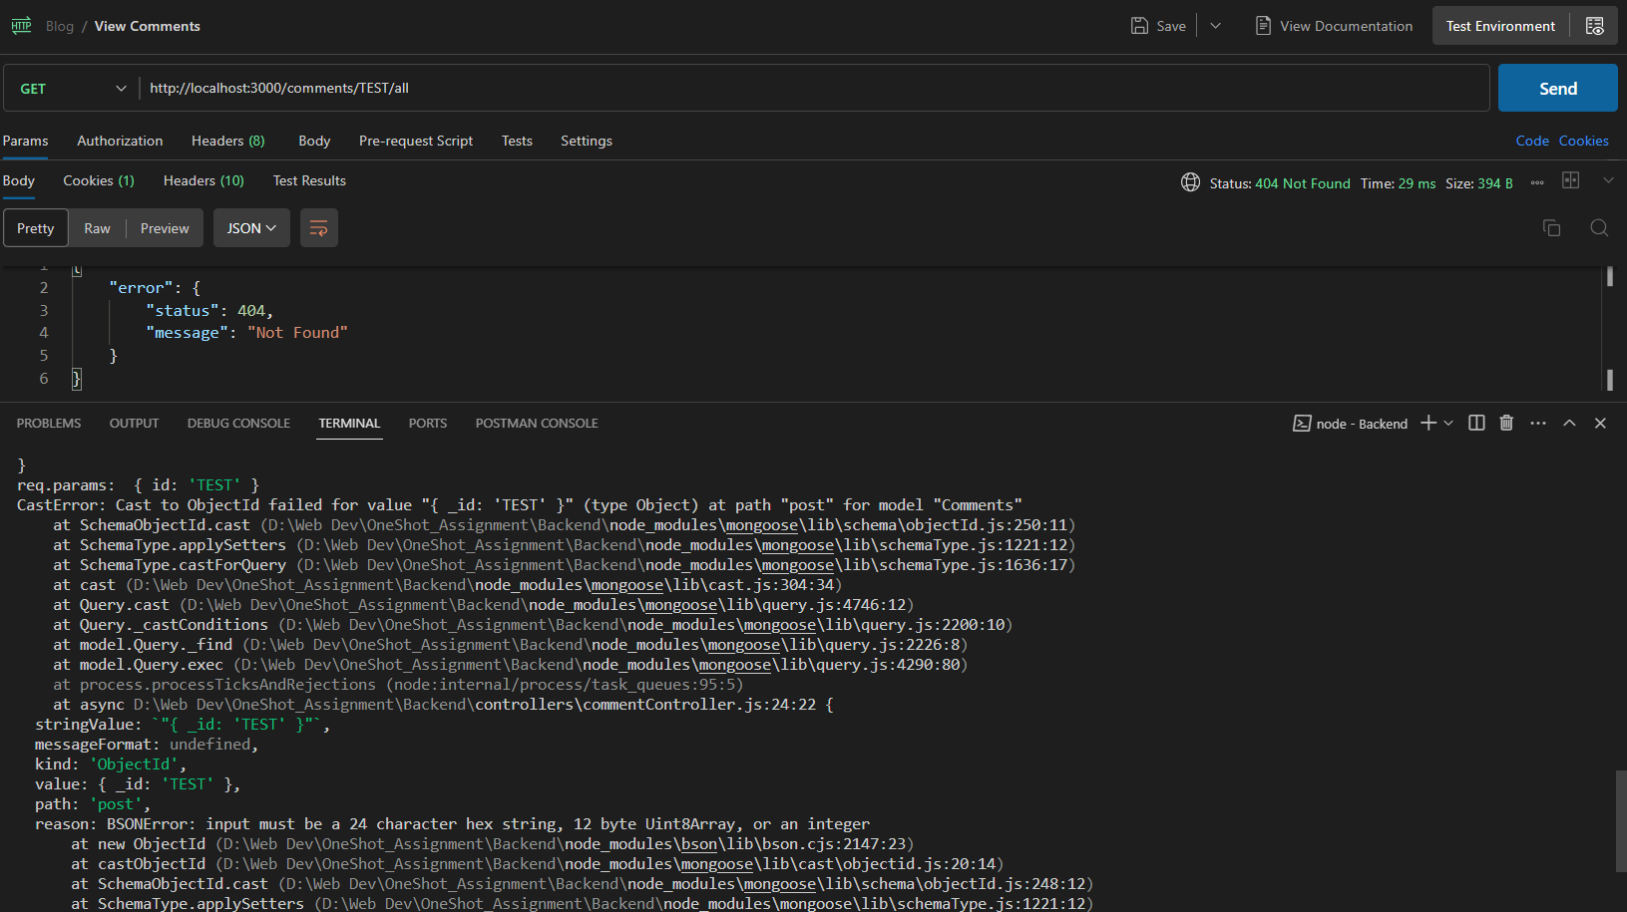

## Create Comment:

POST <http://localhost:3000/comments/:post_id/new>

### Test 1: Sending a POST request without authentication:

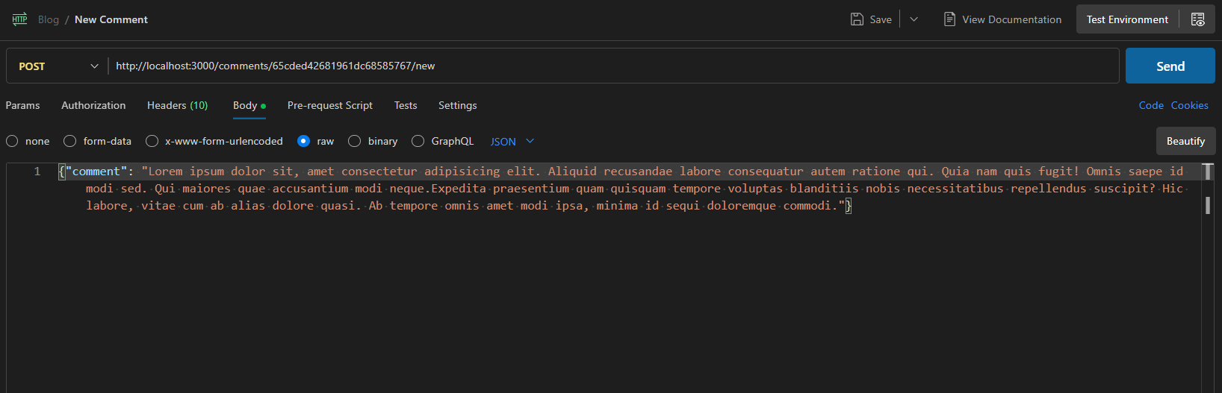

Server Output & Response:

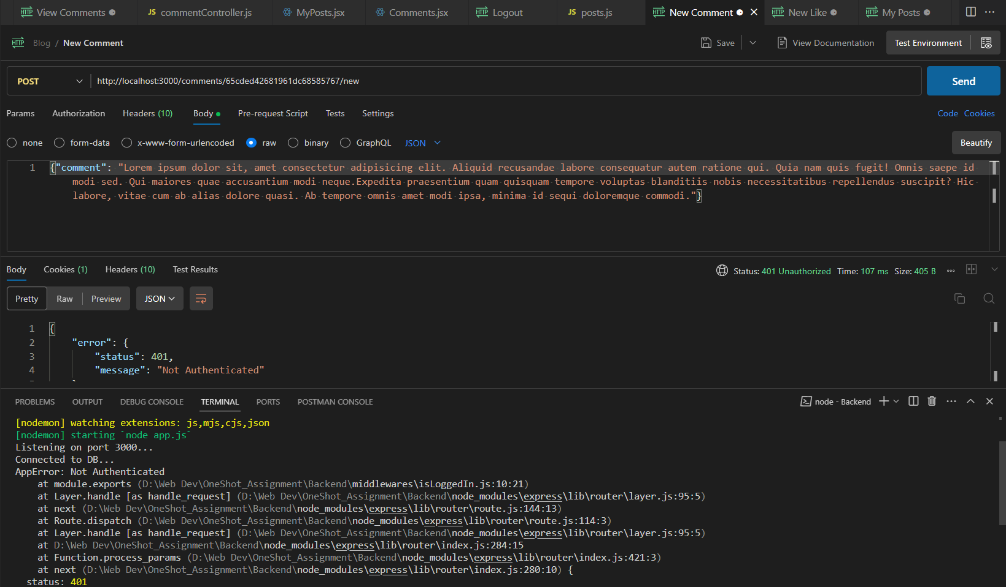

### Test 2: Posting a comment after authentication:

#### Posting a valid comment to a post with status ‘draft’:

Server Output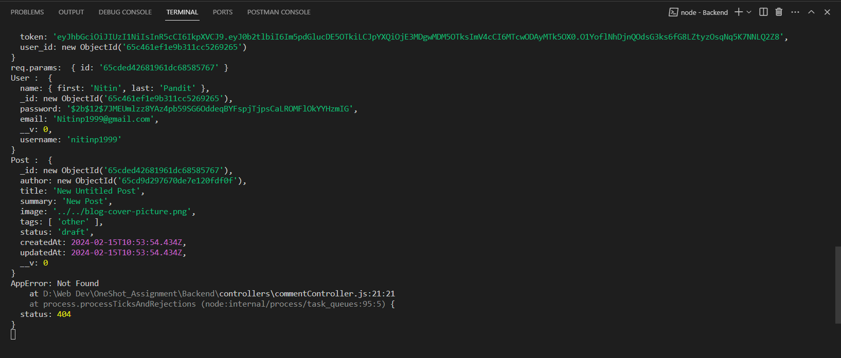

Server Response:

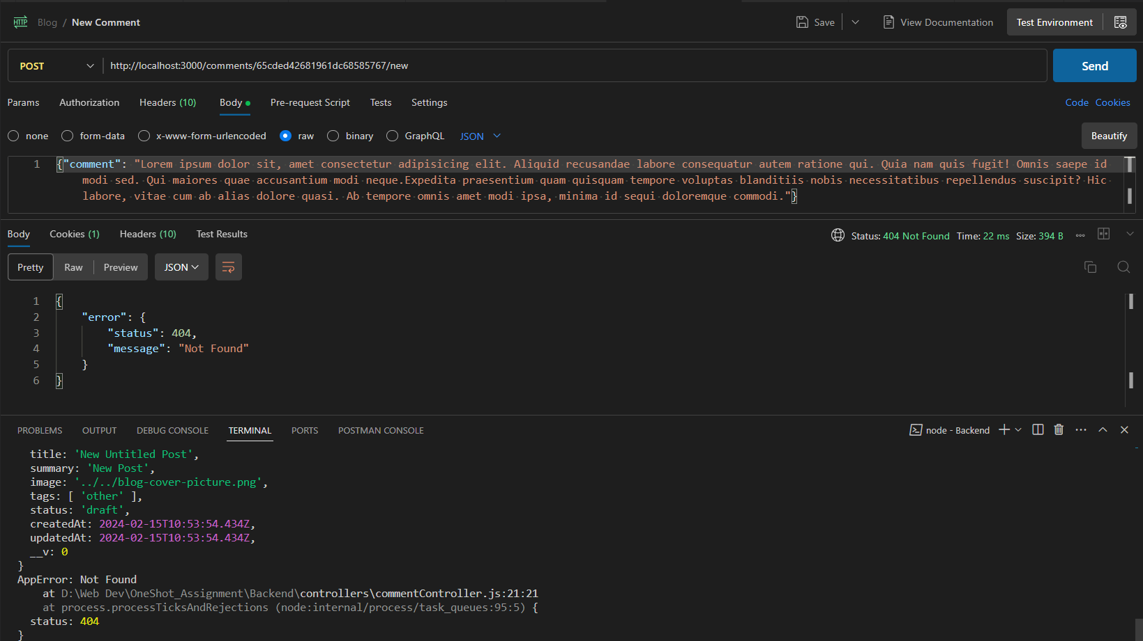

#### Posting a valid comment to a post with status ‘published’

Server Output: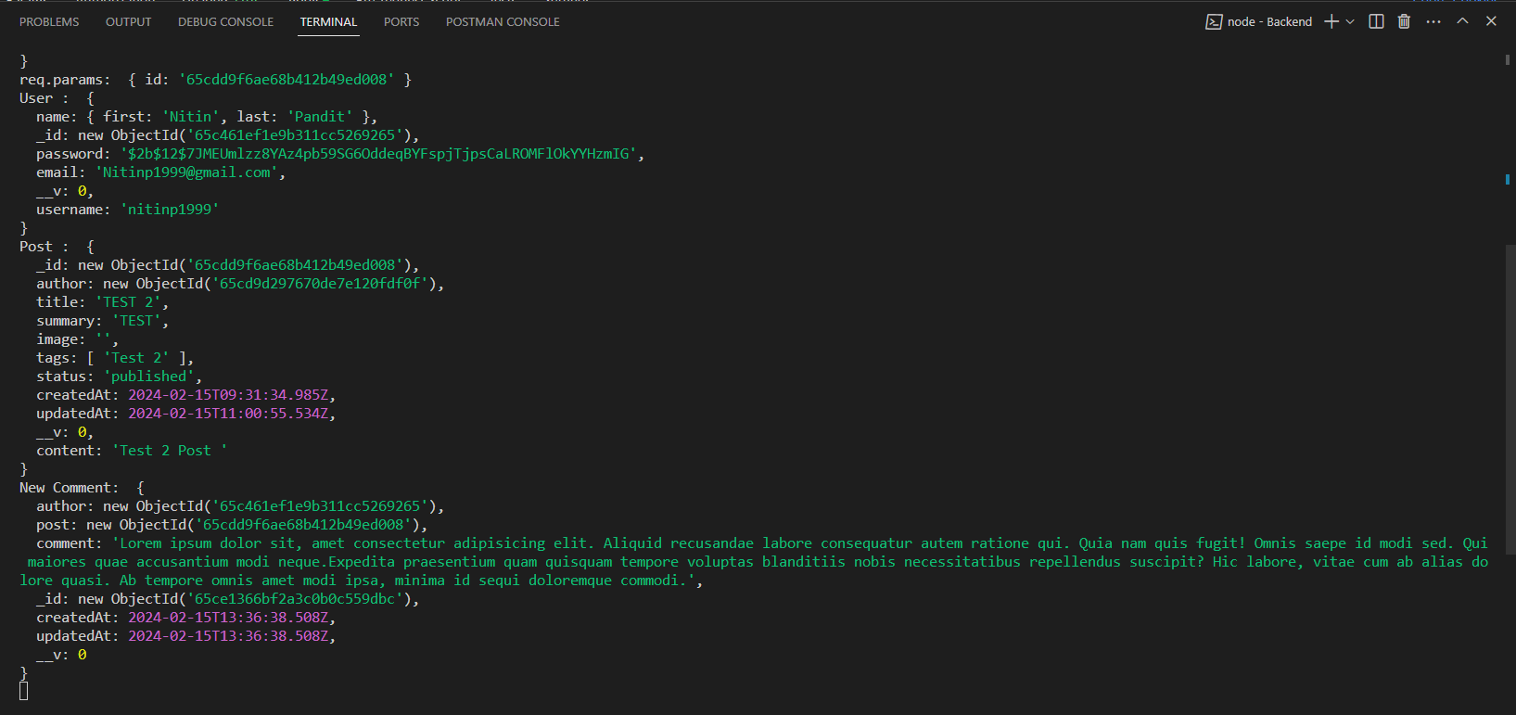

Server Response:

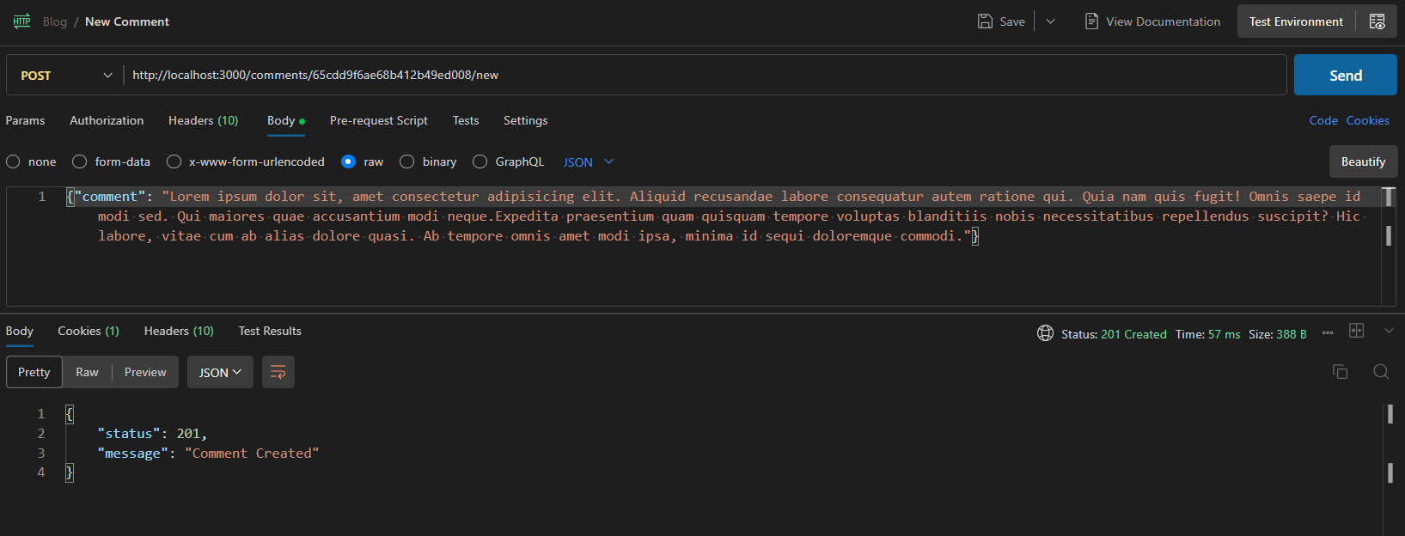

#### Posting a blank comment:

Server Output & Response: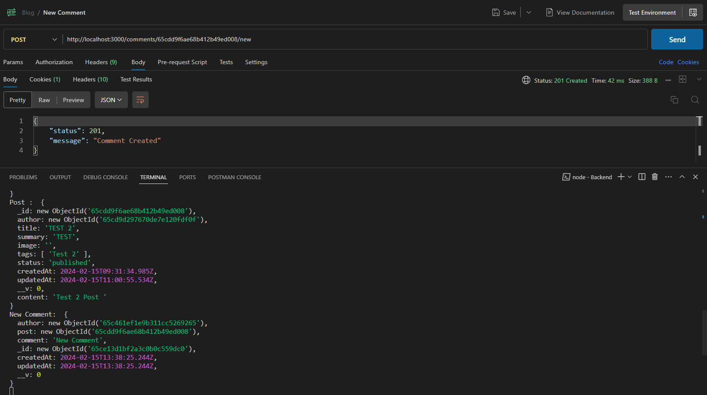

## Delete Comment

DELETE <http://localhost:3000/comments/:comment_id>

### Test 1: Sending a DELETE request without authentication:

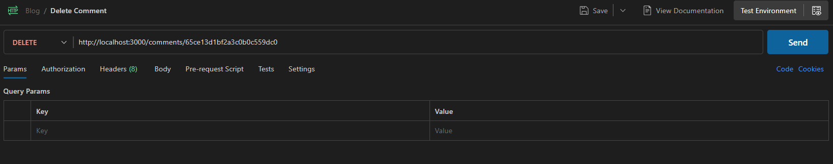

Server Output & Response:

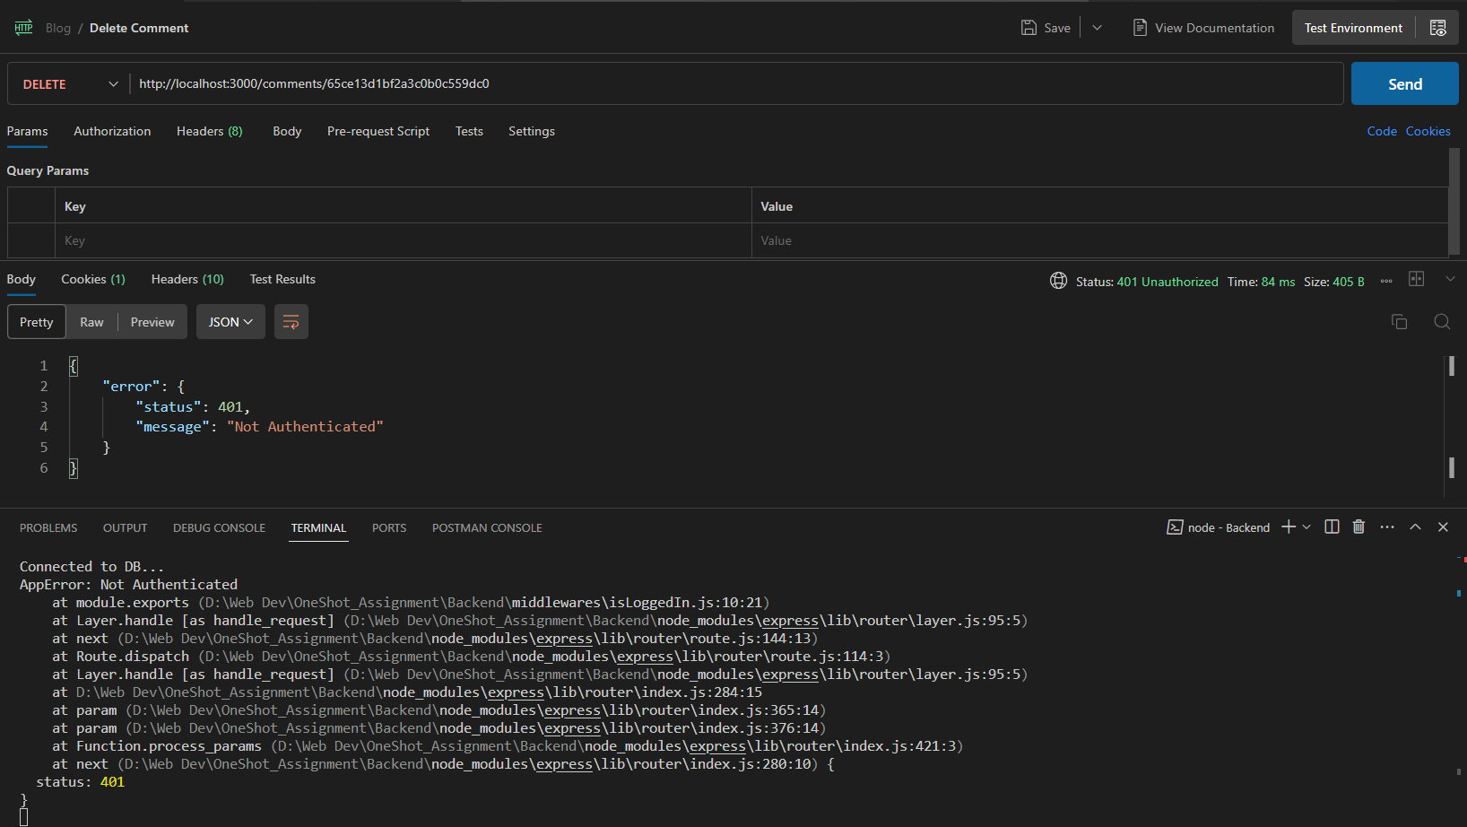

### Test 2: Sending a DELETE request after authentication as author:

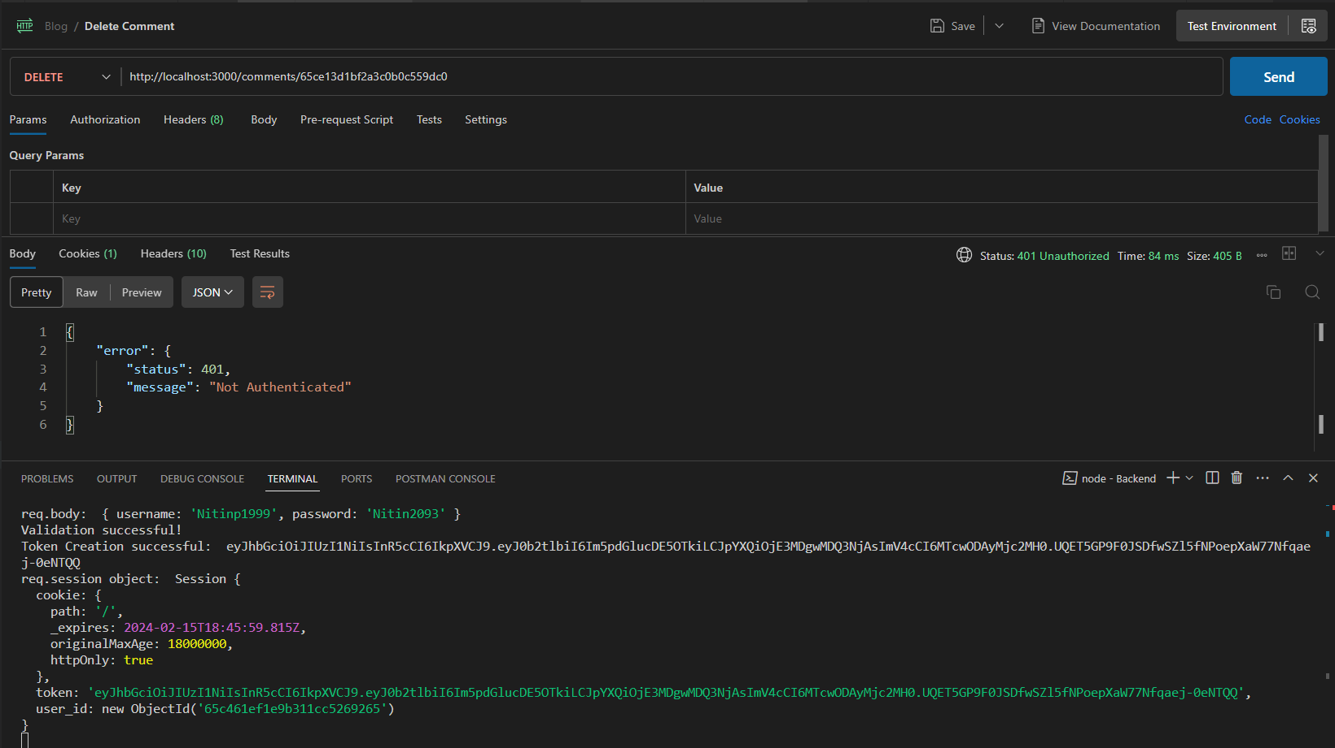

Server Output & Response:

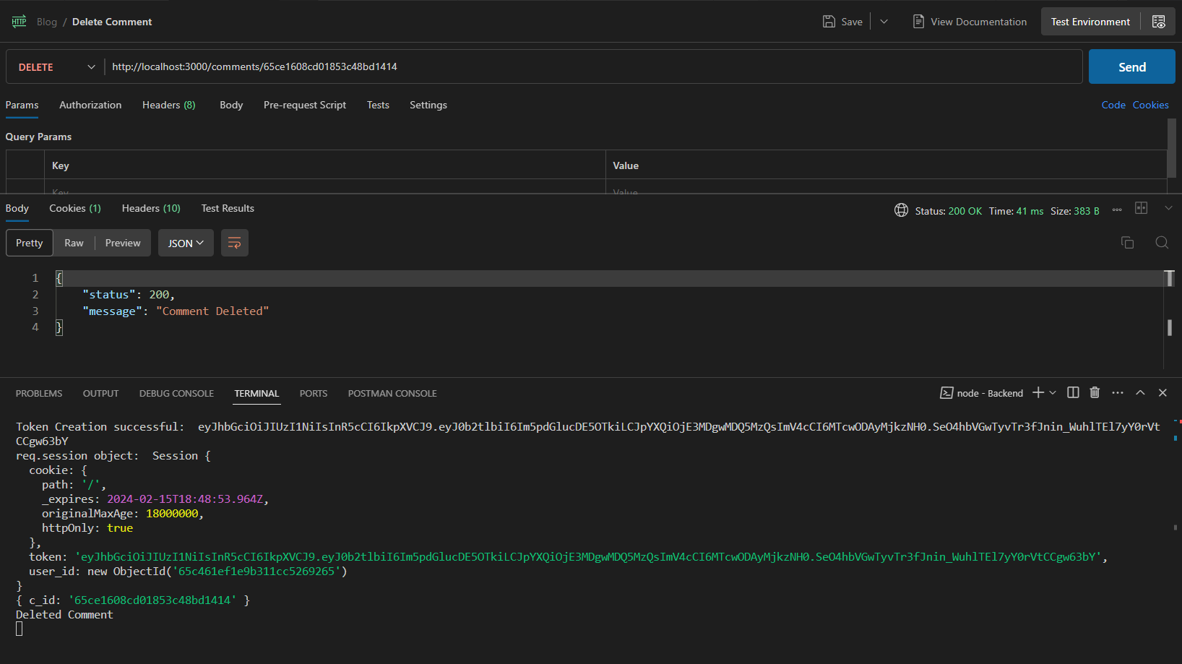

## Test 3: Sending a DELETE request after authentication (!Author)

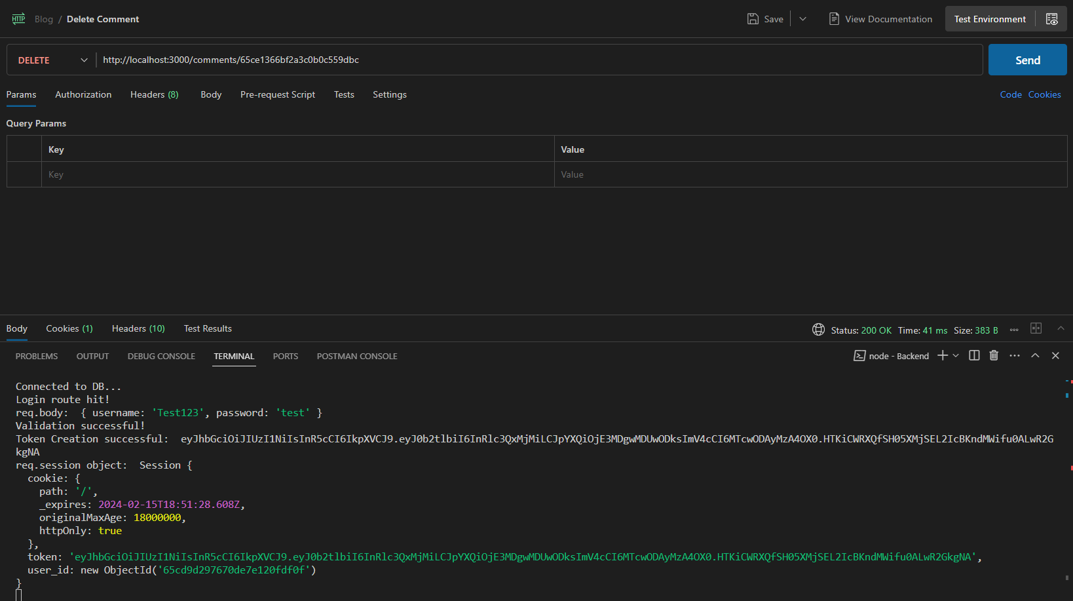

Server Output & Response:

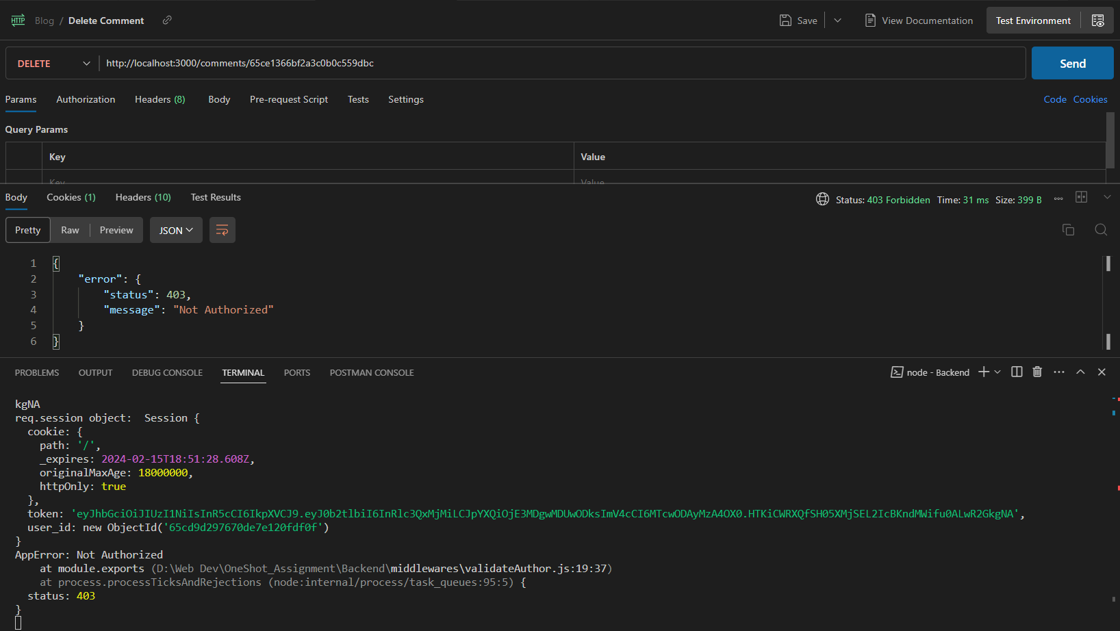

### Test 4: Sending DELETE request after authentication but with invalid comment ID:

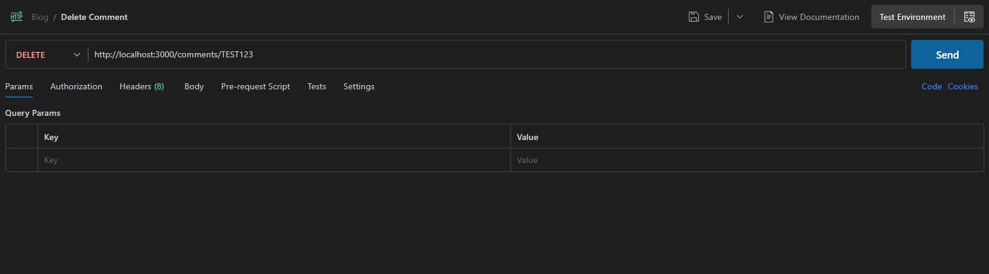

Server Output & Response:

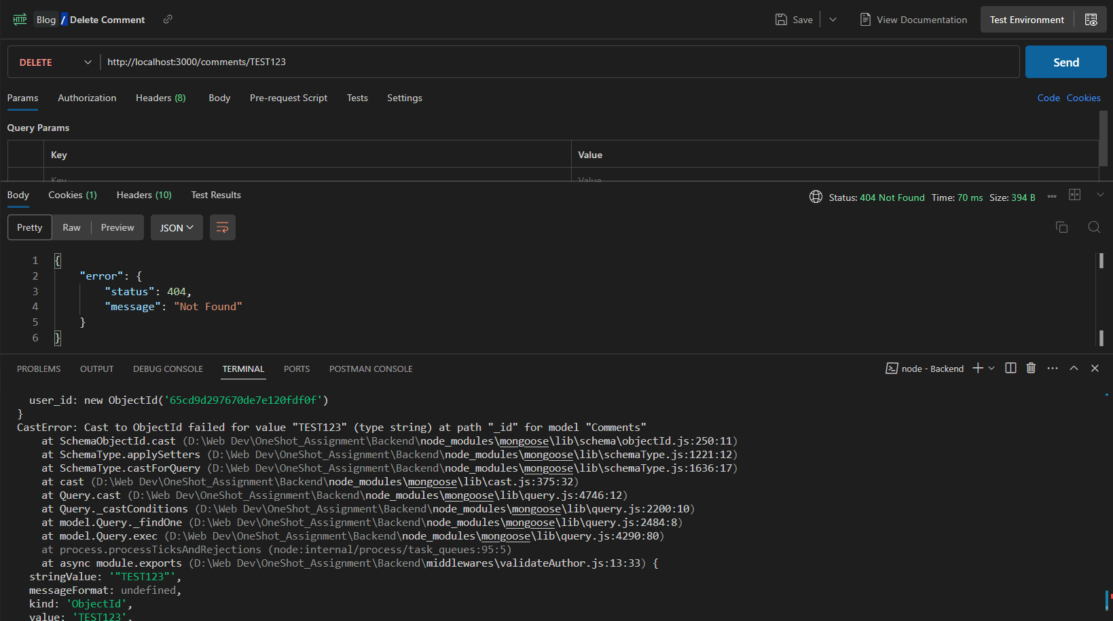

# Likes:

## Create Likes:

POST <http://localhost:3000/likes/:post_id/new>

### Test 1: Sending a POST request without authentication:

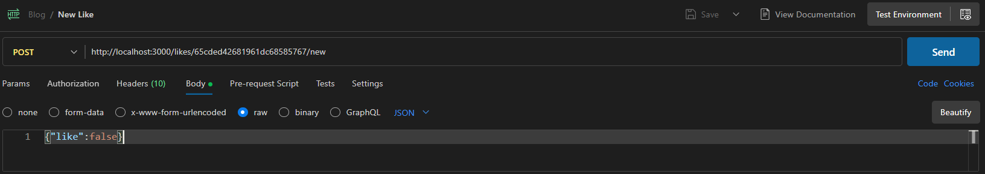

Server Output & Response:

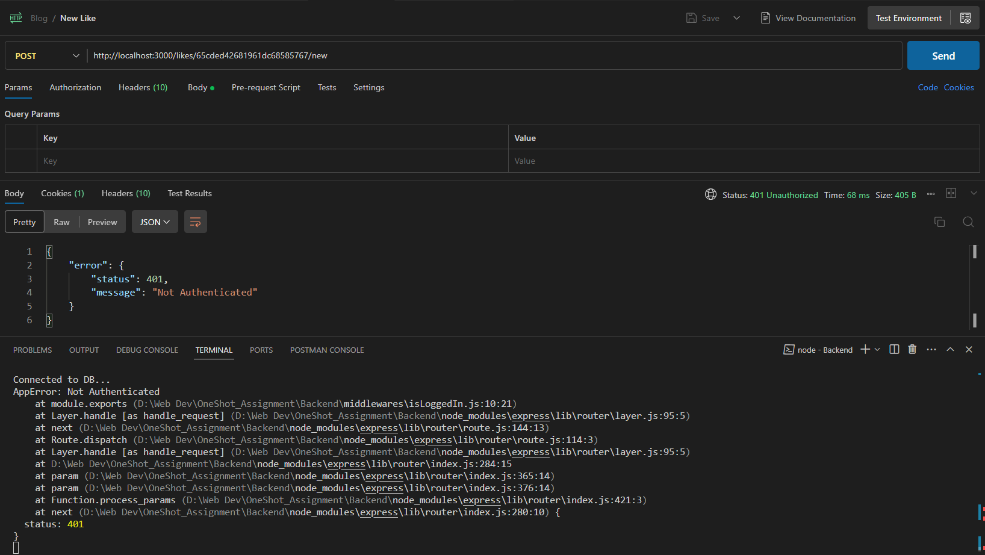

### Test 2: Sending a POST request with authentication:

#### Testing Like creation for a post with the ‘draft’ status:

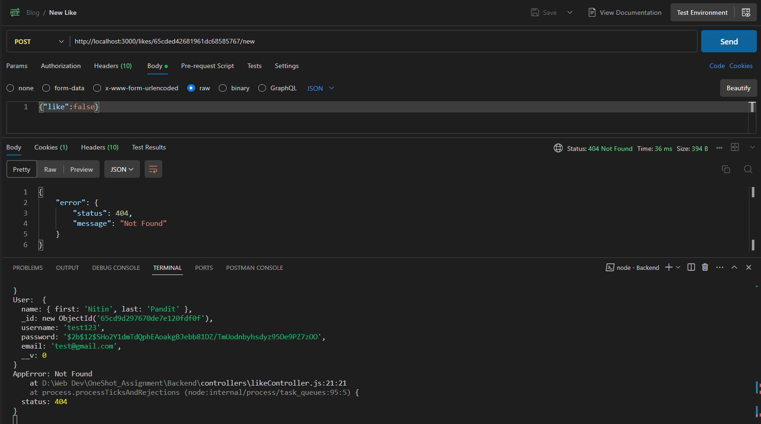

#### Testing Like creation for a post with ‘published’ status:

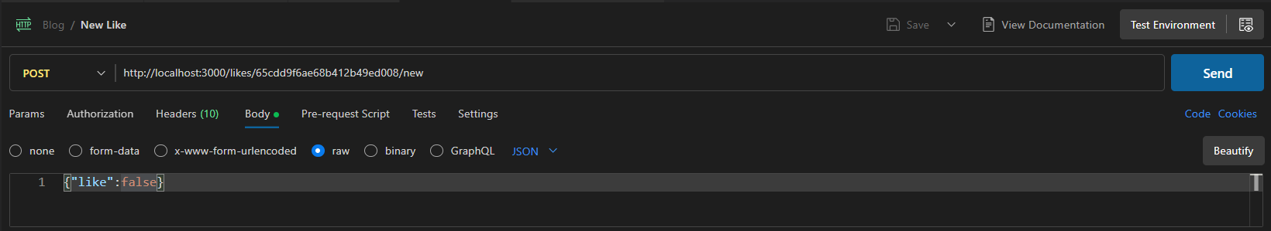

Server Output & Response: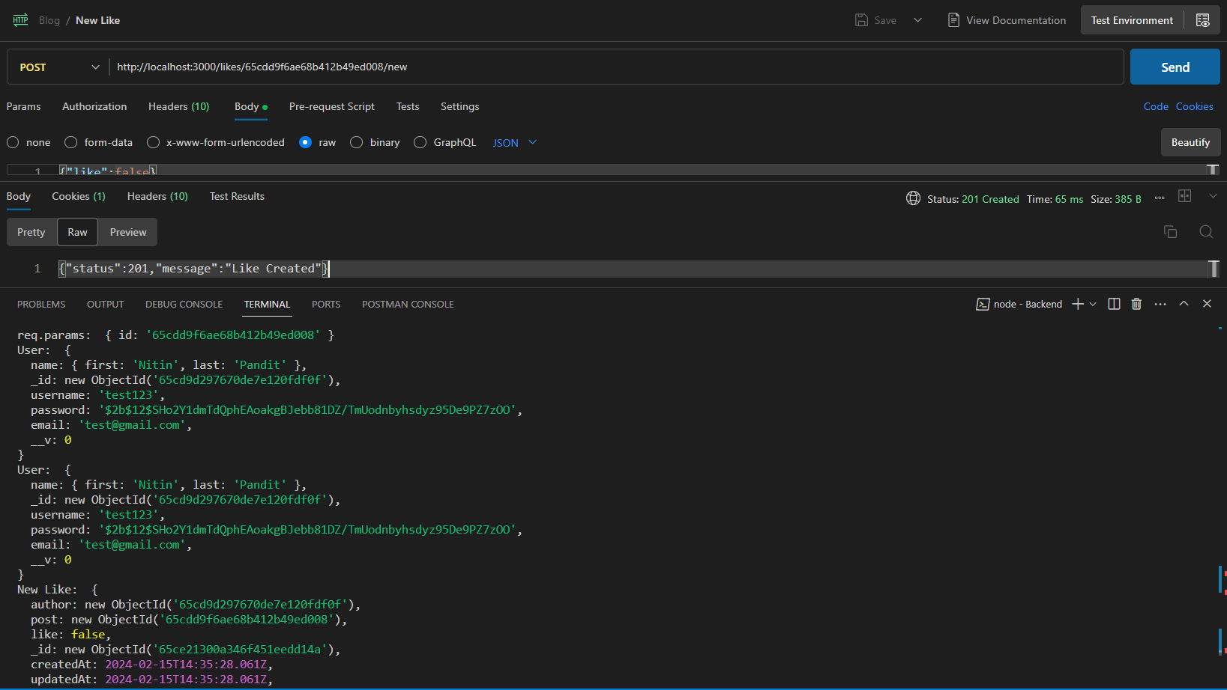

#### Testing Like creation with invalid/missing data:

##### Missing Data:

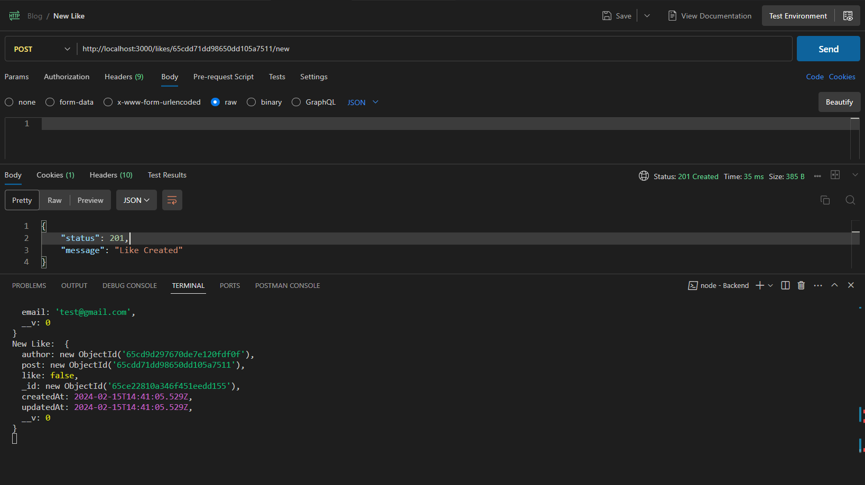

##### Invalid Data:

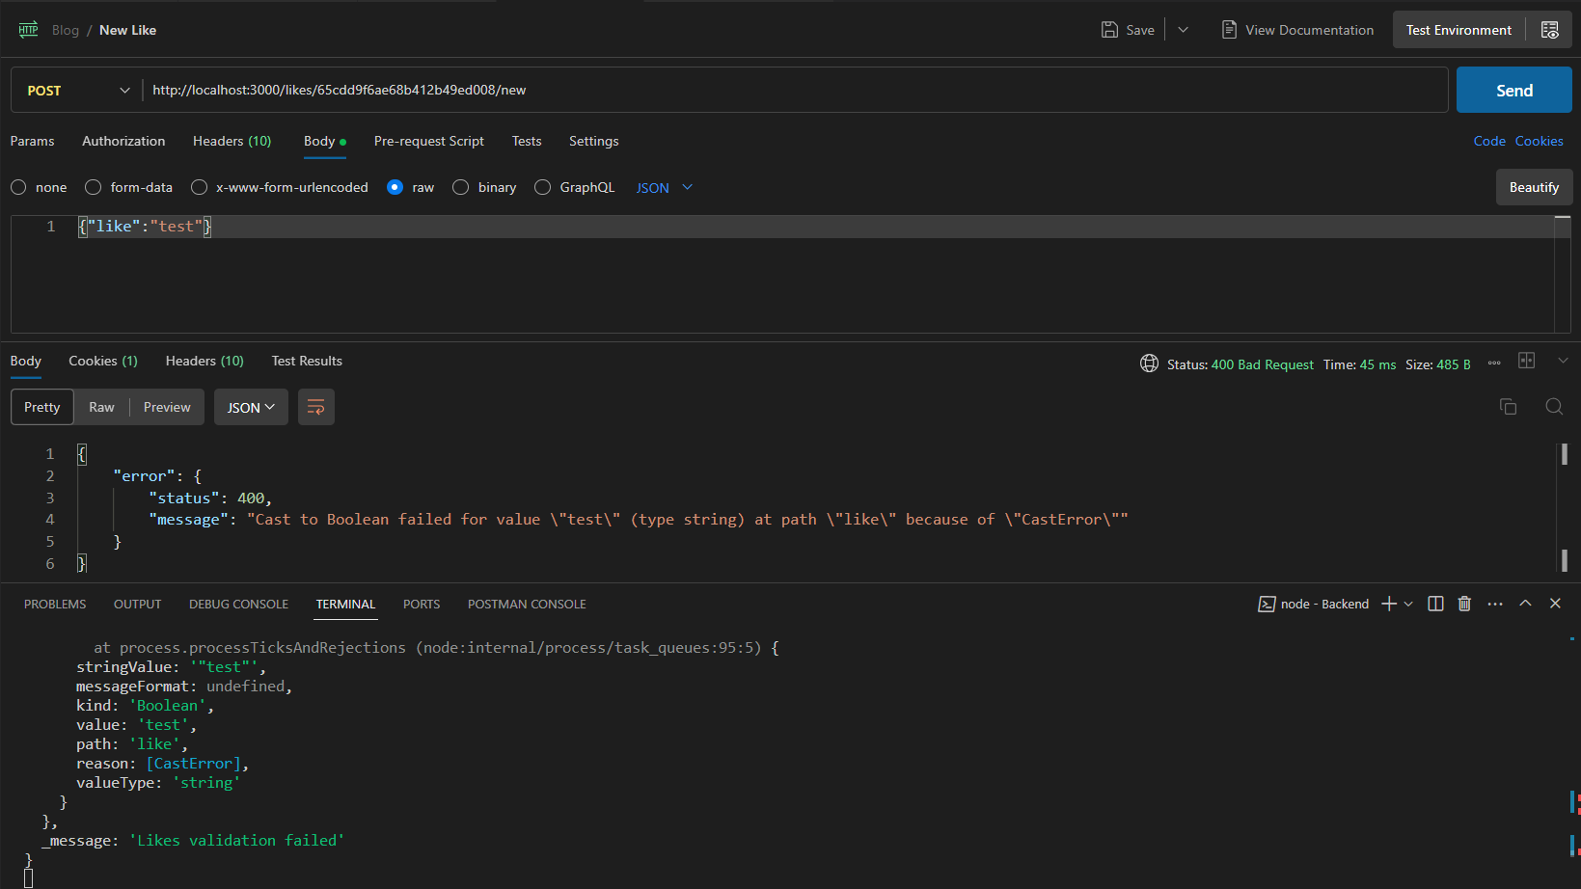

#### Testing Like creation with invalid post ID:

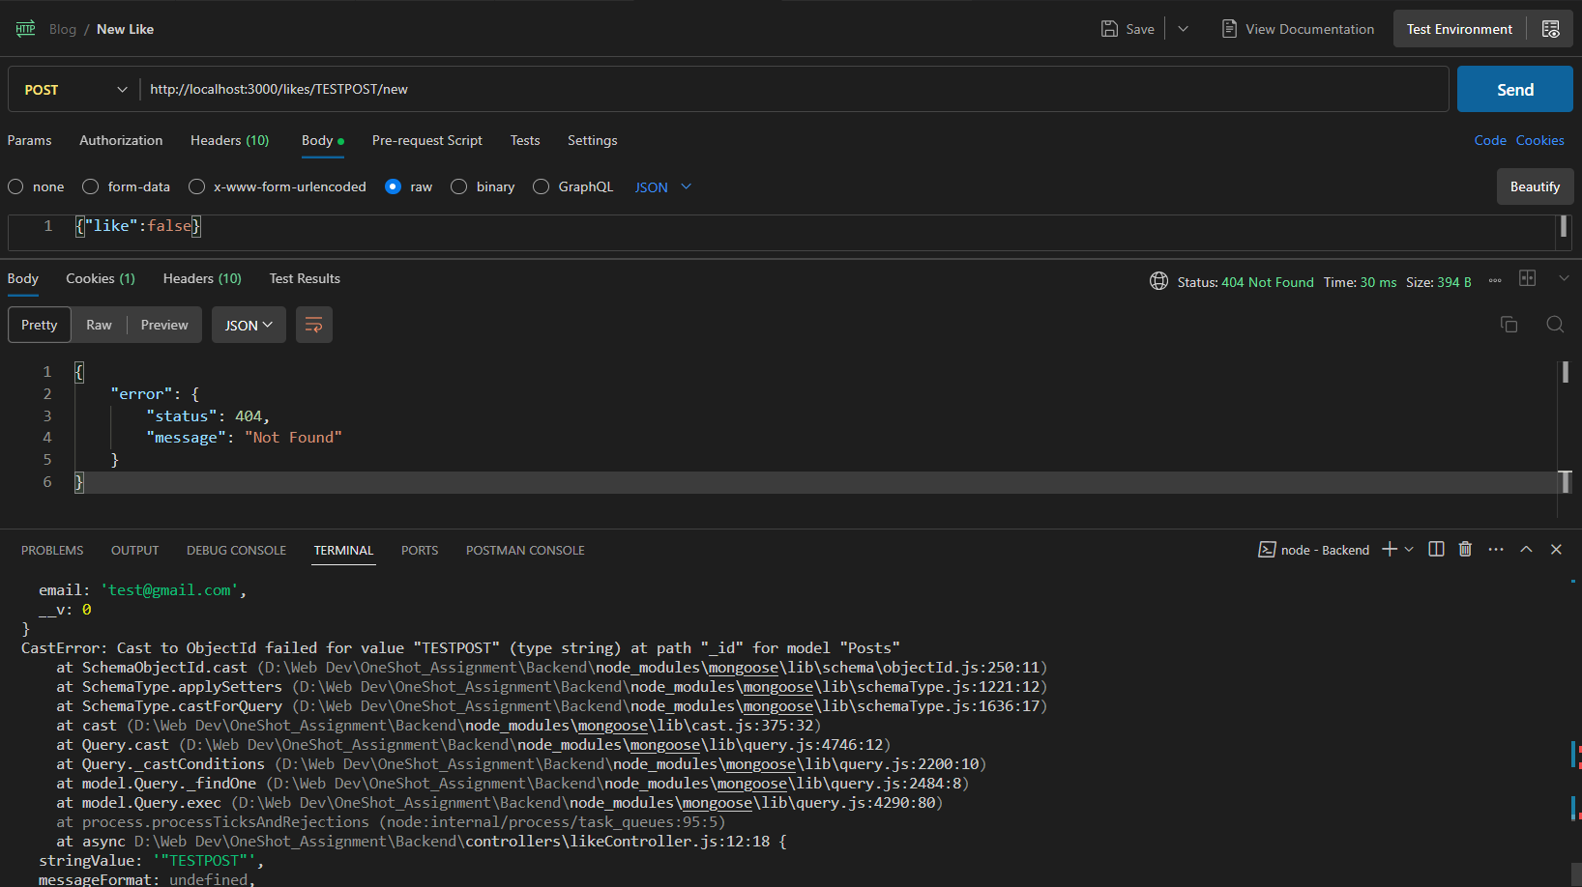

## Get Likes:

GET <http://localhost:3000/likes/65cdd71dd98650dd105a7511>

### Test 1: Sending a GET request without authentication:

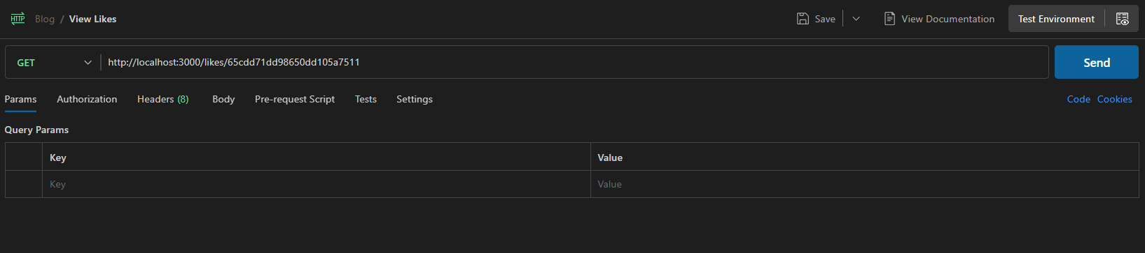

Server Output & Response:

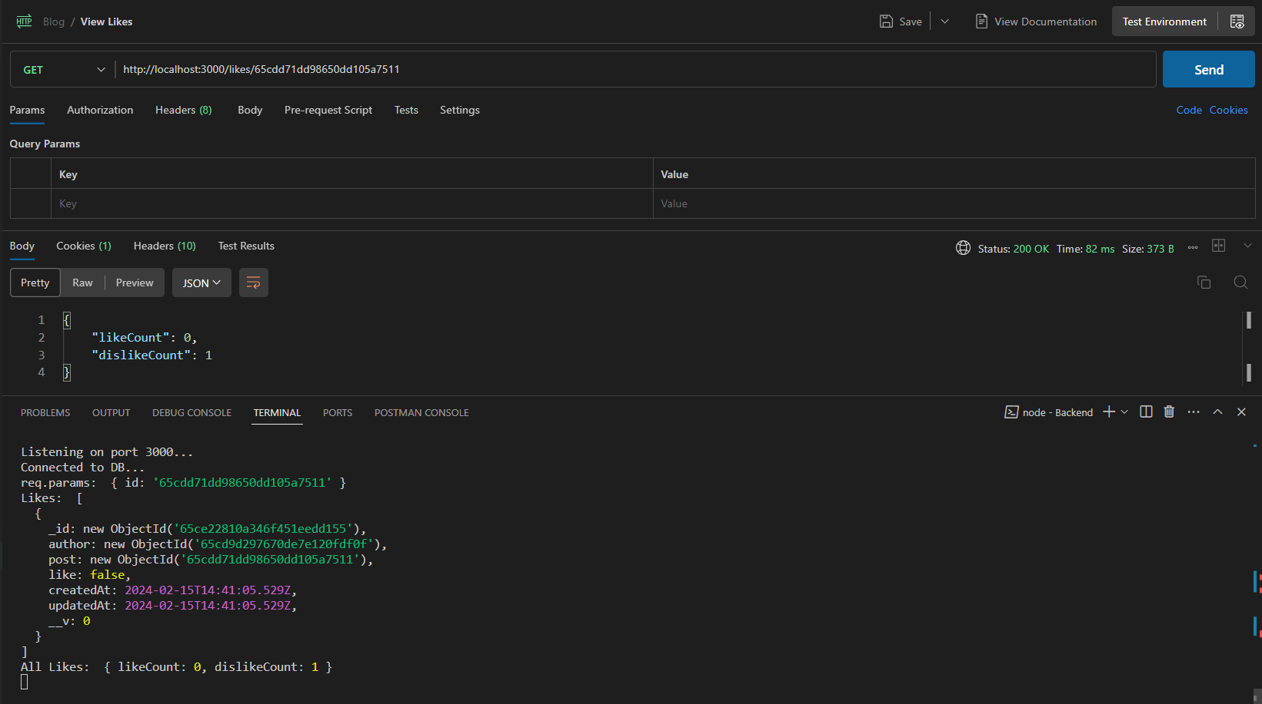

### Test 2: Sending a GET request post authentication:

Server Output & Response: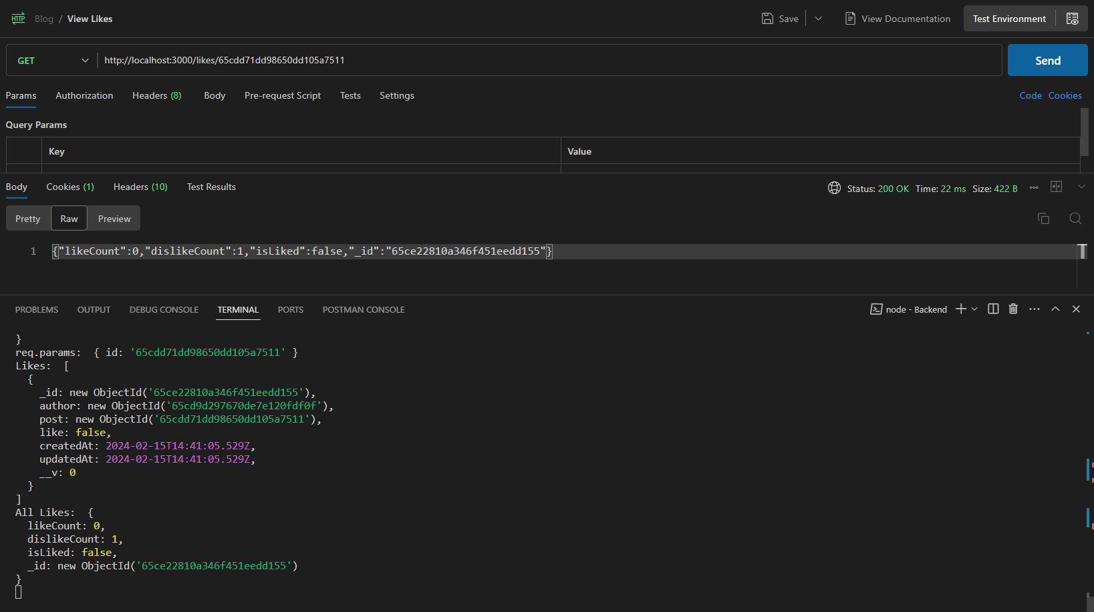

### Test 3: Sending a GET request with invalid post ID:

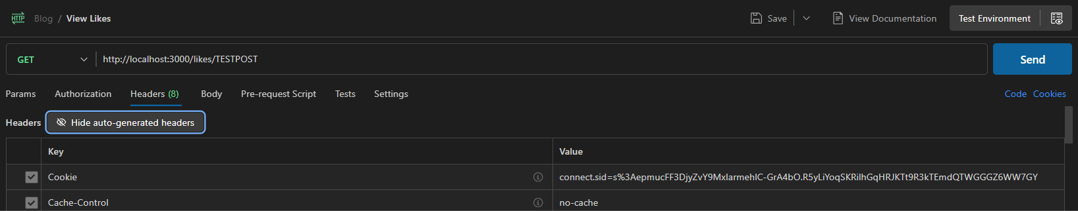

Server Output & Response: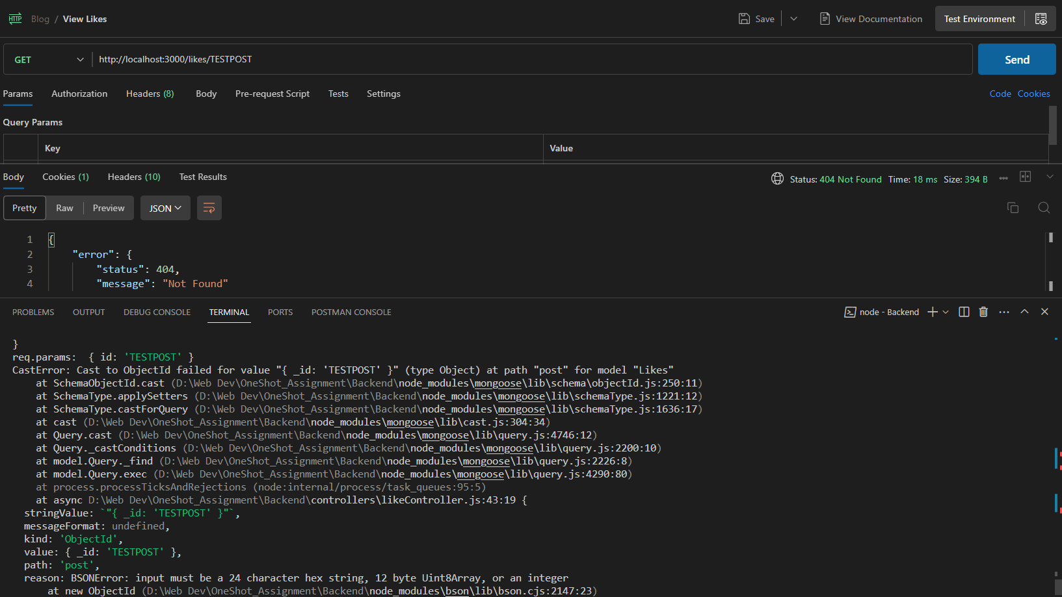

## Edit Likes:

PATCH <http://localhost:3000/likes/:like_id>

### Test 1: Sending a PATCH request without authentication:

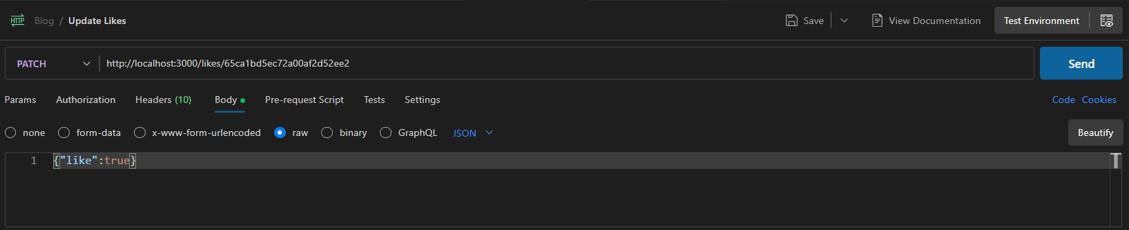

Server Output & Response:

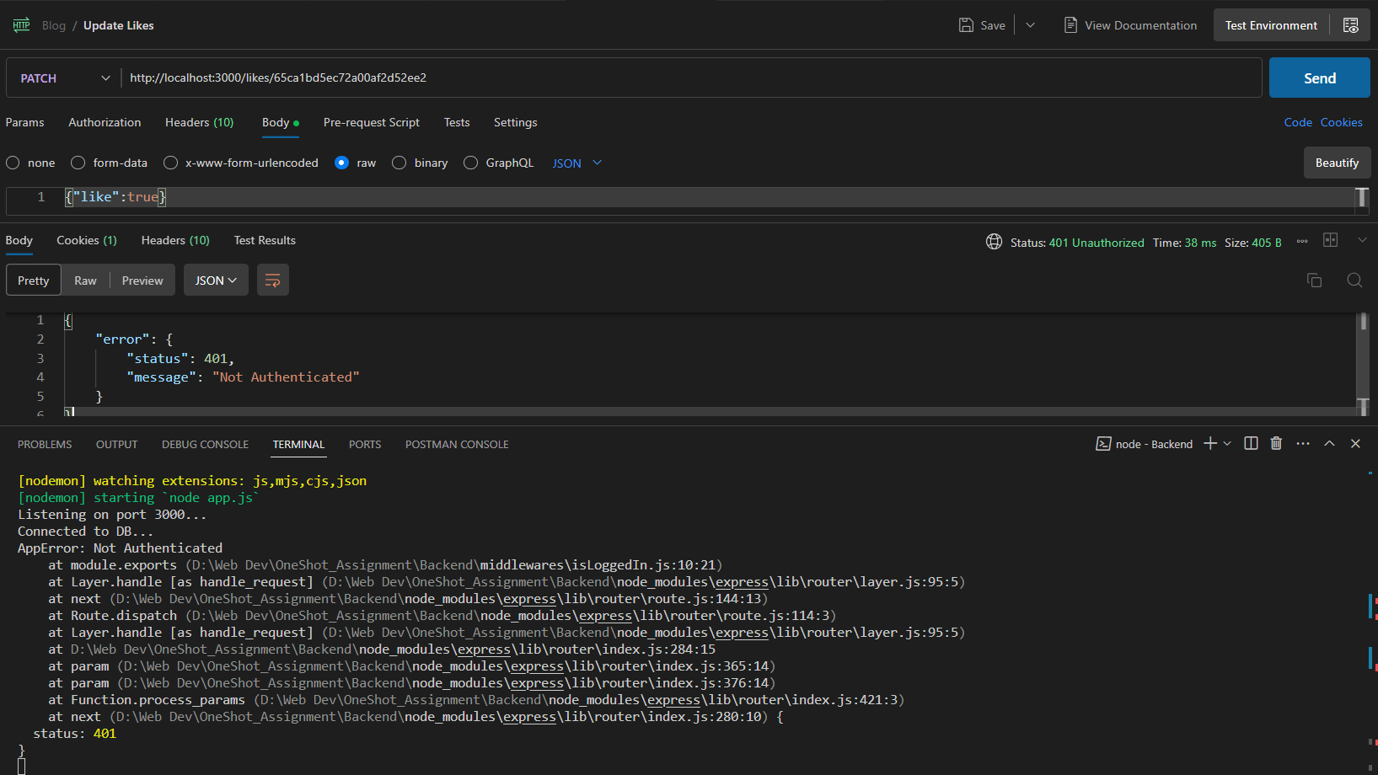

### Test 2: Sending a PATCH request with authentication:

#### Testing valid Like Update

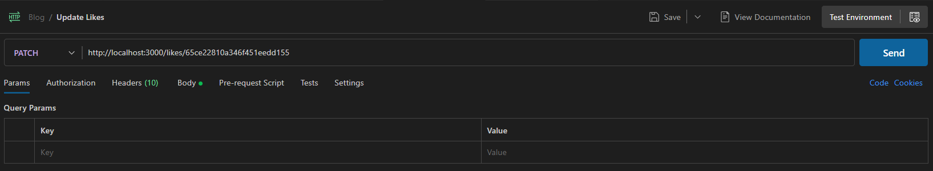

Server Response & Output:

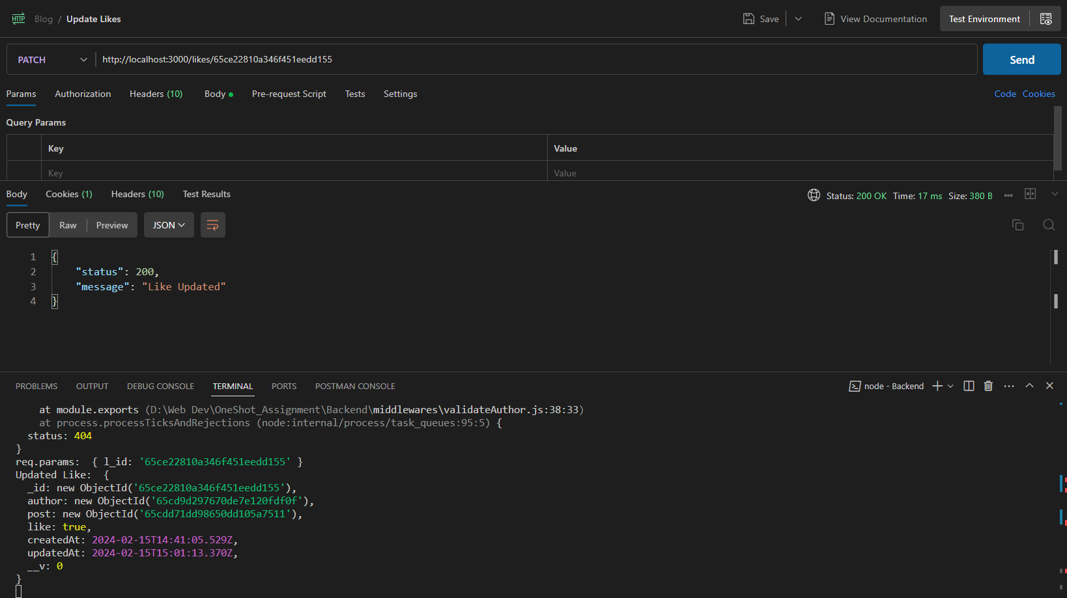

#### Testing Like Update without authorization:

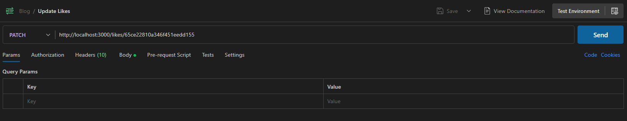

#### Server Output & Response:

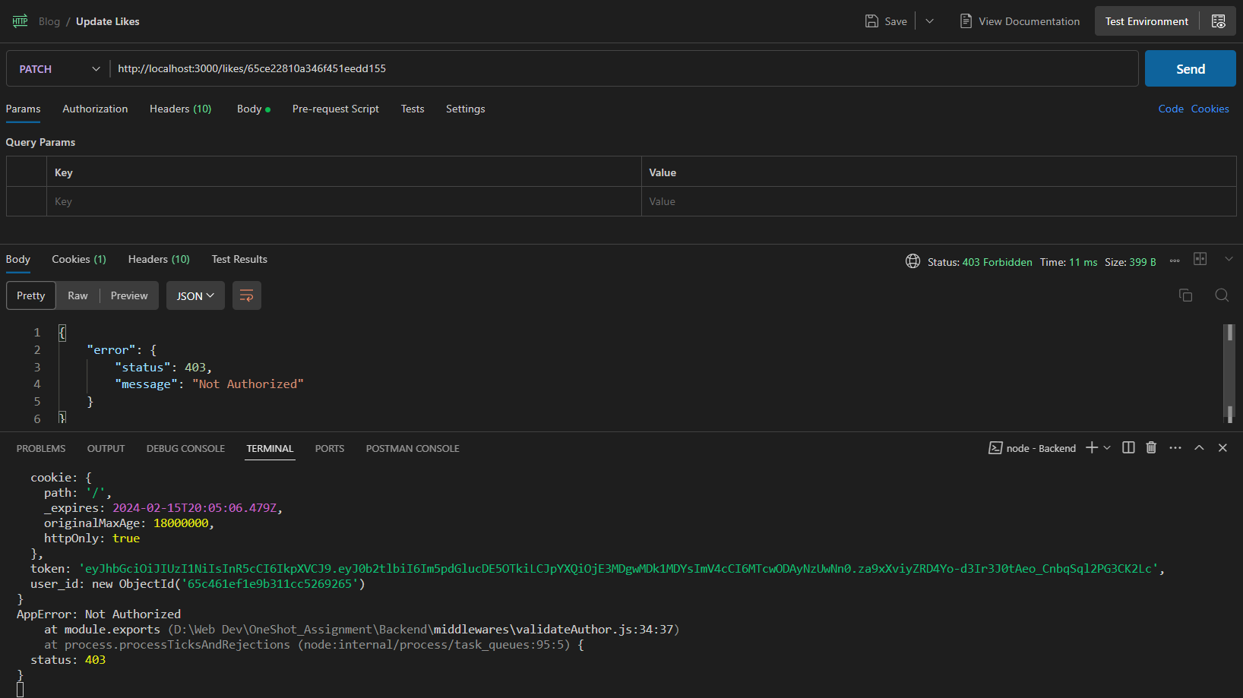

#### Testing Like Update with invalid/incorrect data:

##### Missing Data:

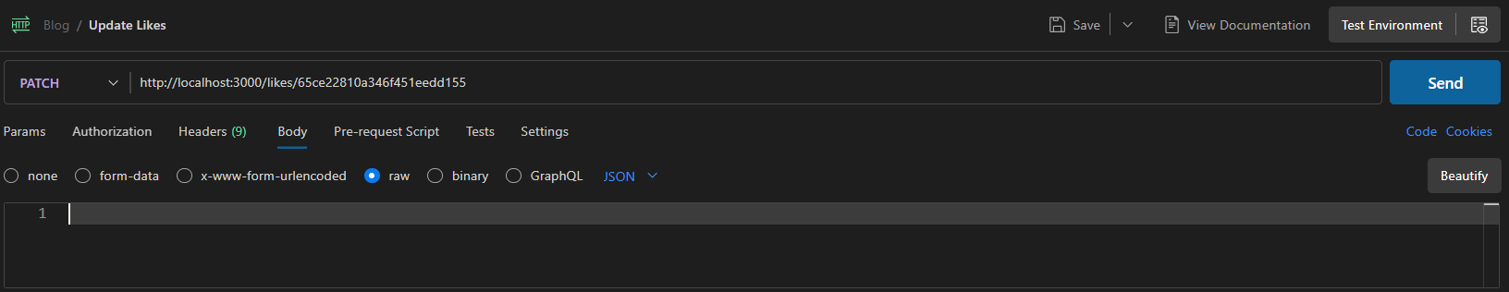

Server Output & Response:

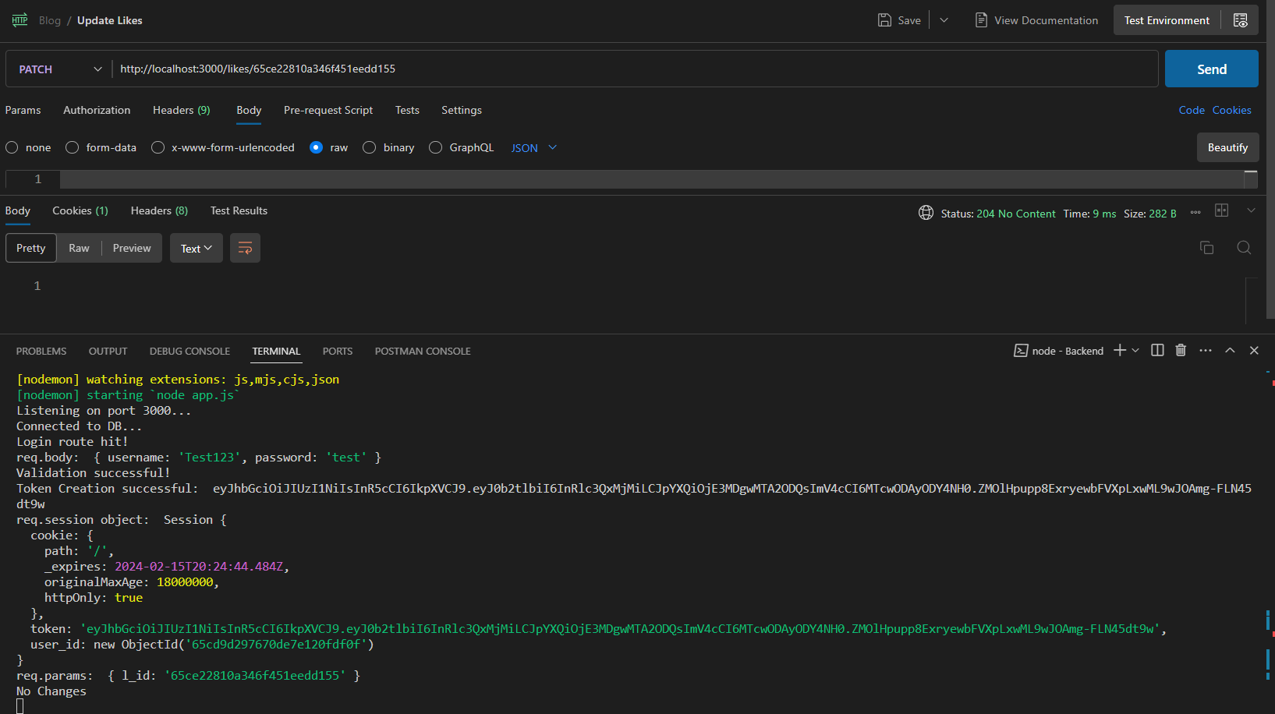

##### Ii) Invalid Data:

###### Passing a number:

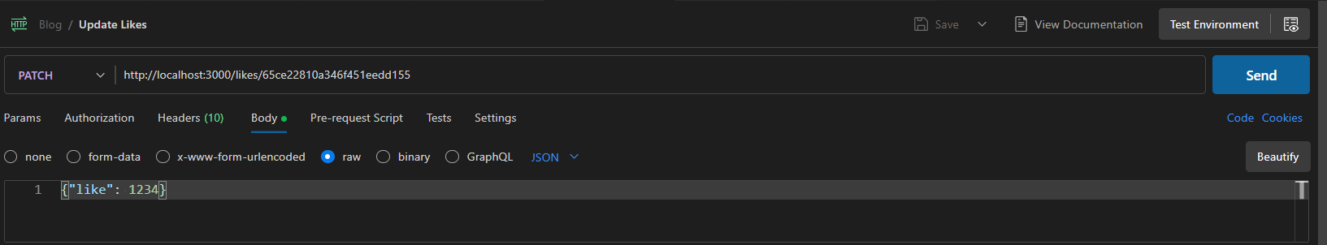

Server Output & Response

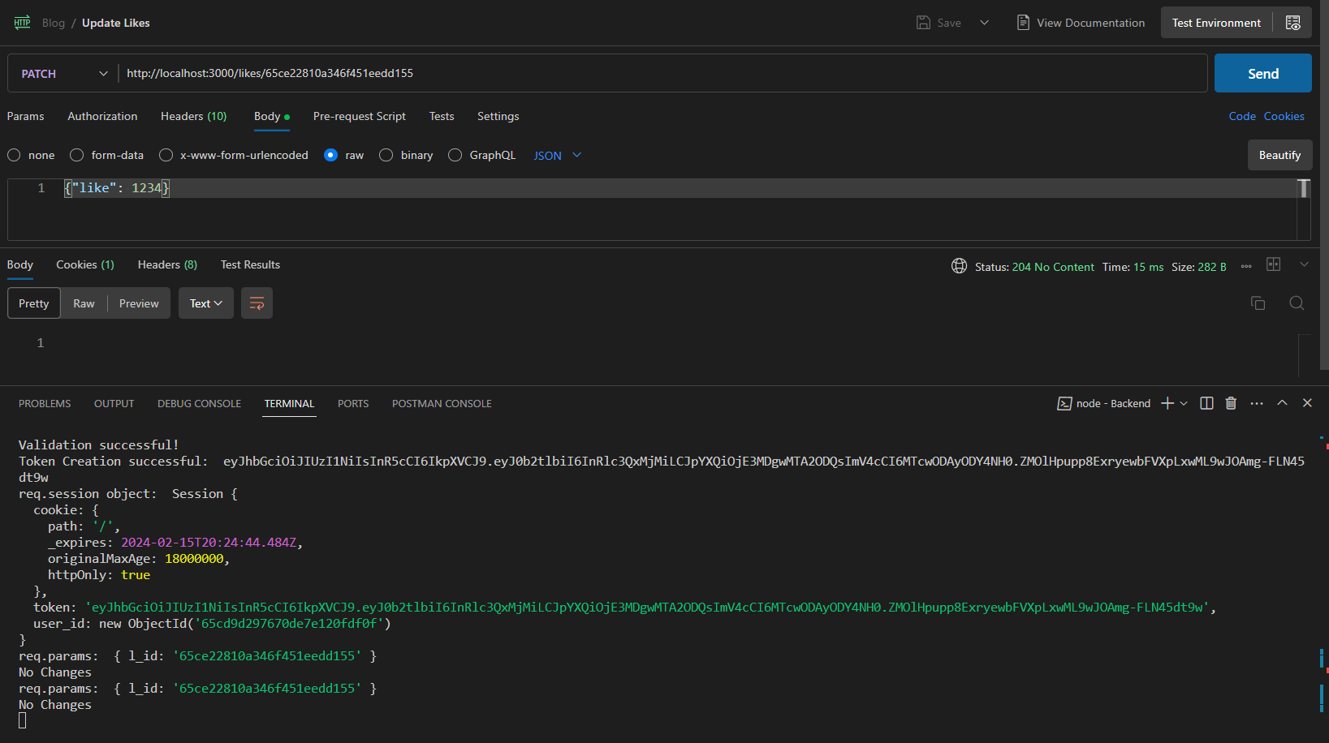

###### Passing a string:

Server Output & Response

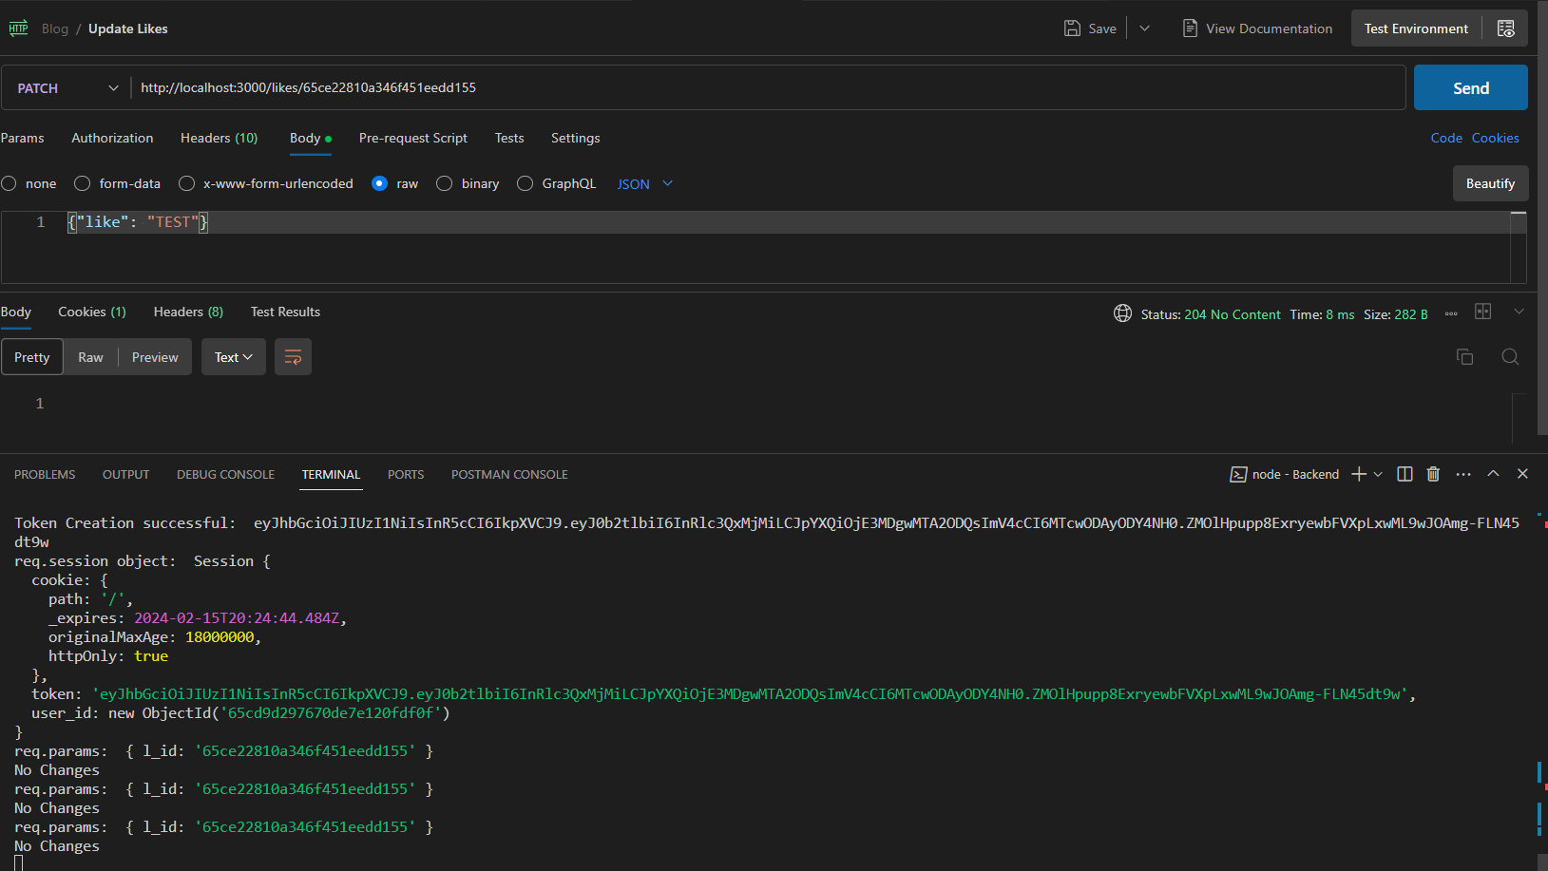

#### Testing Like Update with invalid Like Id:

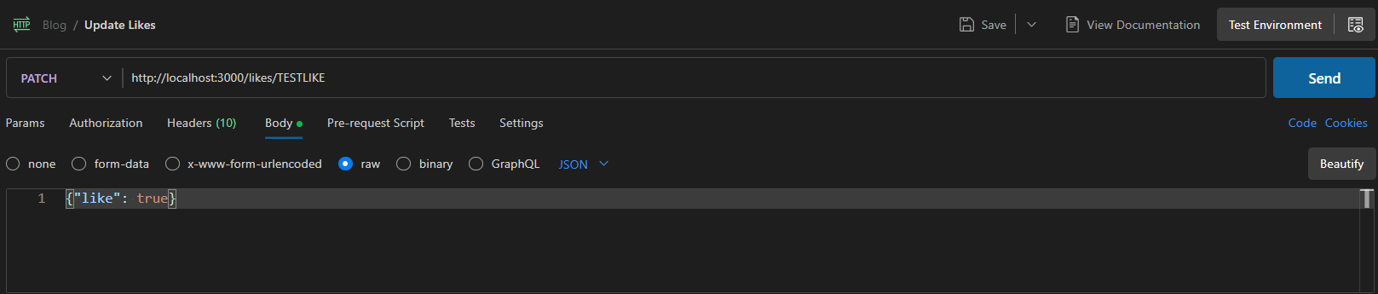

Server Output & Response:

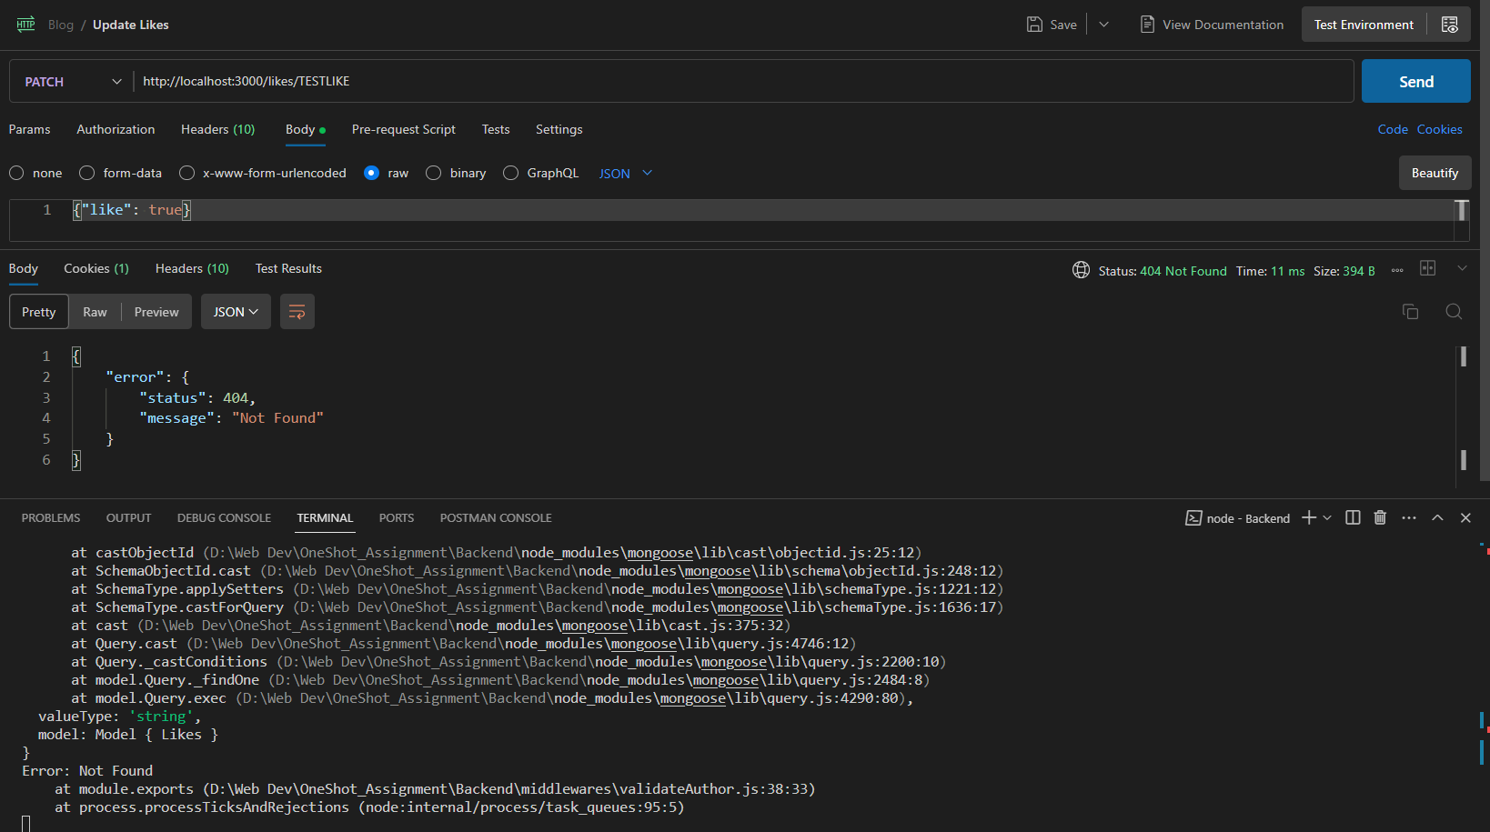

Delete Like:  
DELETE <http://localhost:3000/likes/:like_id>

### Test 1: Sending a DELETE request without authentication:

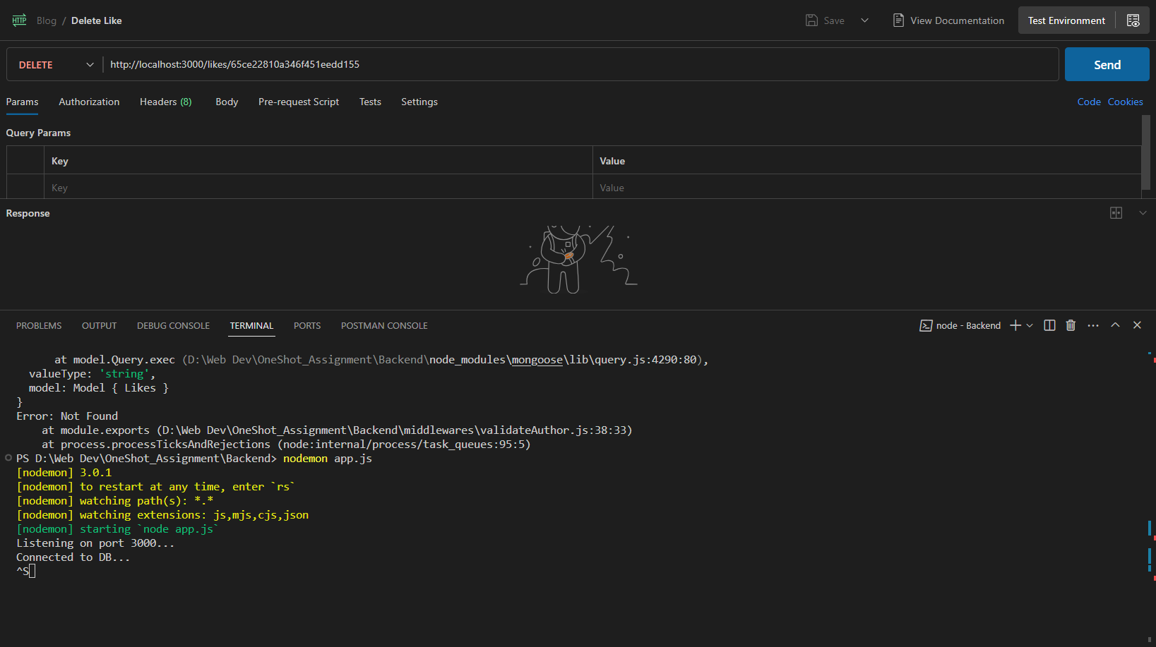

Server Output & Response:

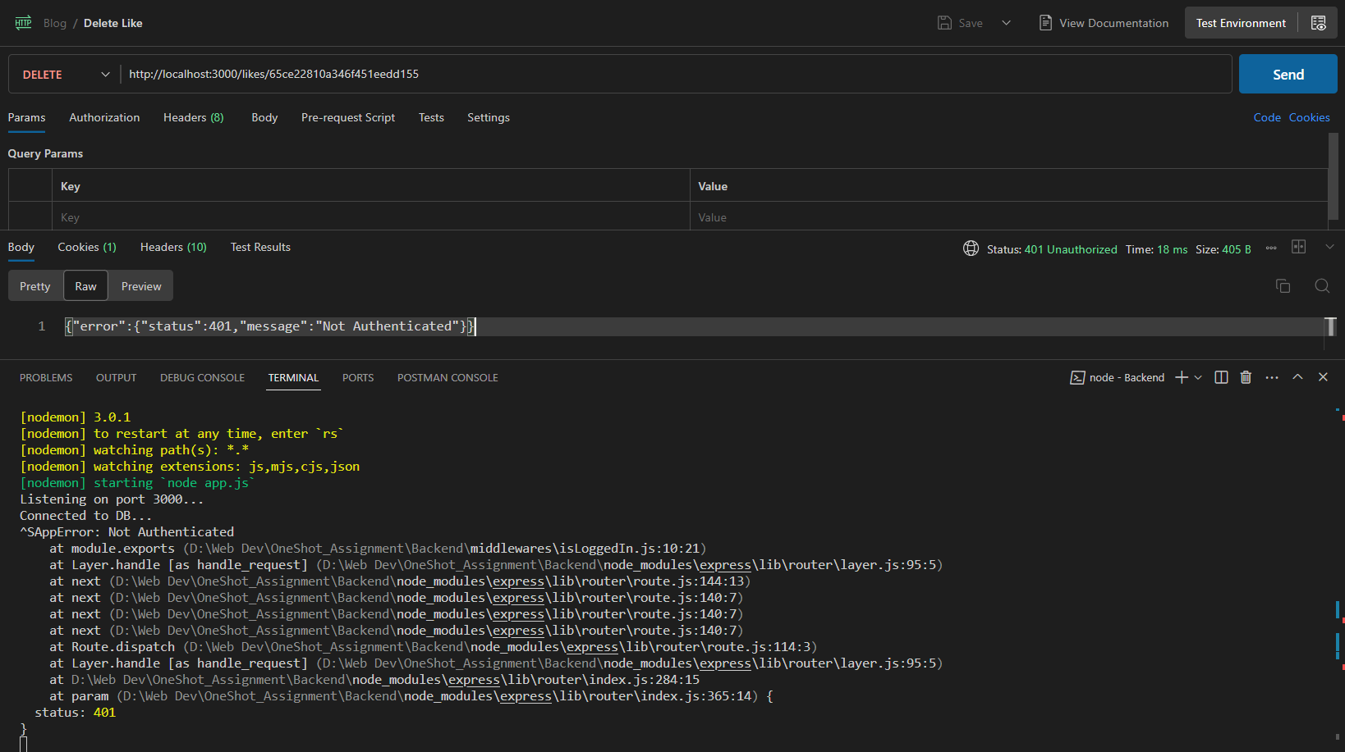

### Test 2: : Sending a DELETE request with authentication:

#### Testing Author Validation:

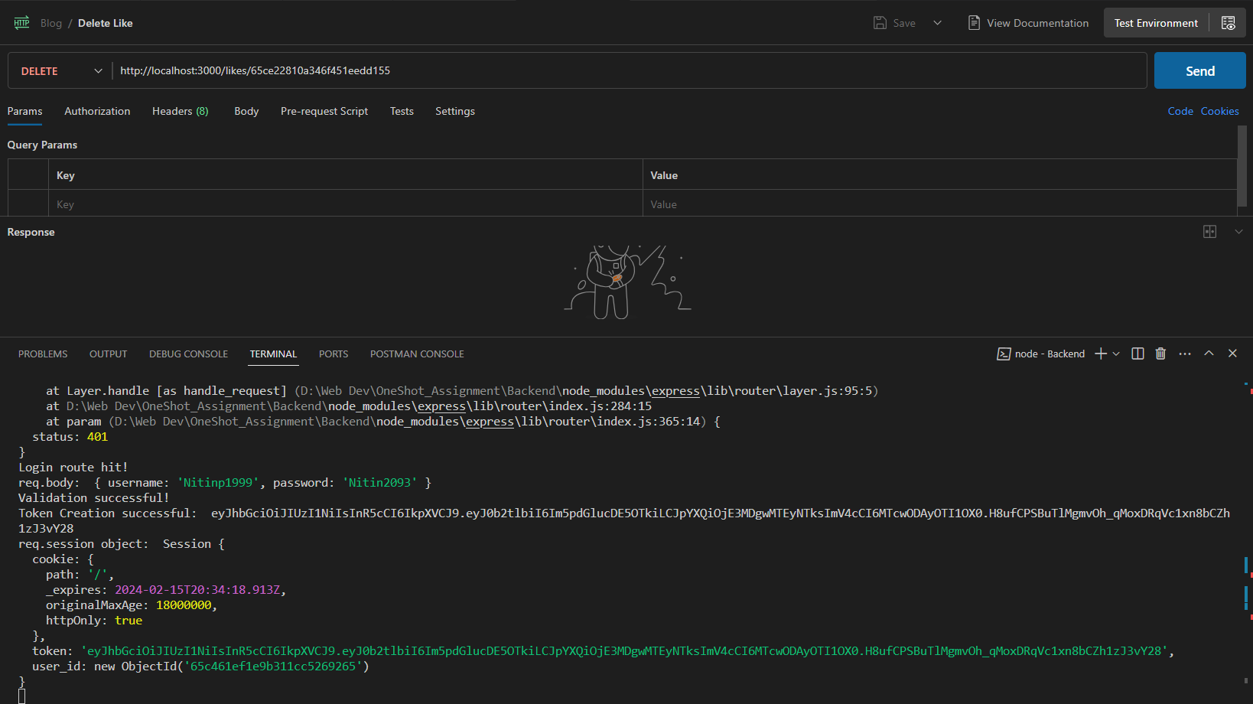

Server Output & Response:

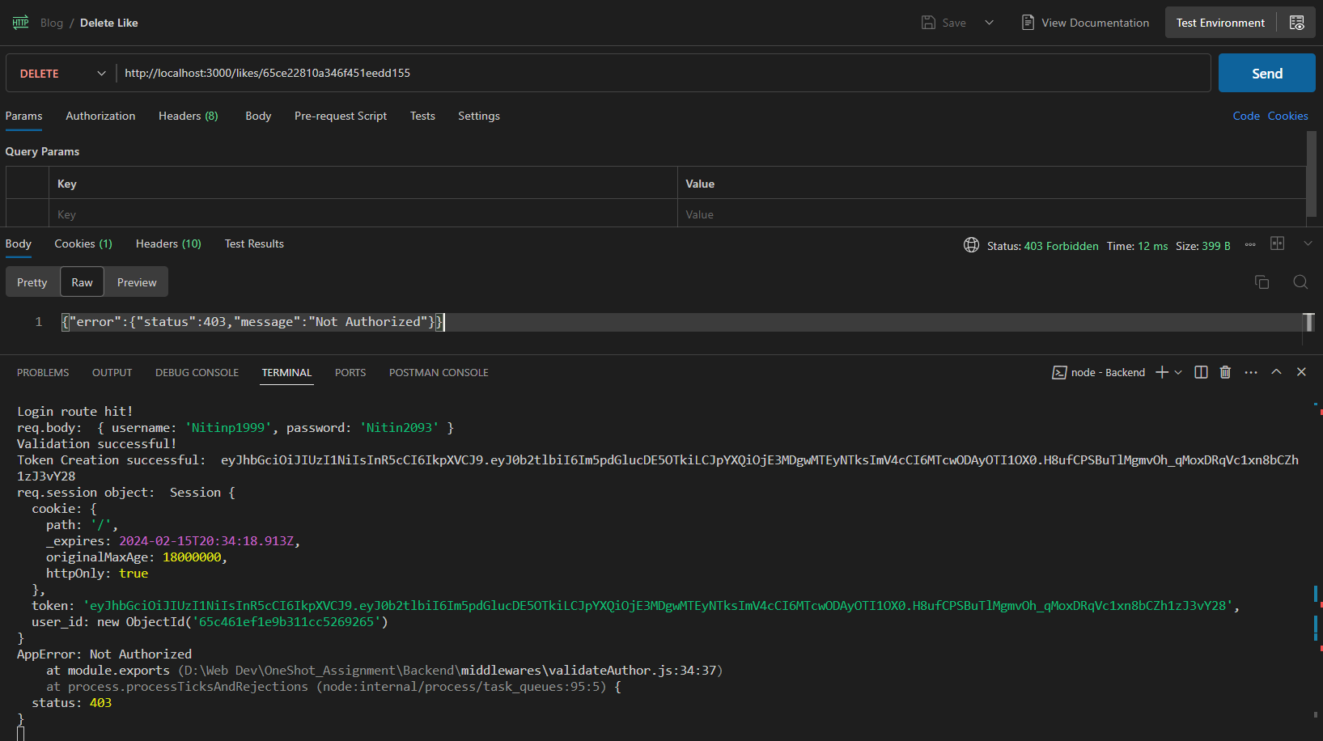

#### Testing Invalid Like Id

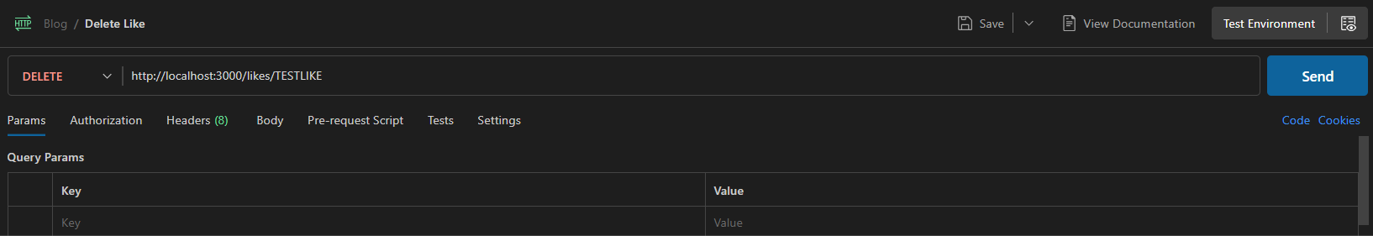

Server Output & Response: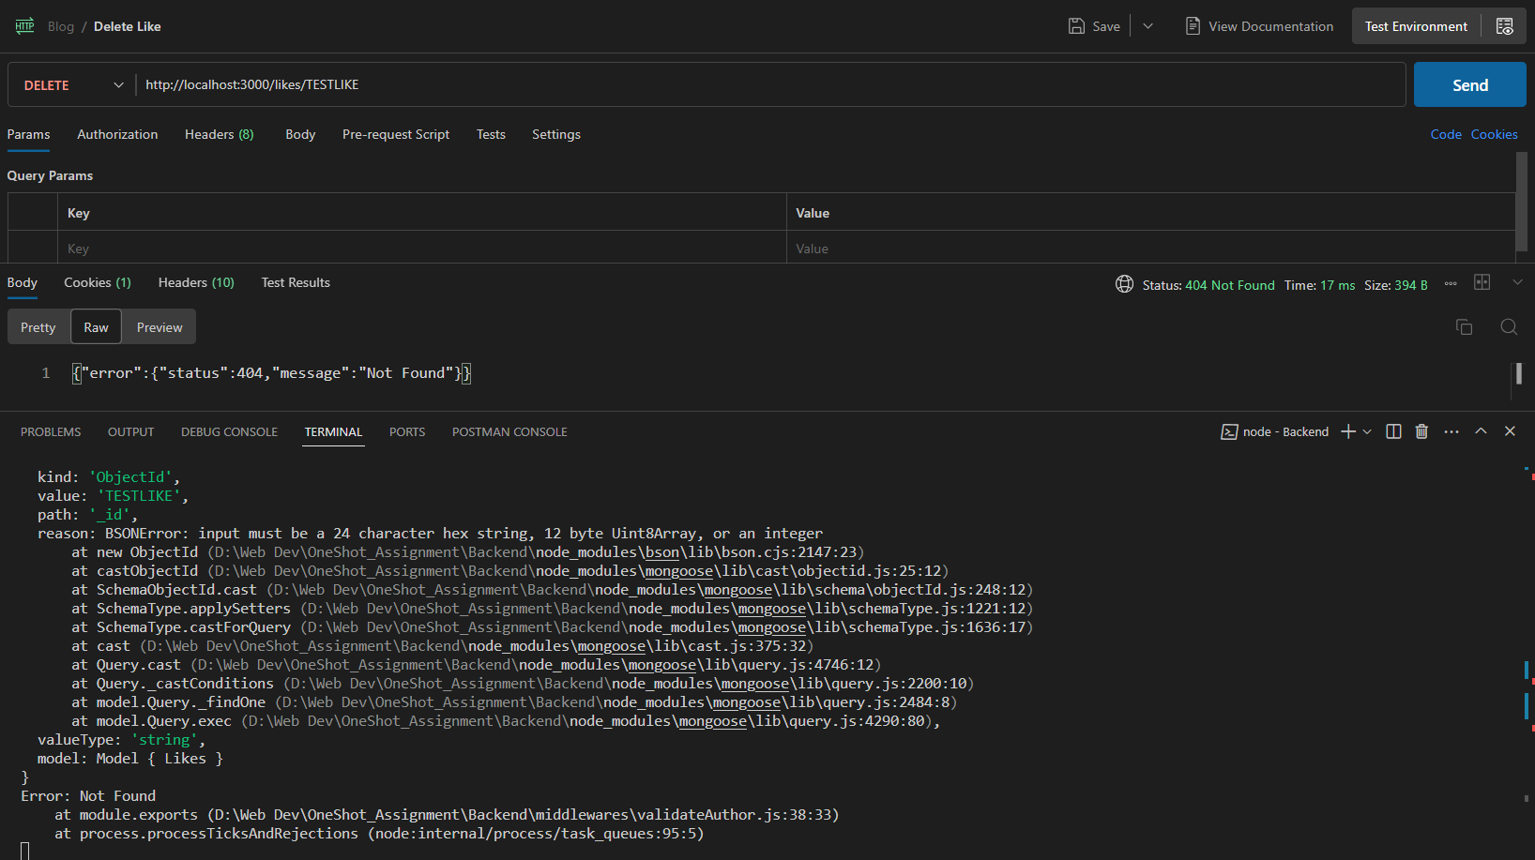

#### Testing valid deletion

Server Response:

